Contents

Analysis 2

Problem Definition 2

Stakeholders 3

Justification of computational method 3

Decomposition 5

Methodology 6

Minimum requirements for user 6

Project Investigation 7

Success Criteria and Objectives 9

Lobby 9

Game 9

Lobby Design 10

Preface: Revisions to the analysis 10

Use case diagram 11

User Interface 11

Decomposition Diagram 12

Design Objectives 13

Data structures 14

Libraries to be used 16

Algorithms and subroutines 16

Modular design diagram 19

Test Plan 19

Game Design 19

Libraries + Methodologies used 19

User Interface 20

Design Objectives 21

Decomposition Diagram 23

Use case diagram 23

Class diagrams 23

Data structures and variables 26

Algorithms 27

Test Plan 28

Stage 1: Matchmaking 29

Window 29

Networking 34

Review 49

Stage 2 – Choose loadout 49

Basic setup 49

Drawing 55

Buttons 63

Review 66

Stage 3 – Buy/Place Items 67

Drawing 67

Interactivity 70

Placing an item 78

Review 94

Stage 4 – Item Interact 95

Component set-up 95

Pathfinding and damaging 102

Effects 115

Review 118

Stage 5 – Miscellaneous finishing up 118

Ending the game 118

Returning home 120

Review 121

Final testing and end user feedback 121

End user feedback 123

Evaluation 124

Criteria reflections 124

Limitations, Solutions and Maintenance 126

References 127

# Analysis

## Problem Definition

The end-user is any consumer who wants to play games with their computers or laptops within the same room and alongside other people. Ideally, this user may be working alongside others and he may want to take a short break from whatever he is doing to play a quick game. One example of this demographic is 6thformers.

Many 6thformers bring in their own devices to their colleges and many 6thforms have study periods where students are expected to study, sometimes for up to 2 hours. Students may want to take a break from their studying and socialise or interact with those around them. One way that this can take place is through playing a game such as the one I plan to make.

However, a problem with this is that many sites where lots of people are connected to one network, employ restrictive and draconian policy restrict users from being able to play online games which are stored on 3rd party servers, since most schools use some form of firewall. This is another problem that I plan to solve as well.

## Stakeholders

There are plenty of stakeholders, but the two largest stakeholders would most certainly be networking administrators for schools and teachers. This is because it is desirable for teachers to rid students of all software or tools that would distract them from their studiers particularly programs that would be used in environments dedicated to studying i.e. study periods. Furthermore, even though there is little network administrators are able to do since they typically only have control of devices that they own and what can enter and leave a network, whilst this solution works with the student’s own device and acts internally within the network.

Other stakeholders include parents who are looking in the interest for students, students themselves and other video game developers such as the ones mentioned below.

## Justification of computational method

There are bypasses to this such as making use of VPN’s and proxies but only highly savvy students have the know-how utilise such tools. As a result, many students are restricted to playing offline games which are only single player (no interactivity with other users).

Based on what was said above, a peer-to-peer multiplayer system that exists within a LAN based environment and doesn’t necessitate a 3rd party router would be a perfect solution, for the problem and this is what I plan to offer.

Now this leads to the second part of the problem, what is the game I am actually going to offer to consumers?

I’ve decided to make a 1v1 PVP (player vs player) strategy game where the goal of the game is to destroy the other user’s base before the user does this to you.

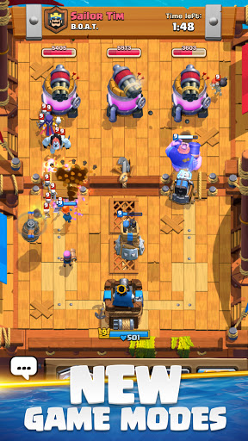Disregarding the criteria that the game be peer-to-peer Lan for the moment, there are quite a few games that appear to be similar to the game described above. Clash Royale and Bloons TD Battles are both games with considerable popularity with the former having 468 million downloads[1] (worldwide and a google play rating of 4.2[2], and the latter having a rating of 4.3[3]. The disadvantage to both is that they are both on mobile.

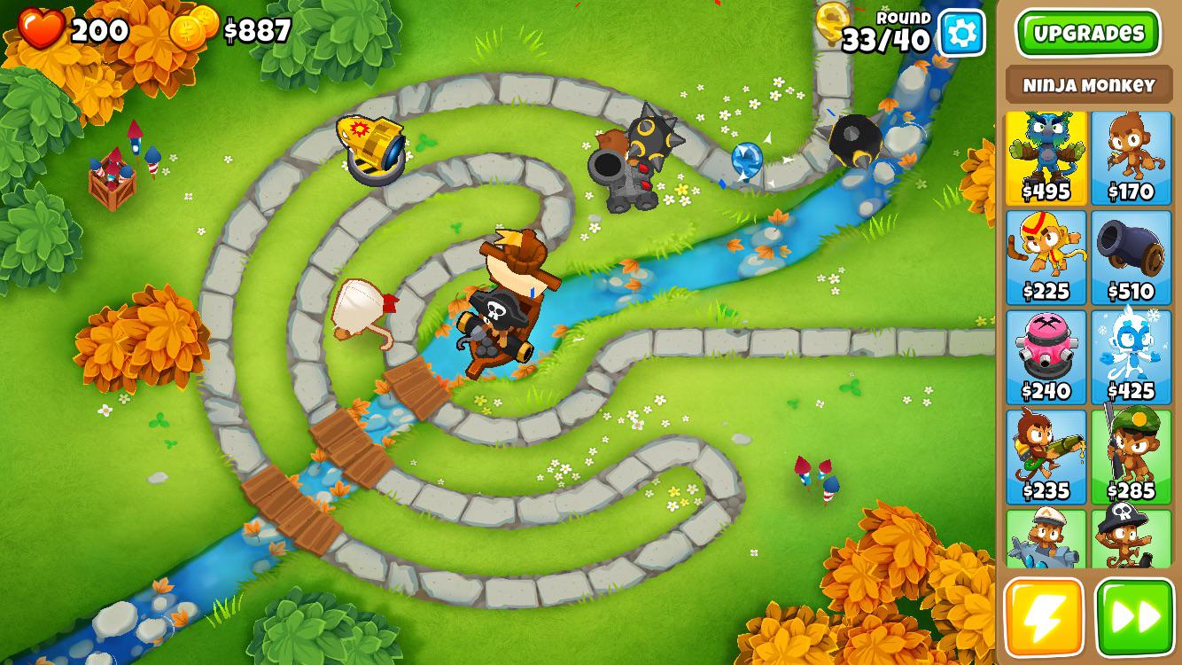

Another game that is similar to what’s described above is League Of Legends, the most streamed game on Twitch (a videogame livestreaming site) in 2020[4], a game that exists on PC but three problematic aspects are that this game is highly addictive, games exceed 25-30 minutes[5] and there is high barrier to entry since the game is highly complicated and the lots of the mechanics would be regarded as archaic, as can be shown in the image below, a lot is going on and it may be difficult to know what is going on.

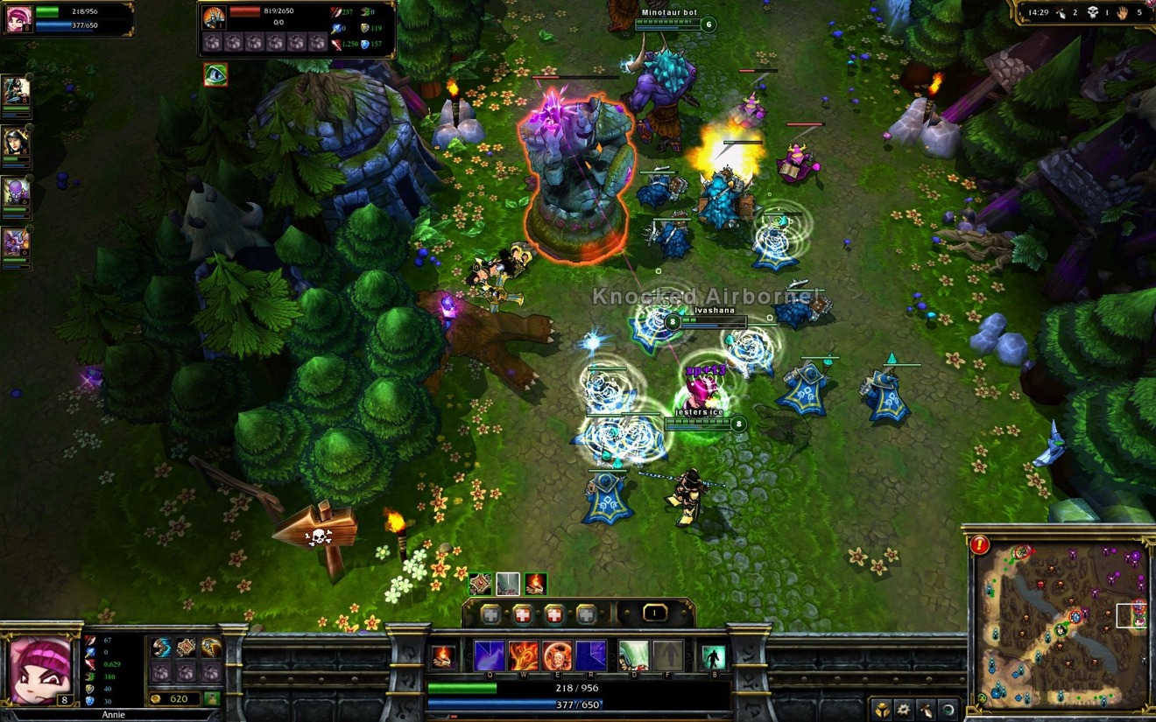

If we look at non-computational solutions to this problem, there are many flaws with them. One non-computational based solution to this problem could be board games, however the problem with this solution is that they occupy a lot of physical space (in one’s bag), they are costly to purchase, ranging from anywhere between £5-50 and games can last quite long, sometimes even hours long, which isn’t desirable since students are at most given 2 hours in their study periods, and these games shouldn’t be expected to take up the bulk of that time. Aside from that, one solution is card games, they don’t have the space issue but the problem that they do have is that one can get board very quickly from playing them. From looking at a few of the non-computational solutions, we can conclude that computational methods are surely better since the user already is expected to have a laptop, so space or cost is not an issue and furthermore, games are much more dynamic in that they can offer anything and are not limited by the constraints of physical items.

## Decomposition

This program can be broken down into two pieces, the lobby and the actual game.

The lobby section can be broken down into the following:

* username input,
* inviting and responding to invites,
* broadcasting, and receiving status messages.

The game section can be broken down into the following:

* Loadouts
* Shop
* Towers (that the user will attack/defend)
* “Minions”
  + Ranged minions
  + Melee minions
  + Other types of “minions”
* Other items aside from minions that you can purchase

## Methodology

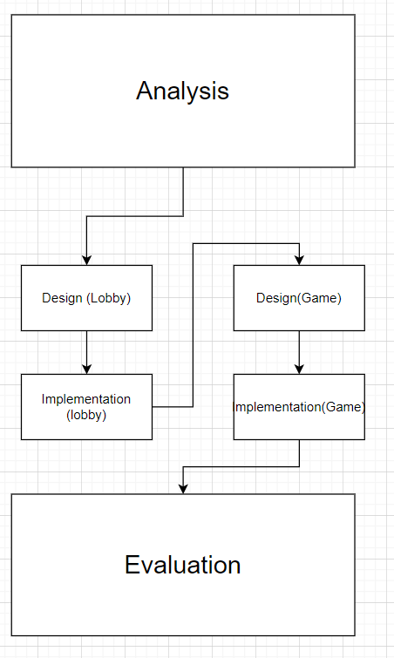Linking in with the previous section on decomposition, my project can be divided up into two distinct areas, the lobby section and then the actual game section. Because of this, I’ve decided to go with a modified form of the waterfall model, that I would call the “double waterfall” method or more traditionally, this would be called agile method, that can be demonstrated from the diagram below.

The way this method works is I work on the design and implementation of the lobby separately to the design and implementation of the game. I have chosen to work in this way since the lobby and the game are two well-defined and separate parts of my project. Furthermore, as of this moment, I do plan on using different programming frameworks for the lobby and game. Therefore, it seems to make the most sense if I divide these two parts up separately.

## Minimum requirements for user

The solution will be able to run on a standard computer or laptop which has some sort of keyboard and mouse input. A trackpad for mouse input will be fine but is less desirable than a real mouse since it is generally more difficult and inconvenient to move the cursor around the screen with a trackpad.

A keyboard is required to allow for the user to input their desired username.

Seeing as my game is 2d, an integrated graphics card would be sufficient to be able to run the game; wouldn’t be necessary.

Finally, the device would require some form of networking capabilities since this game is intended to be played with other players.

## Project Investigation

In order to understand what type of games a user wants to play and what they are looking for in a game, I will be distributing a survey and this input will provide me with data that I can use to mould my initial ideas into something more specific that really fulfils user needs. I planned on asking the following questions to at least 10 people but I received 14 responses. I gathered this data using google forms and I sent the form to some friends and I posted it up in some online communities cantered around gaming as well as in the 6th form age group.

**-Please provide your name or username**

**- Out of the following games, how many have you played before: Bloons Tower Defence, Clash Royale, League Of Legends?**

Only 14.3% of people, (2 people) said they hadn’t played any of the games above, 50% said they had played at least 1, and 28.6% said they had played 2 of the games above.

**- Please enter the name of any other games you’ve played in the tower defence genre**

3 People submitted the game “Plants vs Zombies” and aside from that another person said they played “some miniclip game” (I’m assuming they forgot the name). This question, and the question above demonstrates that the majority of people are at least vaguely familiar with this genre of video games and have probably played a game in the genre in the past

**- Do you enjoy playing games in this genre**

78.6% of people answered with yes or sometimes, whilst only 21.4% of people answered with no.

- What do you dislike about games in this genre?

11 people gave responses to this optional question, which I plan to address to varying extents.

Some people complained about ads for example, I do not plan on including ads in my game, others complained about “Pay to win”, which is a system that many modern video games rely on to generate revenue whereby specific tools and skills, that otherwise have to be earned through “grinding” the game a lot, can be bought. This provides these users with an advantage over other users who aren’t paying.

But by far, the biggest complaint is that the games have a slow pace and can get repetitive and boring. They lack “re-playability”. Why I believe my solution is immune to this problem is that the matches will typically be shorter and furthermore, they will be against other players which will be more fun that playing against the computer.

**- Have you ever stopped playing a game because it was too complicated?**

64% of people responded yes to this.

**- How important is a video game’s art style and graphics to you?**

Only 14.3% of people said that this was very important and 85.7% of people said that this was not important or a little bit important.

**- Do you prefer games with a large amount of options for your next move or a small amount of options?**

64.3% said large amount, 35.7% said small amount of options

**- How important is a realism of a game to you (i.e. if a game had fantasy elements would that stop you from playing it?)**

50% of people said not important at all, and 50% of people responded with somewhat important. Therefore, I do not plan on focusing heavily on the design of the game and I may potentially design to do as little as possible.

**- What is your opinion on RNG and Chance in video games?**

Two people said that it should not exist at all, 6 people expressed a desire for RNG to be implemented but implemented in such a way that the game isn’t rendered unfair, and 6 other people had no problems or criticisms for RNG.

**- Do you think that RNG and Chance can sometimes make video games more fun?**

No-one responded no, 28.6% of people responded sometimes, and 71.4% of people responded yes

**- Do you think that taunts make videogames more fun?**

7.1% of people, 1 person, responded no, 35.7% responded sometimes and 57.1% of people responded yes. Whilst taunts are not necessary for a videogame, on the basis of this feedback, I plan on adding them into my game

**- Which of the following devices do you use to play games?**

100% of people responded computer or laptop, which means that they would be able to play my game, 35.7% responded with console, and 21% responded with phone.

**- Have you ever played games with a friend?**

100% of people responded yes.

**- Do you have any additional comments?**

Nothing of value

**- Would you be interested in playing my game once complete?**

35.7% of people responded yes, and 50% of people responded maybe.

In conclusion, I’ve determined that the majority of users in my target demographic are familiar with the genre that my game is being produced in and they have played games before as well as with other players. Key things that users dislike about the genre are pay to win aspects and lack of replayability. My game is completely free, and I plan to make games short and against other players to increase replayability. Users say they want a lot of choices for their next move, but they don’t want to the game to be too complicated, which I will have to bear in mind later on. People had generally favourable opinions towards RNG, but it must be implemented in such a way that doesn’t ruin the game by making it unfair. I plan on implementing taunts to add more variety to the game.

## Success Criteria and Objectives

### Lobby

The general idea is that the player is in a lobby which displays other players in their nearby real vicinity which they can play with

* Player’s create a username before entering lobby or GUI
* UI
  + Lists player usernames
  + Invite button that invites users
    - Cannot invite players who are in-game
    - Accept/reject button if player receives an invite
* The player makes himself known to other players
  + Player appears in other player’s playerlist
* If a player closes the lobby program, and other players are alerted to this
  + This player no longer appears in other player’s player lists

### Game

* The game will be 2D top-down (aerial view)
  + Pressing the WASD keys moves the camera leftwards or rightwards, up or down based on what key is pressed
  + There will be a dividing line in the middle of the map to designate each side
  + Enemy tower will be drawn on each side of the map for each corresponding team
* The player will see a menu a loadout menu before the game begins
  + In the menu there will be 4 boxes
    - The name of the loadout will be displayed in each box
    - The stats of the loadout will be displayed in each box
    - There will be a “Select” button in each box that the user can click to select the loadout
  + Varying properties of each loadout may include:
    - base health (of tower)
    - starting cash of the player
    - Tower health regeneration rate
    - Max amount of money a player can have
    - Currency increase rate
    - Specific details for reach class will be developed in the design stage and subject to change in the implementation
* Once both users choose a loadout, the game begins, and the loadout menu is cleared
* Taunts
* On the bottom of the screen, there will be a menu for a selection of “character” that the user can buy and place down
  + The program checks that the user is able to afford the character before allowing the user to place it down
  + The user clicks on the entity to tell the program which entity he wants to place down
  + When the user clicks on a place in the map, the entity is deployed
  + I aim for there to be 15 unique entities
    - Each entity has a purchase price property
    - I will describe in more detail what the functionality of each entity in the design phase
* Each entity has a unique functionality
  + Including but not limited to pathfinding, ranged and melee attacks, and explosions
* When game is over, end game screen of who won is presented
* Program returns to matchmaking window once game is over

# Lobby Design

## Preface: Revisions to the analysis

I’ve decided to remove music in my game for the foreseeable future, nor an fps counter, or a settings menu. These are unnecessary complications that are not necessary to solve my problem as stated in the problem definition.

As described above, the game can be split up into two key parts, the lobby, which acts as a matchmaking tool designed so that players can find players nearby that they can play with and the actual game where they play against each other.

Thus, I plan on doing the following development methodology. First, I will do the design of the lobby part, then the implementation of the lobby part. After, I will produce the design of the game, then, I will do the implementation of the game. I believe that the design and implementation will be much more substantial and time consuming than the design and implementation of the lobby

## Use case diagram

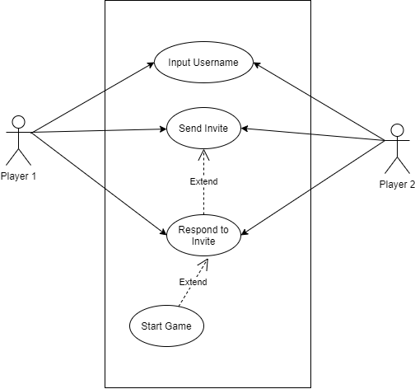

## User Interface

Window for the user to enter his username.

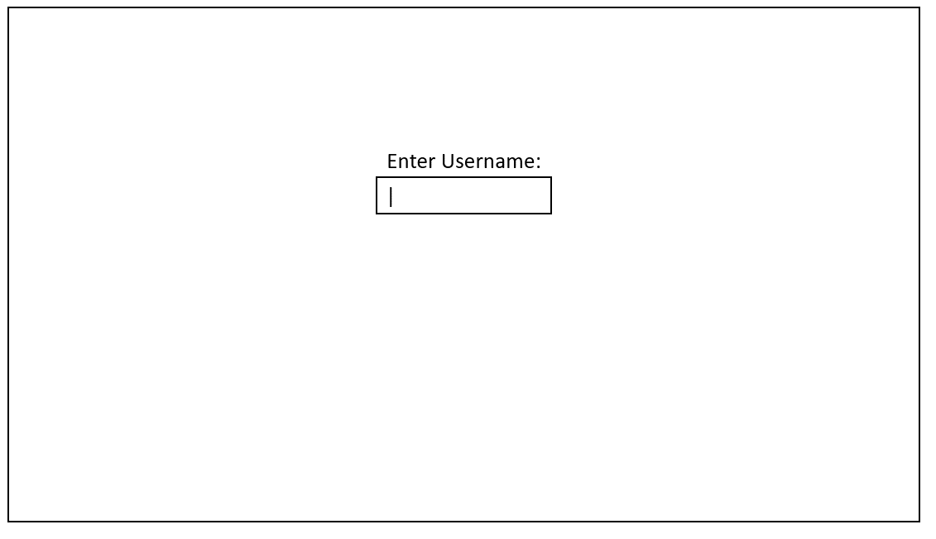

Window for the user to invite, accept, reject, and find a player to play with, (underlines denote buttons).

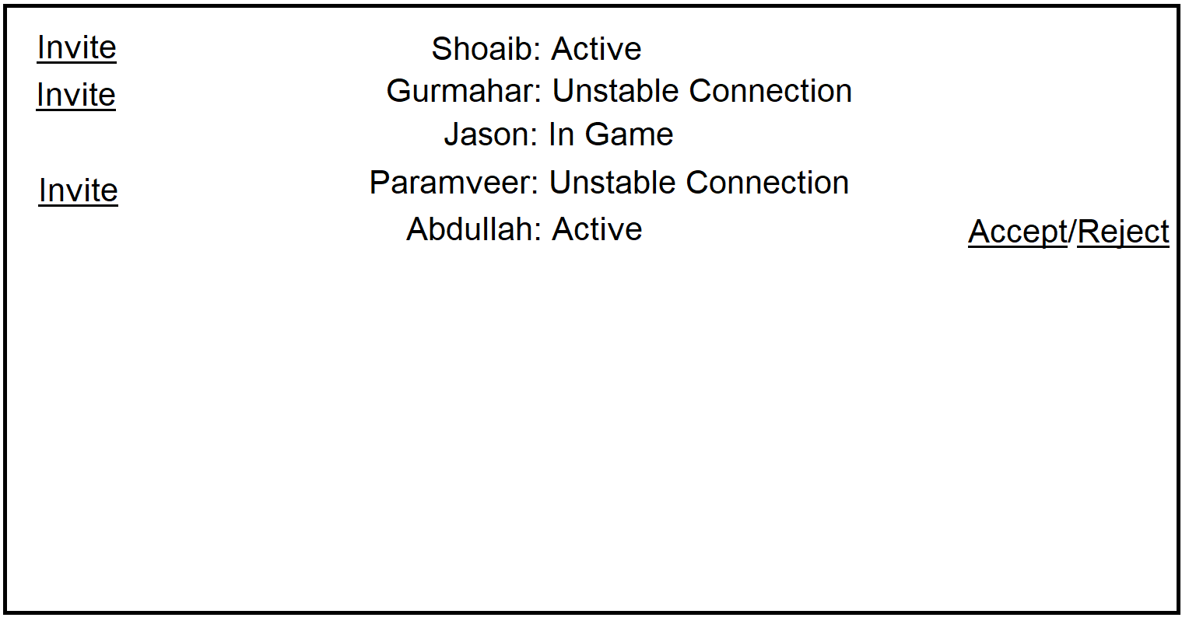

## Decomposition Diagram

Given that we are currently in the “lobby phase”, our problem that we need to solve is how do we provide matchmaking services to players who are near each other and want to play against each other. We can divide the lobby section up into two parts, the start window where the user enters a username, and the main window where the user finds players to play with.

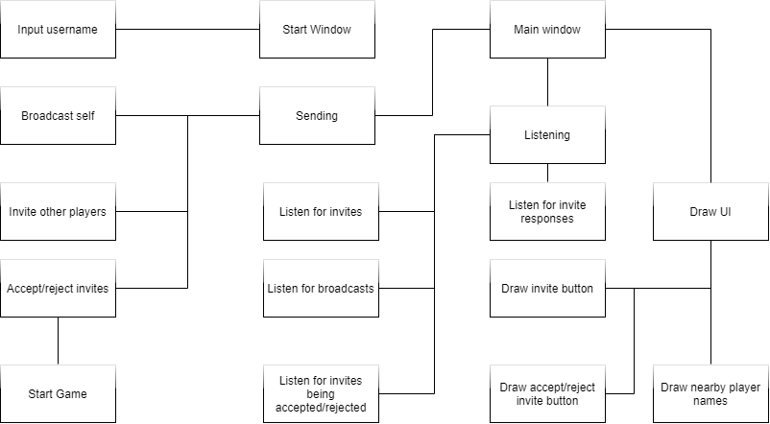

## Design Objectives

To provide this matchmaking service, we can further divide our problem into key areas with specific goals that we want to each associated with each section.

UI/Output

* Username window
  + Black text white background
  + Textbox for username in the middle
  + Textbox has placeholder text saying input username
  + Only accept alphabet characters
  + Once the user presses enter move to main menu
  + Once a username is inputted, move to main window
* Main window
  + Black text white background
  + A number of rows will be visible each corresponding to each player in nearby vicinity
    - Player name will be visible in the middle with status directly to the right
    - Invite button on the left-hand side
    - Accept/Reject button if the player has been invited on the right-hand side
  + The invite button will be hidden if the player has been invited
  + The invite button will be hidden if the player is in game
  + All buttons should be underlined

Input

* Textbox for username
* Button to invite players
* Button to accept invites which will also start the game
* Button to reject invites to players

Processing

* Broadcast player username, IP address, invite port and whether player is in game or lobby every 5 seconds
* Checks are made every 10 seconds if the player has received a broadcast from the other player since the last time a check has been made
  + If not, their status is changed to unstable connection
  + If a player hasn’t received another player’s broadcast in 50 seconds, they are removed from the player list
* When a player receives a new broadcast, the player is added to the player list, and their status is set based on their game status

Output

* Move user to main window stage after inputting username
* Display new players that get discovered
* Update changes to player statuses

## Data structures

In the main window phase, I will be using a dictionary to store all the players. The dictionary will be structured in the following way:

Every time a player is added, a new key will be made into the dictionary, the key will be a concatenation of the players IP and the players username, ensuring that the key is unique. The value of this key will be another dictionary. Inside this dictionary, there will be a key called address, containing the IP address of the player, username for the username of the player, port, for the port that the player is listening to, status for the status of the player’s connection, time for the time the last broadcast was received and invited, a Boolean that will be true or false based on whether or not the user in question is awaiting a response for our user to an invite. There will also be a socket object associated with the key socket and a socket status as a key as well. InvitedByMe will be true if an invite has been sent to another player. Here’s a mockup picture using json of what this will look like:

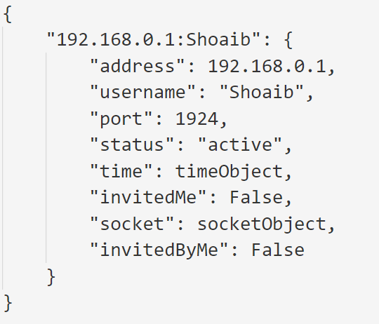

Aside from this, there are some key constants that are going to exist in the program that will be same for everyone.

**BroadcastPort**: The port which players will be listening to for broadcasts

**BroadcastTime:** The interval for which a player will broadcast out

**UnstableConnectionTime:** The amount of time that another player’s connection will be determined as unstable if the last broadcast from that player exceeds this variable

**RemoveConnectionTime:** The amount of time it takes for a players “row” to be deleted form the list if the last broadcast from that player exceeds this variable

## Libraries to be used

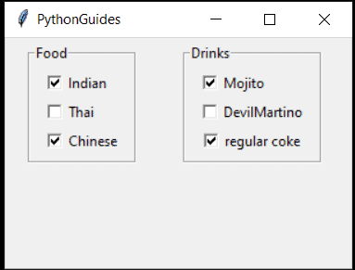For the lobby, I plan on using the Tkinter module in python for the user interface and the sockets module in python for the networking aspect. The user first inputs his username and then the user either sends invites to other players or accepts/rejects invites from other players and once an invite has been accepted then the game program is launched. Here is an example image of what Tkinter looks like [6]:

The reason that I am choosing to use Tkinter is that I am familiar with it and have had prior experience with it in previous projects; hopefully, this should save some time in the implementation phase.

For the networking aspect, I plan on using the sockets library. This will be responsible for sending and listening to broadcasts and sending and listening to invites. The sockets module is responsible for creating sockets which are endpoints for sending and receiving data in a network.

Additionally, I will be using the threading library in python. This allows broadcasts to be fired automatically after a set interval as well as being non-blocking meaning they can run simultaneously with the same program.

## Algorithms and subroutines

The lobby which is where the user finds someone to play with can be divided up into smaller problems, listed below:

* Creating and validating a username
* Broadcasting Ips every 5 seconds
* Updating player status based on when last broadcast was received
* Checking for and managing IP broadcasts, invites and acceptation or rejections
* Generating and updating UI which displays all players, their statuses, and accept/reject/invite buttons
* Inviting other players
* Accepting/rejecting invites

**Creating and validating a username:**

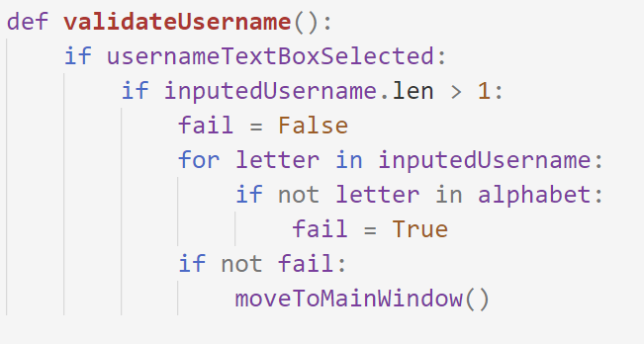

**Broadcast**

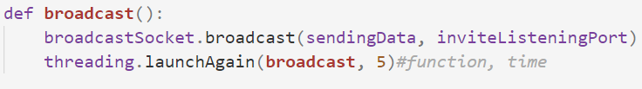

**Managing received broadcasts**

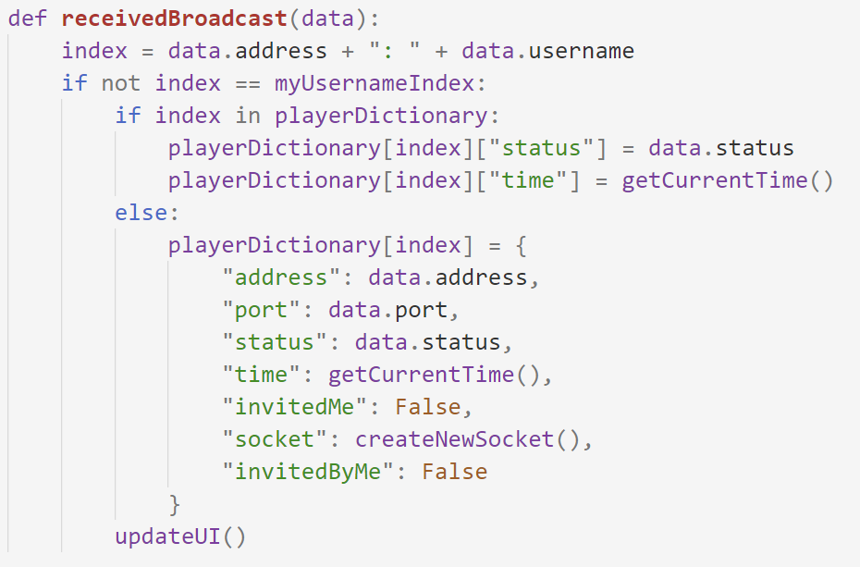

**Updating statuses based on time**

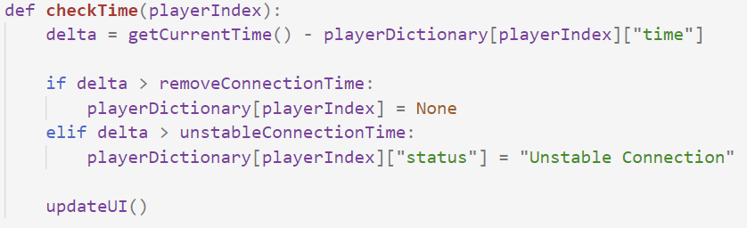

**Send and receiving invites and responses to invites**

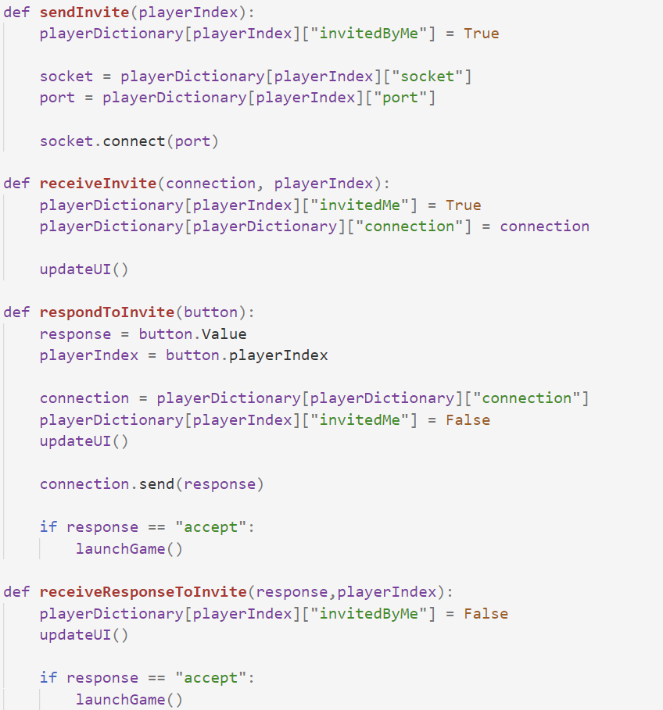

**Generating and updating UI:**

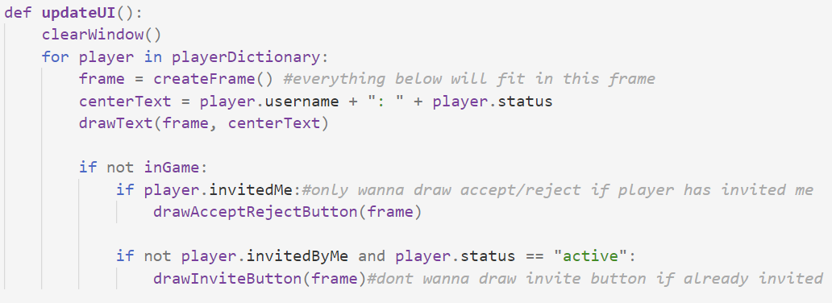

## Modular design diagram

Input Username → Main window

Main window → Invite Player → Update UI→ Player accepts Invite → Receive knowledge of acceptance → Start game

Main window → Receive player Invite → Update UI→ Accept invite → Tell player you accepted invite → Start game

## Test Plan

The lobby phase will be tested according to the following table.

|  |  |  |
| --- | --- | --- |
| **Function** | **Input** | **Expected output** |
| Username can only enter valid username | Types in username | Valid text passes through, invalid doesn’t |
| 2 people in network name appears | N/A | Display name and invite button |
| Other player receives invite | Click invite | Accept/reject button appears |
| Other player rejects invite | Click reject | Invite button reappears |
| Other player accepts invite | Click accept | Game is launched |
| Other player leaves | N/A | They disappear |

# Game Design

## Libraries + Methodologies used

For the game aspect of my solution, I plan on using the game engine Love2d, which utilises the language Lua. I am choosing love2d as I have prior programming experience with the engine coupled with the fact that the engine is sufficient for 2d games. To surmise, the objective of the game will be for the user to destroy the enemy tower before their own tower is destroyed. During the game, players can do this by purchasing entities which have different properties and pathfind to inflict damage upon the enemy tower.

## User Interface

Loadout phase. The red is a placeholder for the name of the loadout, green for the properties/stats of the loadout and blue is a button to select the loadout

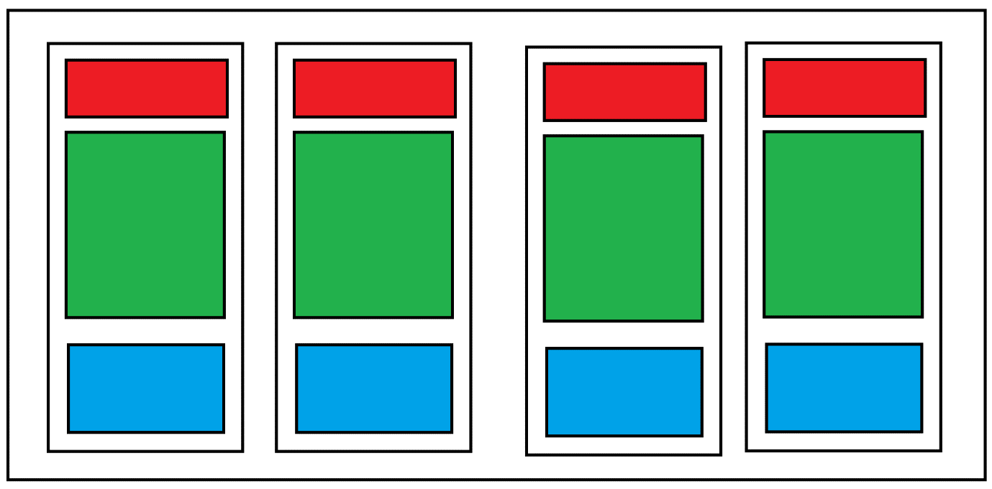

The below is the main game window. You can see the bottom window, each frame within this window represents all the entities that are available to be purchased. Within these there will a button to purchase as well as the name and price being visible. Hovering over the box will reveal a popup window that can be seen in the 3rd box down that will contain more information about the entity, such as a brief description. The centre, the rest of the screen will contain the actual game.

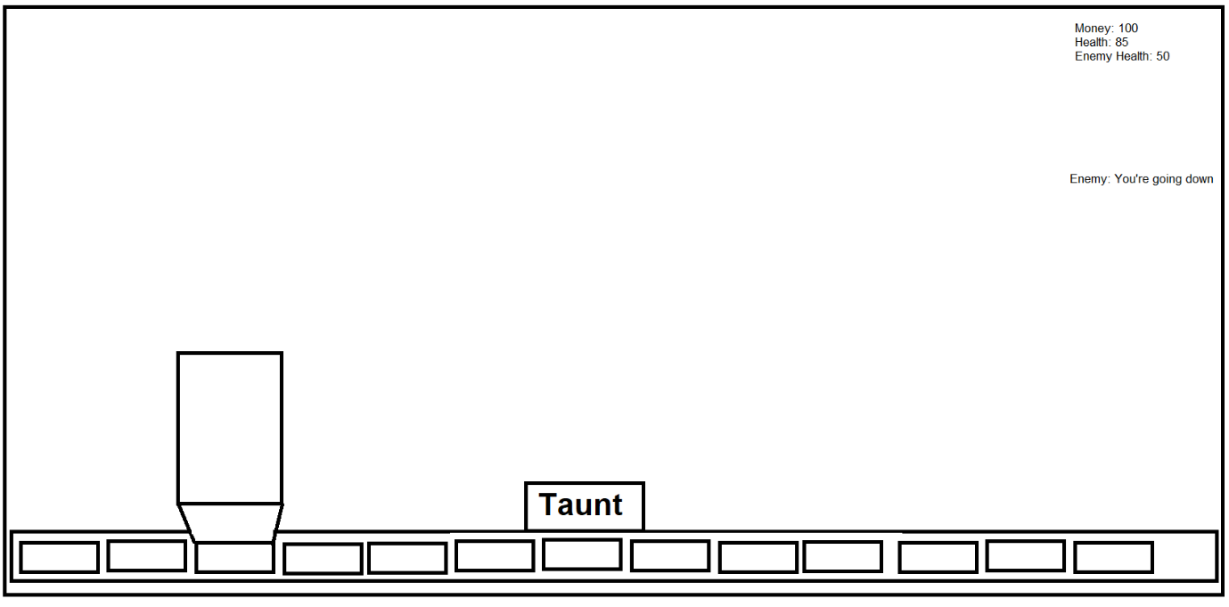

Here is what the end screen will look like, a corresponding end screen will be produced if the user has lost.

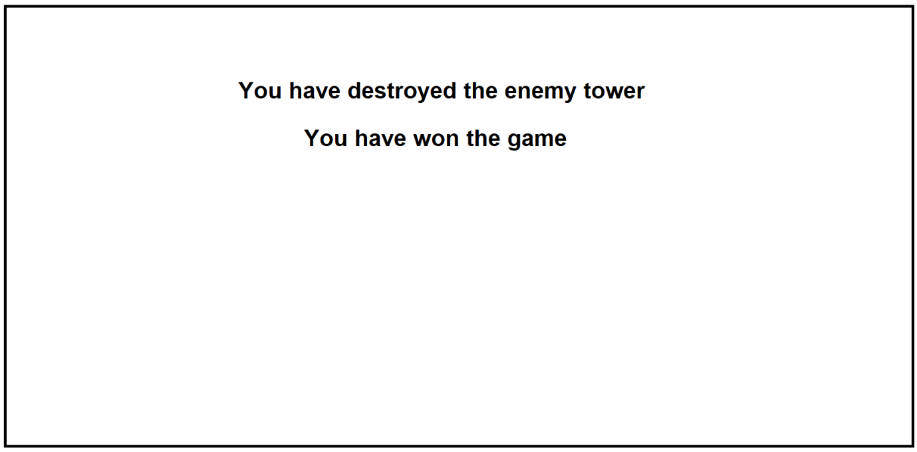

## Design Objectives

UI/Output

* Loadout menu before the game commences
  + In the loadout menu, the player will see 4 UI frames
  + The name of each loadout will be displayed in each box
  + Each box will have a select button that the player uses to choose the loadout
  + Each box will detail the properties of each loadout and it’s stats
* Main game
  + At the bottom of the screen there will be a “shop” menu where the user can buy various entities
    - 15 entities to be in the shop
    - Each entity will have a UI frame
    - Inside the box, there will be the name of the entity, it’s price and a button to buy
    - If the user hovers over the frame, a popup frame appears above that providing additional information of the entity
  + Above the shop container, there will be a button – taunt
    - If taunts are pressed, the taunt will appear in a text label at the right side of the screen, with the other players name “homer: You’re dead”
  + At the top right corner there will be a bar containing various user information
    - Number of money the user has
    - Health of user tower
    - Health of enemy tower
  + Main game screen
    - Display all entities in given camera area

Input

* Click button to select loadout
* Click button to purchase an entity
* Mouse Hover over entities in shop revealing pop up to display stats
* Mouse Hover out of this pop up causes the pop up to disappear
* Click location to place down entity once entity has been purchased
* Left key, right key inputs to pan camera across map

Processes

* When clicking to purchase entity
  + Check if player has enough cash to purchase
* When placing down an entity
  + Check to see if in valid location
  + Deduct cash
* Update player money after set interval of time based on loadout
* Check to see if a set time has passed before permitting taunts to prevent taunt spam
* Specific entity methods
  + 1, pathfinds towards tower and causes damage to tower, if there is no way to the tower, doesn’t damage enemies but can damage walls
  + 2, pathfinds towards tower but enemies in the way have priority
  + 3, wall, doesn’t move, merely serves as a barrier
  + 4, stationary, “shooter”, doesn’t pathfind, shoots whatever enemies enter it’s range
  + 5, pathfinds towards tower but enemies have priority, can shoot but reduced range
  + 6, splash potion, causes damage to all enemies in a given a circle
  + 7, splash heal, increases health to all “allies” in a given circle
  + 8, building that generates money independently of tower, can be destroyed, treated as a wall
  + 9, entity 3 but deals damage when attacked
  + 10, building that generates a mix of entity 2 and 1, can be destroyed, treated as a wall
  + 11, splash potion, freezes enemies for a set amount of time
  + 13, splash potion, poison, causes damage over enemies over time
  + 14, entity number 1, but after every given time period that it’s alive, tower health is regenerated
  + 15, entity 3, cheaper but weaker
* Visual demonstration of entity actions
  + Loss of health by entities, causes them to temporarily appear red, the more damage that is inflicted, the more red they become
  + Ranged attacks causes a temporary line to be drawn between shooter and target
  + Splash potions draw a circle around click target and fades away
* Once game is complete, after a set amount of time, the window will close
  + The status in user lobby will update from in game to active again, signalling the player can play another game

## Decomposition Diagram

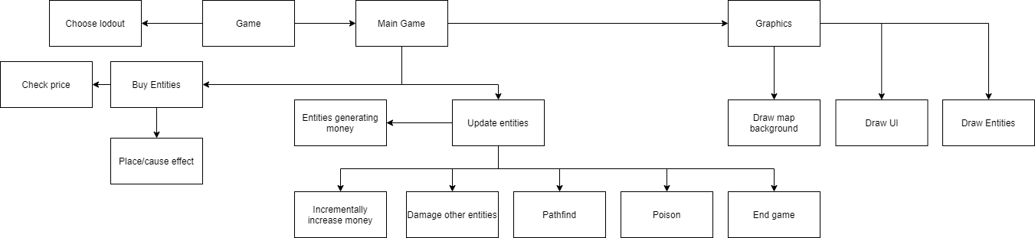

## Use case diagram

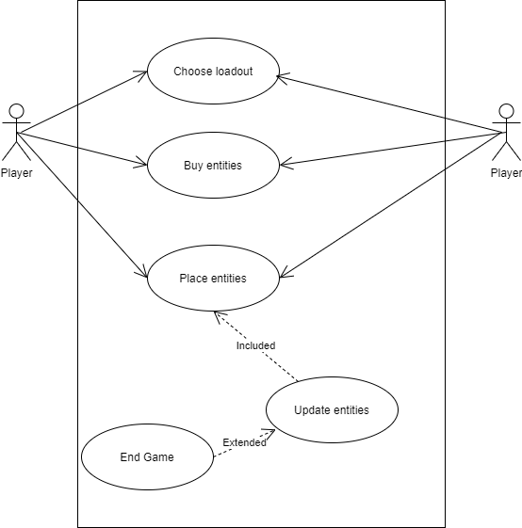

## Class diagrams

One class that I have will be the item purchase class.

PurchasableItem

Name

Price

Box Colour

Description

Button Pos, Size

Purchase()

An example of this object being instantiated for entity 1 could be the following

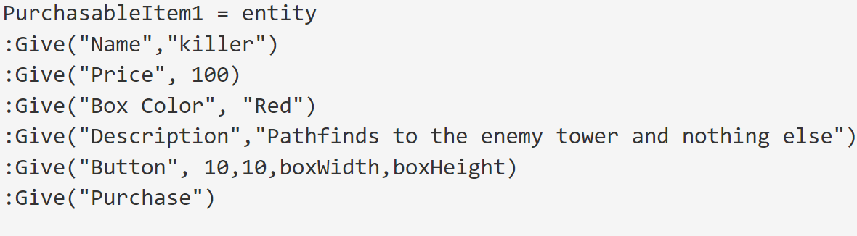

With the purchase method being described independently elsewhere.

Specific attributes such as price and box colour amongst others are subject to change and tinkering in efforts to make the game more balanced.

Entity1

Health: 100

MaxHealth: 100

Pathfinding: True

PathfindingMainTarget: Tower

PathfindingNoPossible: Wall

Update()

Entity2

Health: 100

MaxHealth: 100

Pathfinding: True

PathfindingMainTarget: Tower

PathfindingAttacked: True

Update()

Entity3

Health: 100

MaxHealth: 100

Entity4

Health: 100

MaxHealth: 100

Range: 10

RangeRate: 0.5

Update()

Entity5

Health: 100

MaxHealth: 100

Pathfinding: True

PathfindingMainTarget: Tower

PathfindingAttacked: True

Range: 10

RangeRate: 0.5

Update()

Entity6

Damage: 30

Range: 10

Entity7

HealthBoost: 30

Range: 10

Entity8

Health: 100

MaxHealth: 100

MoneyAmount: 20

MoneyRate: 0.5

Update()

Entity9

Health: 100

MaxHealth: 100

DamageWhenHit: 3

Update()

Entity10

Health: 100

MaxHealth: 100

GenerationRate: 0.5

Update()

Entity11

Health: 100

MaxHealth: 100

FreezeTime: 15

FreezeRate: 0.5

Range: 10

Update()

Entity12

Health: 100

MaxHealth: 100

HealthBoost: 10

Damage: 10

Range: 10

Update()

Entity13

Health: 100

MaxHealth: 100

Damage: 10

DamageRate: 0.5

Time: 10

Update()

Entity14

Health: 100

MaxHealth: 100

Pathfinding: True

PathfindingMainTarget: Tower

PathfindingNoPossible: Wall

TowerHealthBoost: 10

TowerHealthBoostRate: 0.5

Update()

Entity15

Health: 50

MaxHealth: 50

Here is an example of what it could look like instantiating entity1, using the given entity component system.

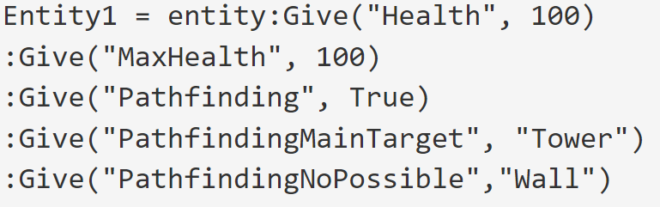

Intentionally, I’ve been generic to the methods of the classes in the class diagram, merely providing update(). In adhering to the principle of composition over inheritance, methods are programmed independently of the class; the symbolism of the method “update()” is merely placeholder to suggest that it has methods associated with it.

Methods, are associated with systems which are composed of components, in our ECS model. I will go into this in more detail in my algorithms section.

## Data structures and variables

In adhering to the principle of composition over inheritance, I will be using an entity component system for the entities in my game. The principle of composition over inheritance exists to solve the following problem.

Say you had a class called gun; this has a method called shoot. Say you had another class called plane, and this had a method called fly.

What if you wanted a class called fighter plane, that had both the methods fly and shoot? This wouldn’t be possible. You could have a super class called fighter plane and make gun and plane children of them, but then the gun class would have the redundant method, fly and the plane class would have the redundant method shoot. Or you could make fighter plane one of the children of plane or gun. Say fighter plane was a child of plane, the method fire would be written twice.

More simply, entity component systems solve the problem of wanting to inherit from two different classes.

Entity component systems can intuitively enough be split up into 3 parts: entities, components, and systems.[7]

Component values are simply containers of related data. Components do not contain functions

Entities are objects which have a collection of components. They have no data inherent to themselves, rather these are all granted by components

Systems are responsible for reading and modifying entity components. For example, entities with a position and velocity vector may be updated by a motion system.

With that being said, to implement this ECS, I will use a library called concord[8] to help me do this; this library was specifically designed for love2d and Lua, I will be using both, so it will be perfect for my use case.

**XScrollOffset:** The user can pan the camera across the game, and the variable pixel scroll offset is a store of this value

**placing:** string of the item being placed, if nothing is being placed then set to None. If set to a value, buttons are ignored, otherwise they aren’t. If set to None, it won’t do anything if something is clicked onto the map

**team:** Boolean, true or false. Each of the two players player will be on a team, true or false

## Algorithms

This algorithm, adjusts xScrollOffset according to keypresses

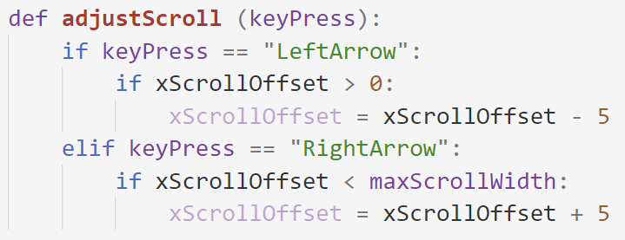

For pathfinding algorithm, I will be using the A* Search algorithm. I will briefly describe how it works.

At a giving start point, the program looks at all the potential nodes around that it can go to. For each of these, it determines which node has the lowest sum value for the distance between the start node and the end node. It then goes to this node. This node then get’s added to the path.

Including all the old potential nodes, that didn’t become the path, again, it is determined which potential node has the lowest sum value for the distance to the start node and the end node, this time adding the potential nodes of the newest node to the path. It keeps doing this until a path is created.[9]

Here is how potion methods will work, both damage and heal.

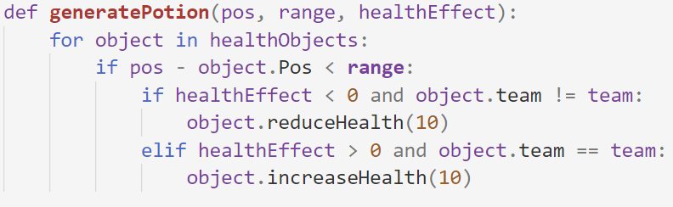

Here is the algorithm for increasing and reducing health

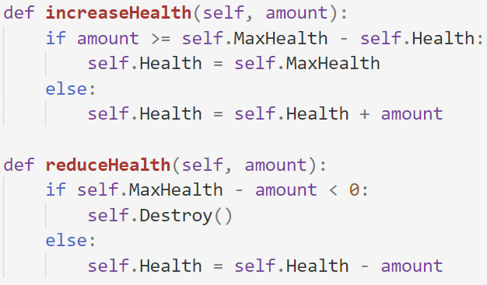

## Test Plan

I will be using iterative testing which means testing throughout. The below is the table of testing that will take place.

|  |  |  |
| --- | --- | --- |
| **Function** | **Input** | **Expected output** |
| Choosing loadout results in corresponding stats | Click loadout | Corresponding stats appear on the side |
| Items won’t place if the player can’t afford | Clicking on item when cash is below price | Nothing |
| Enemy items appear when placed | Enemy clicks on map | Item appears |
| Pathfinding entities move to tower | Click to place pathfinding entity | Move to tower |
| Pathfinding entities can go around walls | Click to place pathfinding entity | Goes around wall |
| Entities damage enemies when near |  | Damages enemy |
| Tower health decreases when attacked |  | Health value falls |
| When health is 0, game over screen |  | Game over screen |
| When game over screen is closed, launch matchmaking | Close screen | Matchmaking screen |

# Stage 1: Matchmaking

## Window

Firstly, a window must be created.

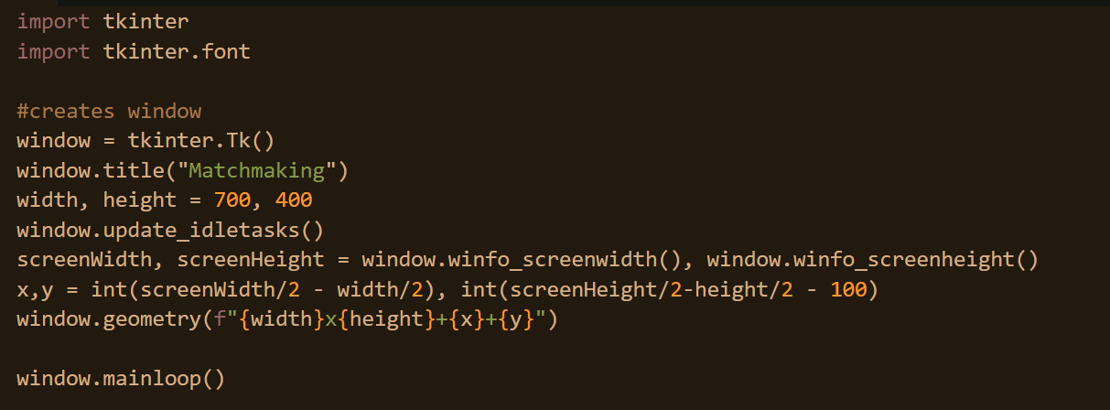

The code above imports Tkinter module which is what is being used for the UI of the matchmaking phase of the implementation. The height and width is predetermined and the screen height and width is fetched so that the window that is created is able to be centred in the middle of the screen.

Here is the product.

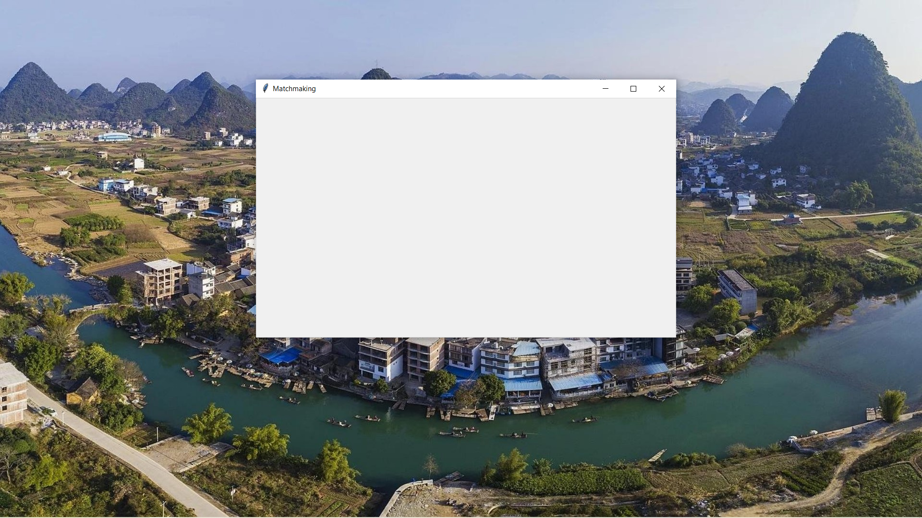

Now a textbox must be created so that the user can input their username. It should be noted that there is no database to which this username will be validated against, this username is temporary against the session.

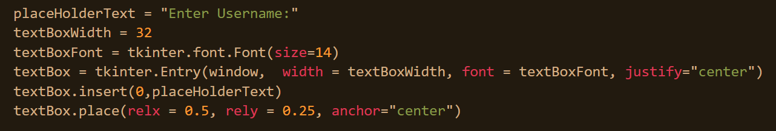

An entry textbox is being created. The width and font of the textbox is specified as well as it’s position in the window, it is centred horizontally in the window and vertically exists a bit more towards the top.

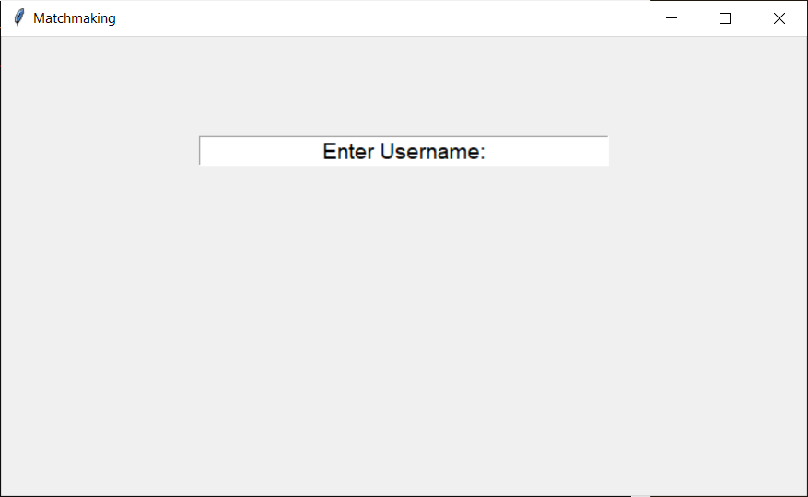

Should someone click on the textbox, they’ll be able to type. But if they click off the textbox, the textbox is still active. Furthermore, the first time they click the textbox, the enter username prompt is still there. This is fixed below.

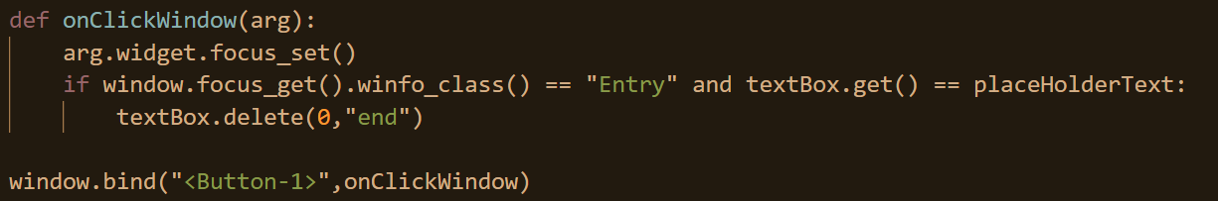

Left clicks on the window are now bound to the onClickWindow function. Whatever widget is clicked is now made focused. This means if someone clicks on the textbox, that is made focused and if someone clicks away, focus is removed. Secondly, if the textbox is focused and the text inside of the textbox is the default text, the text is deleted.

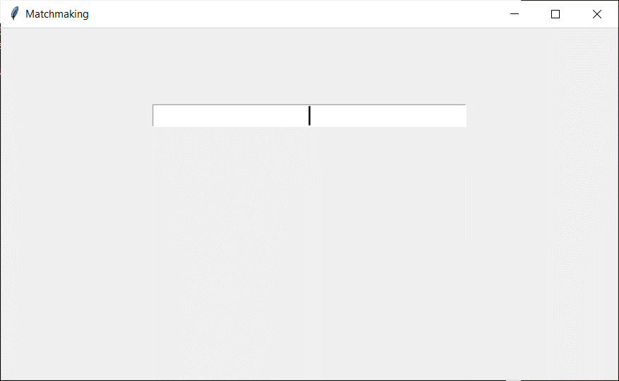

As soon as the textbox is clicked for the first-time text is deleted.

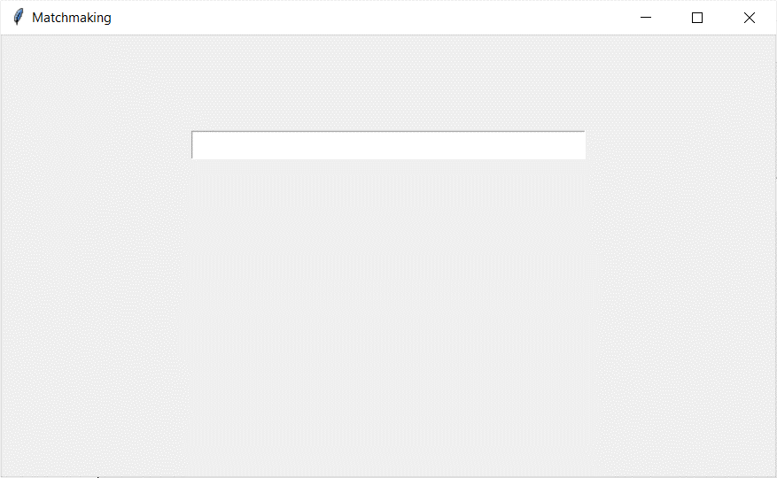

As can be seen above, when a click outside of textbox is made, there is no more focus on the textbox. This can be seen through the absence of the flashing vertical bar used to prompt the user to input.

Once the user has inputted their desired username, there needs to be a mechanism by which the user can move to the next stage. However, there needs to be some validation to ensure a valid username is submitted. Here, the user can press enter and the entry textbox is removed.

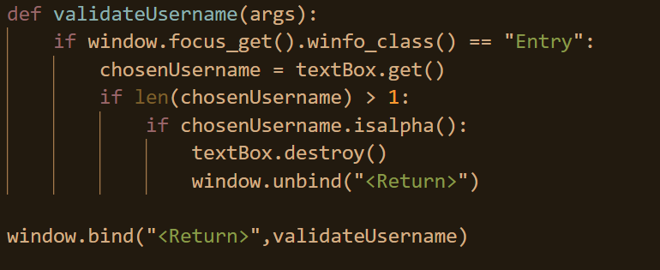

The return key or the enter key is bound to the function validateUsername. A check is initially made to ensure that the focus is on the textbox. It is presumed that if the textbox is not active, the user does not desire to move onto to the next stage so it must be checked that the textbox is what is focused. Once this is determined, whatever the username that the user has picked is fetched. The two basic checks that are done are to ensure that the length of the input is greater than one and that the input is exclusively comprised of alphabetical characters. If both of these are conditions are deemed true, the textbox is destroyed as it is no longer needed and the binding between the function validateUsername and the return key is removed.

The finished state resembles the first screenshot in this document.

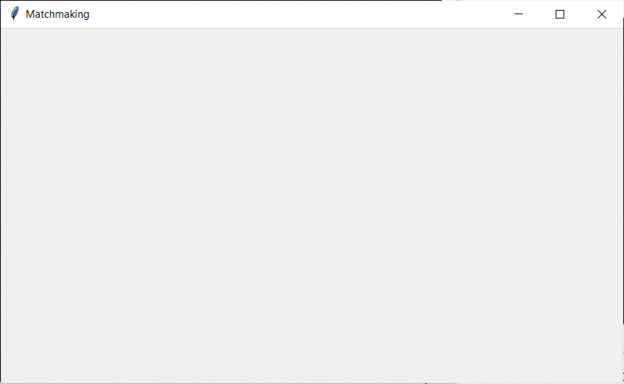

The textbox was tested with the input of numbers, emojis, grammatical characters and of single and no characters. The single and no character tests initially failed and so a line of code had to be implemented validating that the input was greater than 1 line.

## Networking

The first step in networking is to broadcast oneself so all neighbouring devices are aware that the device of the user exists. For organisational purposes the networking side of the matchmaking will be kept in another file.

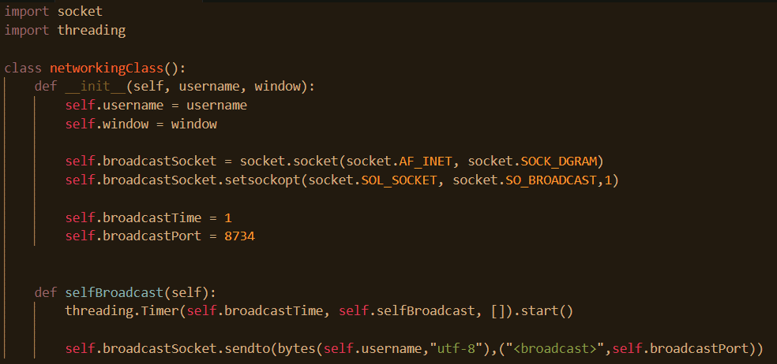

Firstly, the socket and the threading library are being imported. The socket library is a default python library that allows networking to occur. The threading library is used for multitasking which is useful when working with networking. Next, the networkingClass is declared and username and window are passed as arguments in it’s initialisation. The reason that window is passed is so that later on, functions associated with the UI are able to be called. Next, a socket called broadcast socket is created. The socket is using the AF_INET family which means that it is going to be Ipv4. The reason that Ipv4 is being used in lieu of Ipv6 is that Ipv6 is incompatible with broadcasting. Secondly, the SOCK_DGRAM is specified as UDP is being used instead of TCP. T he reason TCP is not being used is that to use TCP, the destination IP address needs to be known in advance, but this is simply not the case when data is being broadcasted.

It should also be noted that the purpose of the broadcast is that other players know of the users existence and so are able to invite them.

The purpose of the next line is simply to enable the fact that the socket will be able to broadcast. The broadcastTime variable indicates how often the user will be broadcasting oneself, at the moment this is set to ever second. The broadcastPort is the port that the packet will be directed to when a computer receives this data. If a user is running this program, they will in the future be able to detect this packet when he receives it because they will be listening into this port.

In the selfBroadcast function, the purpose of threading.Timer is to run a function after a given amount of time. It’s first argument is the amount of time, broadcastTime, which was specified earlier, next the function that it will call, which happens to be itself, and finally it’s arguments which are nothing. In brief, every time this function is called, it creates a thread that will run a function after a given interval.

Finally, the data is sent out. The sendTo method of broadcastSocket takes two arguments, the data that is being sent, and the destination. The function of bytes is to convert a string into a bytes object which is able to transferred over a network. Utf-8 specifies the encoding that is being used. Next, the address is specified, broadcast is used to indicate that the data isn’t being sent to any particular destination, rather it is being sent to all endpoints on the network. Secondly, the port is specified which was discussed above.

For this to run from the main python file, the file needs to be imported and then once the username is validated, the class needs to be instantiated and selfBroadcast needs to be called.

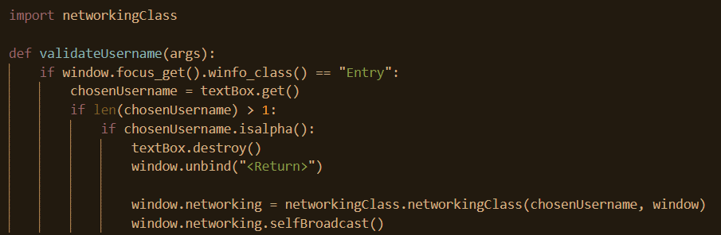

As of now, listening for these broadcasts hasn’t been set up, so therefore, the scope of testing is limited. One thing that can be tested is that the method selfBroadcast actually runs repeatedly after a set interval and we can do this by inserting a print statement into the function and confirm that it is being printed repeatedly. This test has been run and it the application functions as expected.

To be able to listen for broadcasts, a socket must first be created to accommodate this.



This has been created inside of the initial declaration of networkingClass. Again, AF_INET indicates the usage of Ipv4. SOCK_DGRAM is being used because the packets being broadcasted are UDP as explained earlier. Then the socket is configured to listen for broadcasts. The SO_REUSEADDR option needs to be enabled mainly for testing purposes. It is easier to test on one device than multiple devices. The ramification of this is that an error will occur if the same port is assigned to the same IP more than once. Therefore, the SO_REUSEADDR option needs to be enabled which allows for this to be the case and this resolves any conflict that occurs when the socket tries to bind to an address and port that is already bound. Then we bind the socket to the address and port so that the address and port are associated to the given socket.

Next, the socket needs to be listening.

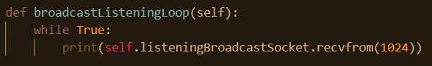

This function is called once and keeps trying to listen for any potential broadcasts. If there is any data to be received from the socket, a pair of values are returned: the data or bytes that are being sent, and secondly the return address of the data being sent. 1024, refers to the maximum amount of size that the data is accepting. The usage of while True, is done because the socket needs to be constantly checked for data.

In python, functions are blocking. This means that if any function is called, nothing else is able to run until that function terminates. Given that the function above has a while loop that has no way to exit, should this function be called, nothing else will be able to run.

A solution to this is multitasking which can be accomplished using threading.



The preceding code runs after the user has submitted their username and it has been successfully validated. A new thread is created where the aforementioned function is called. Now, this function can run without blocking the rest of the program.

At present, the application is able to broadcast messages and detect or listen for broadcasts from other programs. When two instances of this program are created and the usernames in both instances have been successfully validated, broadcasts are sent out and detected successfully as shown below.

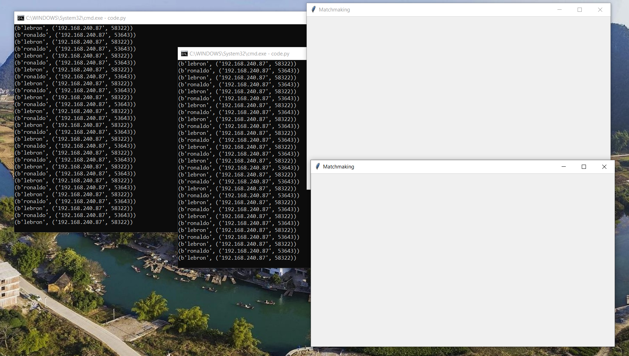

As can be seen above, the two usernames: LeBron and Ronaldo are being printed. As well as their corresponding IP addresses and port numbers. It is evident that two usernames are being printed in each terminal despite the fact that there are two terminals meaning that when a socket is listening, it can detect its own broadcasts. This must be accounted for when in the future when this data is going to be managed and handled.

At the moment, the application is able to send and listen for broadcasts but these don’t appear in the graphical user interface. The first thing that needs to be done is a list of players who are playing need to be stored. This is quite simple, it only one line of code that runs when the class is being instantiated.

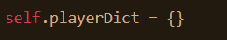

When a broadcast is detected from an unknown player, the unknown player will be added to the dictionary. The following code does this.

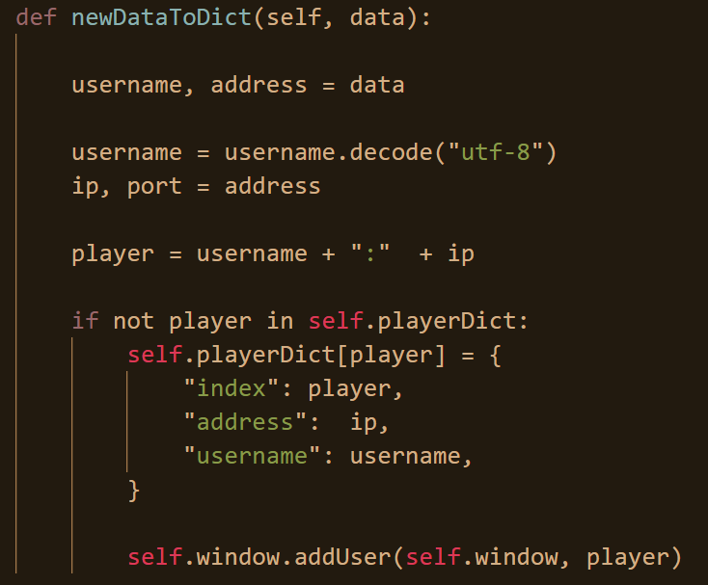

The reason that the key to the dictionary is a composite of both the username and the player’s IP address is to ensure that in the unlikely circumstance that another player has chosen the same username as another player, it is not a problem because their IP address is unique and thus, they both can be stored inside of the dictionary. The reason that the IP address isn’t solely used as the index is that when testing on just one device, the IP’s will be the same, and so both players won’t be able to be stored in the dictionary.

At the bottom, once a new player is added to the dictionary, the addUser method of window is called and the argument player is added. The new method is what is below.

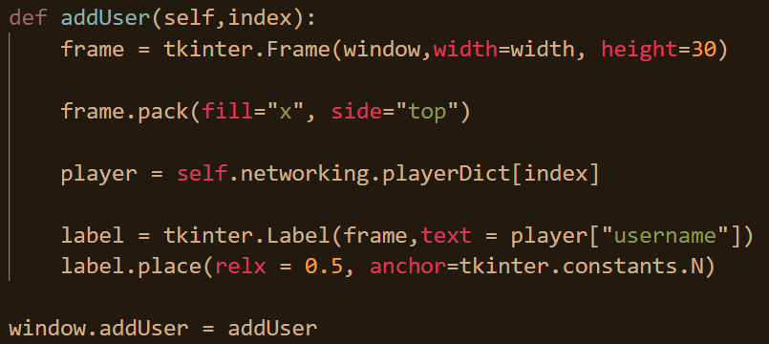

The index that is passed allows the method to be able to reference the specific user in usernameDir. A frame is created, inside of window, with the width of the window and a height of 30. The frame is packed, which is another way of saying placed with the argument fill x, meaning that it’s going to fill the entire horizontal space assigned to it and side top, meaning that it will go as close to the top as possible. Next the specific entry from usernameDir is fetched, and then a label is created, whose parent is frame. The label is placed in the horizontal centre and is anchored to the top. What anchor means is where the origin of the widget is. So if the widget is being moved, is it moved from the centre, the top right, or the bottom left. It can be seen that the code functions as expected below.

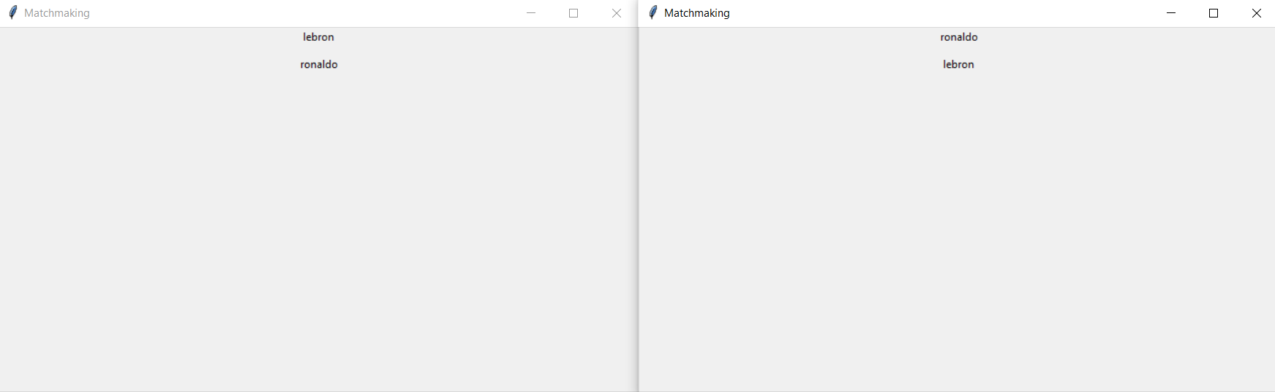

As is evident, the username from two different players appears in both windows.

The next stage is to add the capacity to be able to invite players. But for a player to be able to invite another player, he must know the port that they will be listening to beforehand. Therefore, it would be best to create a socket to listen for invites first before a socket to send invites is created.

As explained earlier, it is easier to test on a single device than multiple but to be able to test this functionality, every instance of the application needs to have a different port with which it is listening to otherwise multiple players will receive the same invite if they were all listening on the same port. Unique ports wouldn’t be needed if testing was occurring across multiple devices since the IP address of each device would be unique.

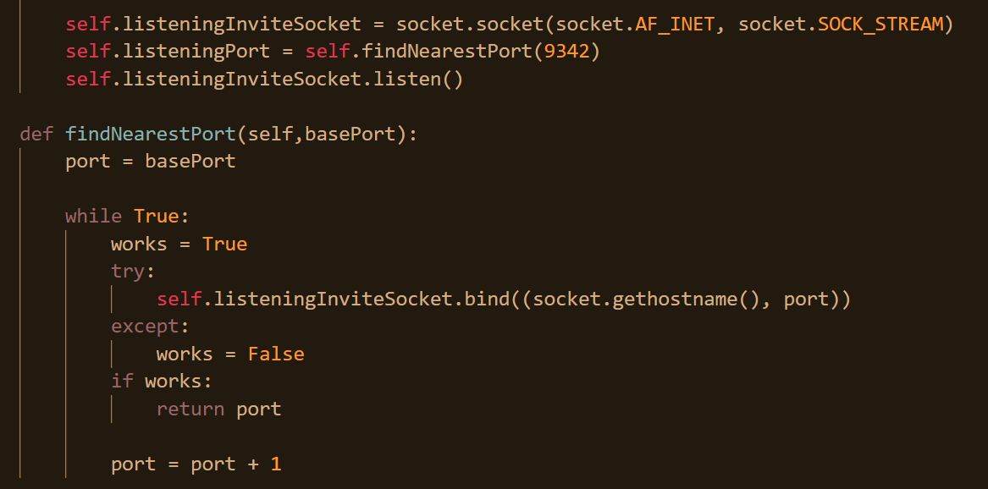

The top section of the code above is inside the initialisation of networkingClass. A socket is created to listen for any invites. SOCK_STREAM is being used this time as TCP is being used and therefore a connection is being maintained and it’s not just a single message connection. Then, the port from which the socket is listening to is determined. The port by default will be 9342. If, however, there is already an application using this port, perhaps this very application, the port number keeps being incremented until there is a free port for it to use. Once it is able to bind to a particular port without an error, the program continues, otherwise, port is incremented and it tries again. Once this method terminates, the listen method is called on the socket which allows for it to accept connections. This is resemblant of how servers tend to operate in that they are usually listening and waiting for a particular user request from which they proceed. The user is the agent contacting the server as opposed to the other way round.

The ”server” is able to cept connections, however, this doesn’t mean that it is actually listening for anything, despite what it says. To actually listen, again, another while loop must be created, whose role it is to listen but this will be done later.

Before that, a button to actually invite players needs to be created. To do this, first a frame class from which each players graphical elements is going to be created. To be able to store all of these elements, a list will be created to do that purpose.

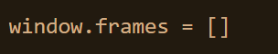

The above code runs once the username of the player is validated in the beginning.

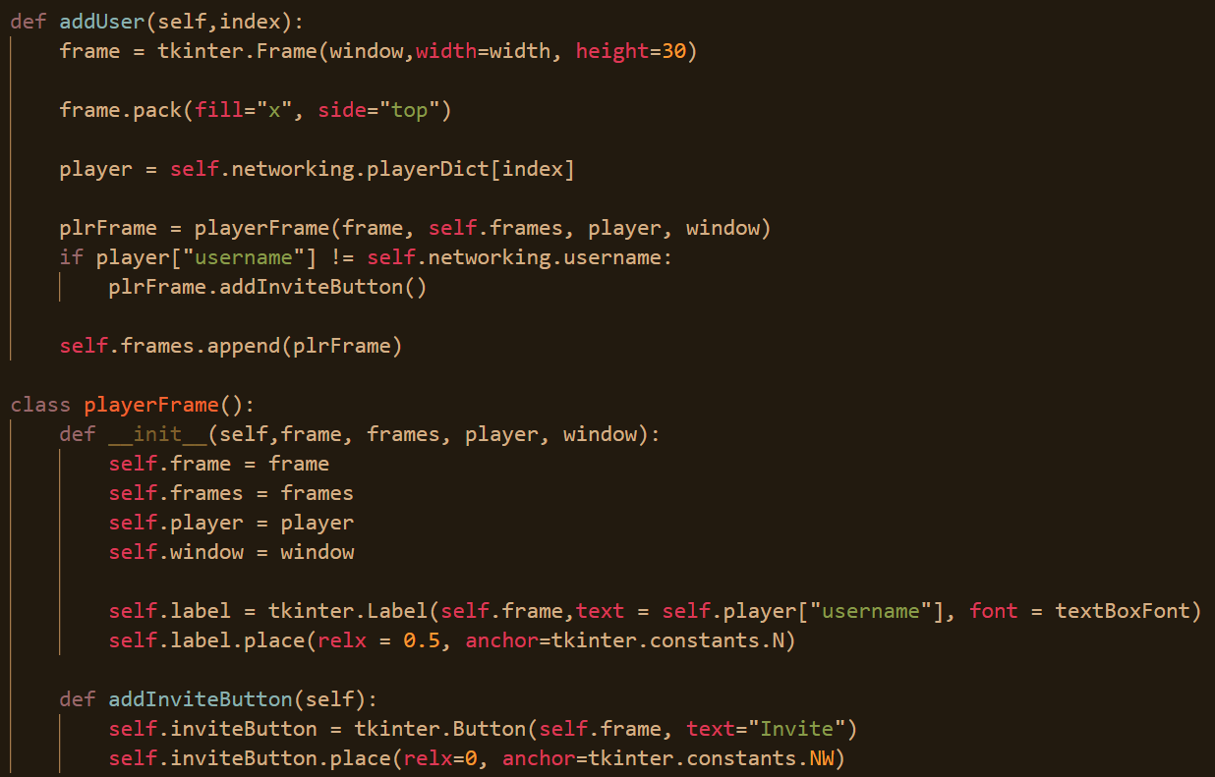

The addUser method has been slightly modified since last time. Firstly, the playerFrame class gets instantiated with the physical frame widget, the frames list, the player and the window being passed as arguments. The label from which the text is displayed is created inside of playerFrame and this label is stored as part of playerFrame. This is to allow for the label to be manipulated later on. A minor change from last time is that the font of the label is also specified as well.

Back to the addUser method, when the username of the player of the given frame is not that which is not the username of the player themselves, then the addInviteButton method is called. This basically means that the player’s own username will appear in the window but he won’t be able to invite themself. This small feature is helpful as it allows the player to see their own name if they have forgotten what they put down.

The invite button is created as an attribute of playerFrame and will have the text of invite. It is placed on the left-hand side of the screen and the anchor from which it is placed in the top left of the frame. Here is the code in action.

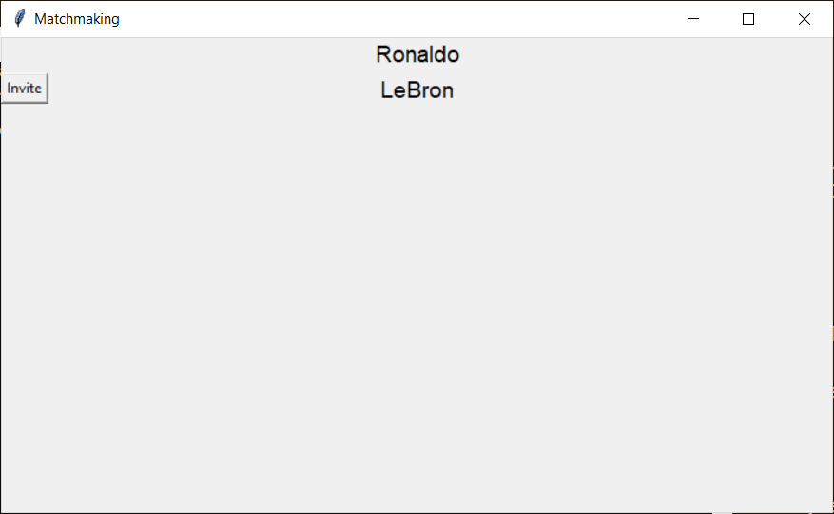

As can be seen, the user, Ronaldo, is unable to invite themselves but they are able to invite LeBron. At the moment, clicking invite does nothing, but functionality will be added to the button.

Next, functionality is going to be added to the button. Firstly, to invite a particular player, a socket object must be created for every player that a user may want to invite. To be able to know the particular port that a player is listening into, they ought to declare that information when they are broadcasting themselves. That adjustment will be made now.



Now, both the username and the port are being sent over.

The port is now being received which means that a socket can be made directed to the correct port now.

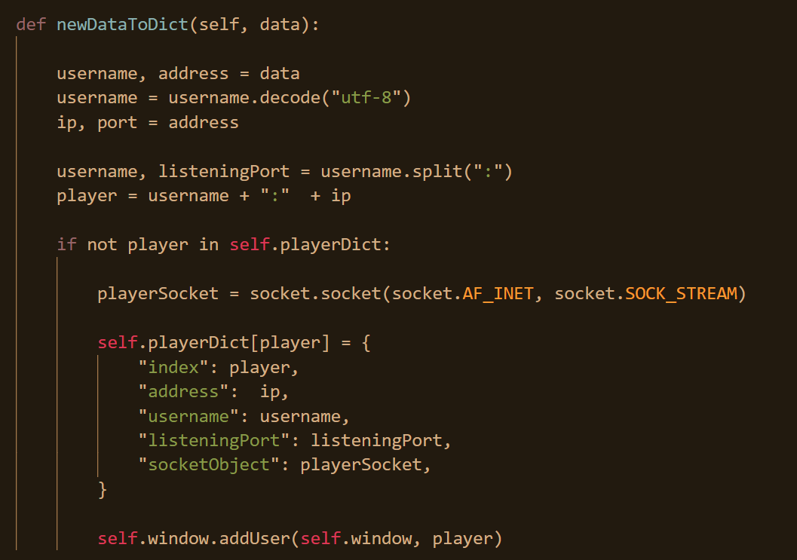

What’s difference now is that the listening port which is being sent as part of the broadcast is something that is obtained and stored now. Furthermore, a socket is being created and is also being stored now.

Now, the player is able to invite the player whose broadcast they have received.

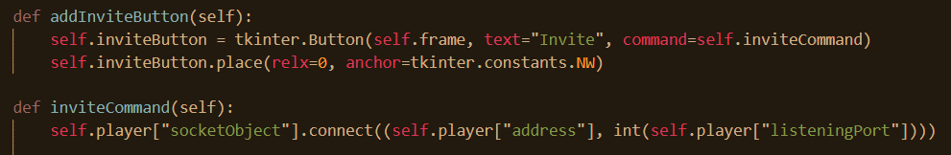

Functionality has been added to the invite button now when the button is clicked the method inviteCommand is called. In this method, using the socket that was created earlier, a connection is initiated between the user and the player whose broadcast they received. Here, the user is acting like a client in that he is initiating a request to the proverbial server.

A problem now is that once an invite has been sent, there is no reason for another to be sent again or for a series of spam invites to be sent, but there is nothing stopping this from happening at the moment.

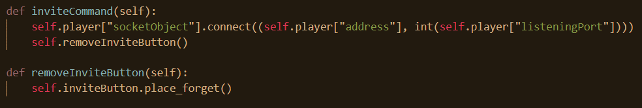

Now, once the inviteCommand method is called, the button will be removed so that no more invites can be sent.

The user is able to send and receive broadcasts and respond to broadcasts by inviting players.

The user is unable to see that he is received any invites at the moment, let alone accept or reject them.

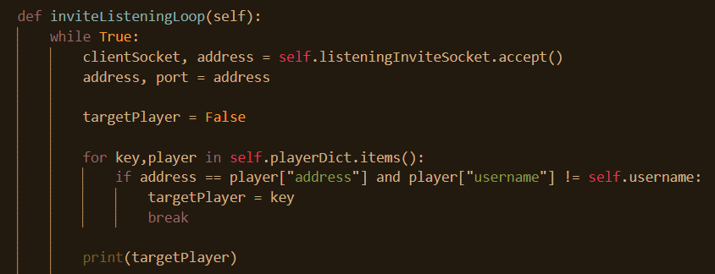

This method of networkingClass waits until it has received a connection request until it proceeds. Then, it tries to determine which player has invited the socket through trying to match the address in playerDict.

Like with the while loop that is listening for broadcasts, this is called inside of a thread such that other parts of the program are able to run at the same time. 

The next step is to graphically represent the receiving of invites.

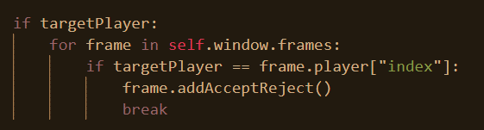

Firstly, it needs to be verified that the address of the invite actually existed in the directory of players that have broadcasted to the user. If so, then all the frames in the window are iterated until the one whose player matches the player from whom the invite was received. If this is the case, then the accept or reject invite buttons are added.

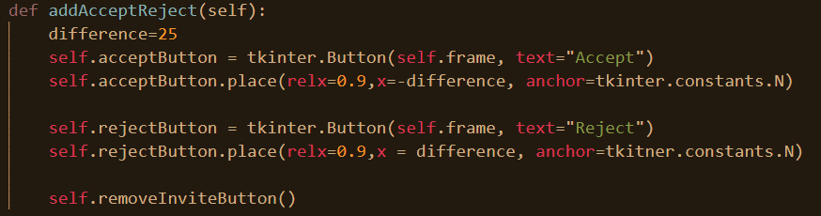

Both the accept and reject button are in the same location but the accept button is just 25 pixels offset leftwards and the accept button is offset 25 pixels in the opposite direction. The invite button is also removed as well, there is no need to invite someone from whom you’ve already received an invite.

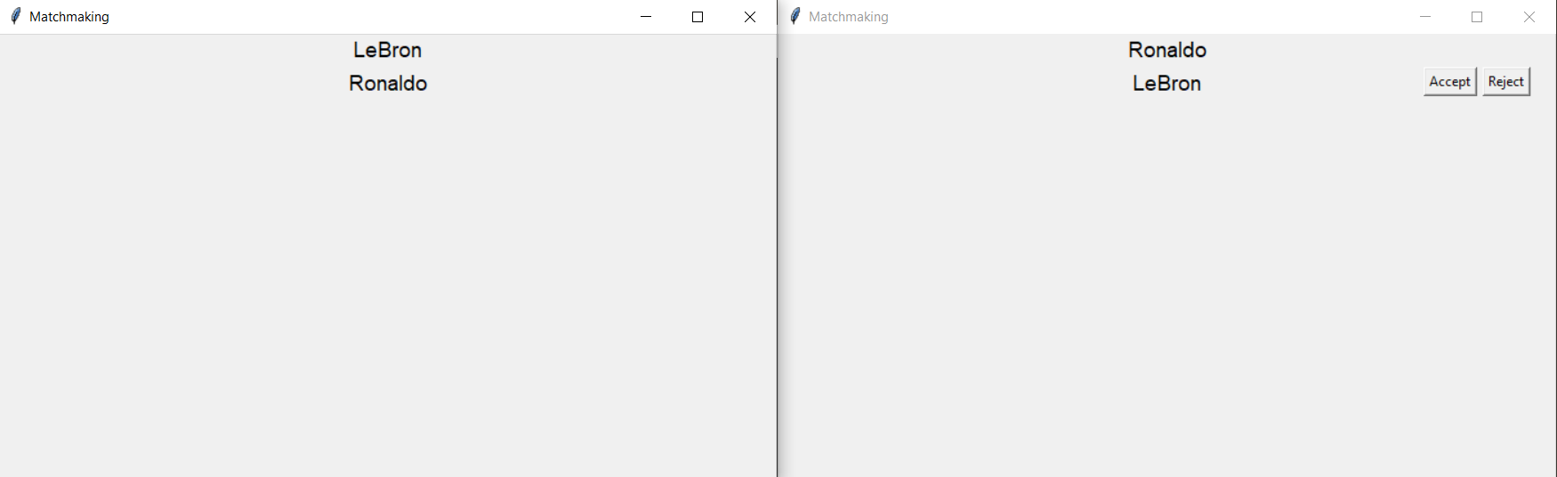

It can be seen that LeBron has invited Ronaldo. LeBron is unable to invite Ronaldo again since he has already invited him and therefore the invite button is no longer present. Ronaldo now sees on his screen an accept and reject button from LeBron indicating that LeBron has invited him. He must decide whether he will accept or reject LeBron’s invitation.

For the moment, the accept and reject buttons both do nothing. To be able to accept or reject any invites, the connection from which any communication is being initiated from needs to be saved.

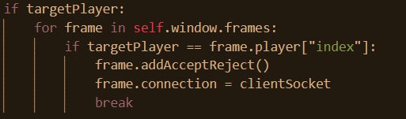

The buttons are now able to be tied to a method.

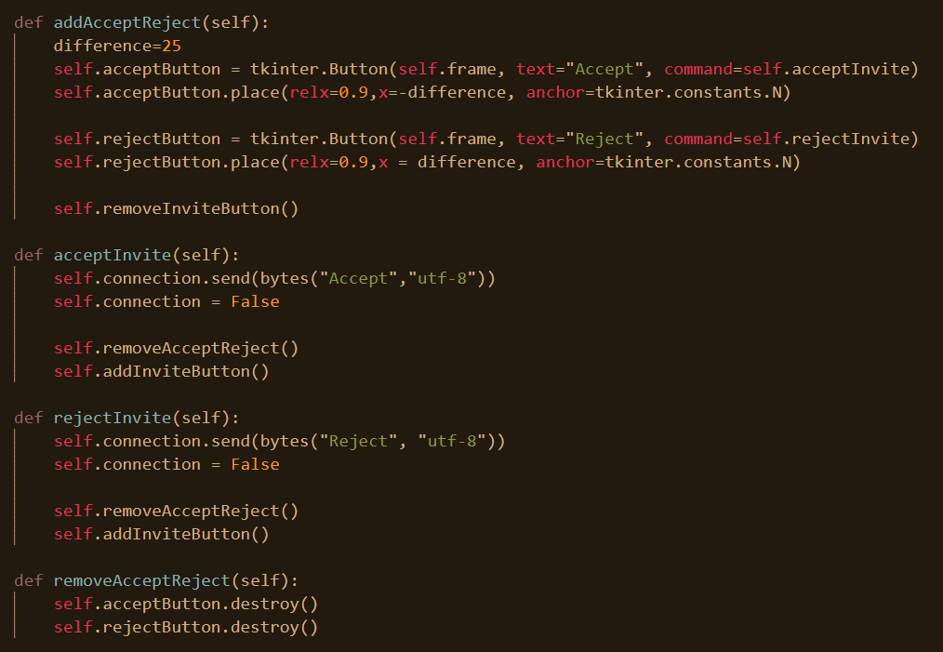Each button is tied to the corresponding method. In both methods, a message is sent according to whether accept was clicked or reject. Then, the accept and reject buttons are removed and the invite button is added back.

Users are able to send invites and these invites are able to be responded to. However, the original user sending the invite is not listening for the response. This needs to be the case.

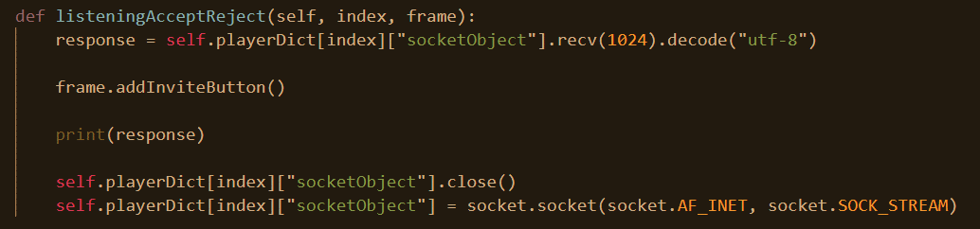

The blocking function recv waits for a response. Once a response is received, the invite button is added back and the socket is closed because the communication is over. Then, a new one is created in anticipation of a new connection that may be initiated. Because this function is blocking, this needs to be called as a thread using the threading module.



Whenever a player invites another a player, a thread will now be created calling the aforementioned function.

Before moving on to the launching of the actual game, there is one other feature that needs to be implemented. There needs to be a feature that deletes or discards players that haven’t broadcasted in a long. Such a feature is necessary as a player may leave or stop running the application for a plethora of reasons yet the player will still appear in the list of potential players for all other players when he is not available.

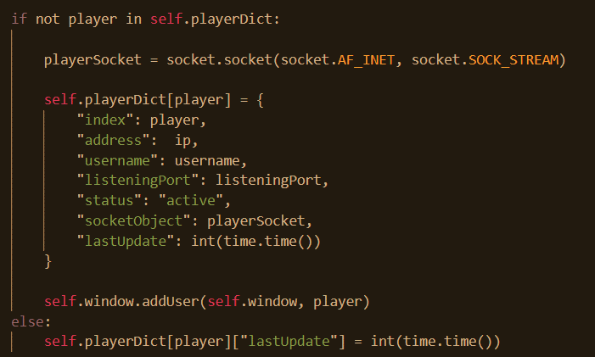

Here what we are doing is every time, a user broadcast is received, the time at which the broadcast is received is being saved. Next, it is necessary to regularly check which users have not broadcasted after a certain interval.

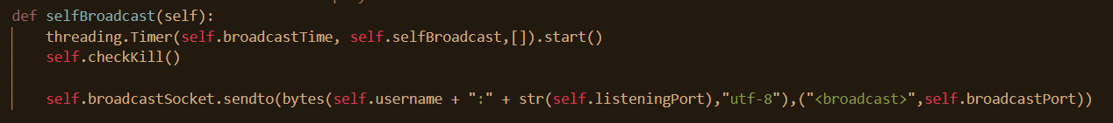

Every time a broadcast occurs, the program will call the method checkKill which will determine which users are “out of date” and have not broadcasted after a given time.

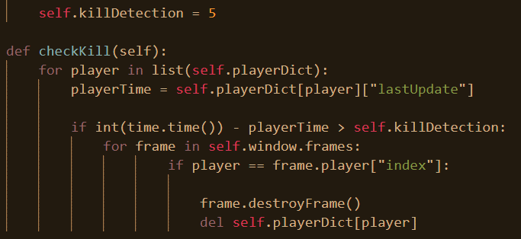

In the initialisation of the class, a variable called killDetection is declared. This is the amount of time that the program is going to wait until it will consider another player “dead” and delete them. So, in this current rendition of the program, if no broadcast has been received after 5 seconds, the user is considered dead and this will be elaborated upon now.

In the method checkKill, every player inside of the player directory is iterated through. If the time since their last update is greater than what is currently 5, the frame is deleted from the GUI and the player is deleted from the directory.

This is the method to destroy the frame.

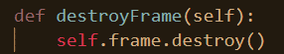

Now, it is time to actually launch the game from python. First of all, it is necessary to create a variable that tracks whether the player is already in a game or as not to launch multiple games. 

This is declared as soon as the username is validated and checked. Next, checks need to be made to ensure that the user is not in a game, when doing things that could cause a player to launch a game, primarily accepting invites and receiving acceptances of invites.

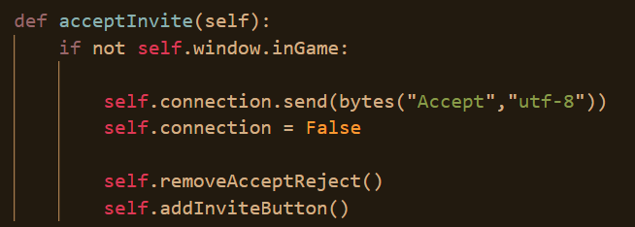

Next up is the launching of the game. The game itself is not programmed in python, rather it’s programmed in LUA, using the game engine love2d, so it will be slightly more difficult to run than a typical python script, furthermore arguments need to be passed into the program, the arguments being the different ports and IP addresses to be listening into.

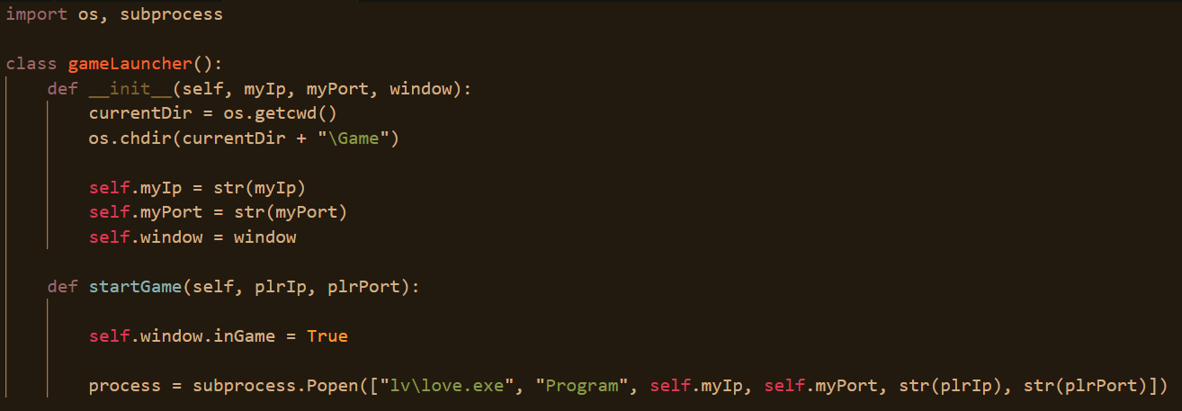

This code is written in a separate file called launch.py for organisational purposes. Upon it’s declaration, it is given the IP and port of the user as well as the reference of the window object itself. The act of giving the game launcher this reference enables the launcher to toggle on or off the state of being in game. Next, a process the program love.exe is ran. Subprocess.popen is used to accomplish this as you are able to pass arguments into the execution and no new shell window is launched.

In networkingClass.py, we import it this file and class as shown below.



Inside of the initialisation of networkingClass, we create a launcher attribute to which we assign the gameLauncher object.



The reason that listeningPort cannot be supplied as an argument by itself is that the python program will already be listening in on that port, so a different one is needed.

The reason that the launcher is assigned to the window is so that it can be accessed inside of the original code.py file. When an invite is accepted, the code is run below as follows.

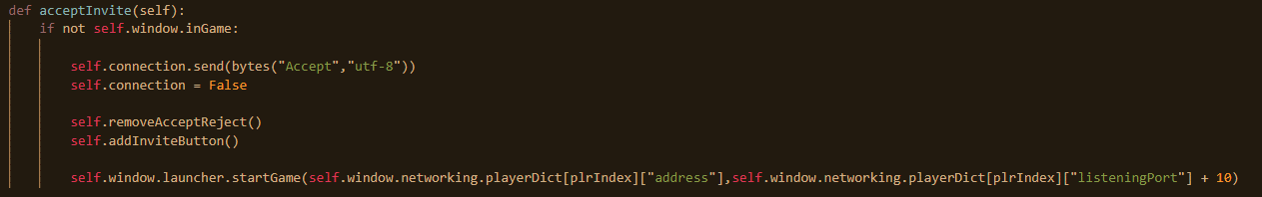

The IP of the target player is passed as well as the target player’s port.

This is how invites are accepted. If someone were to receive confirmation that their invite has been accepted, this is how that will look.

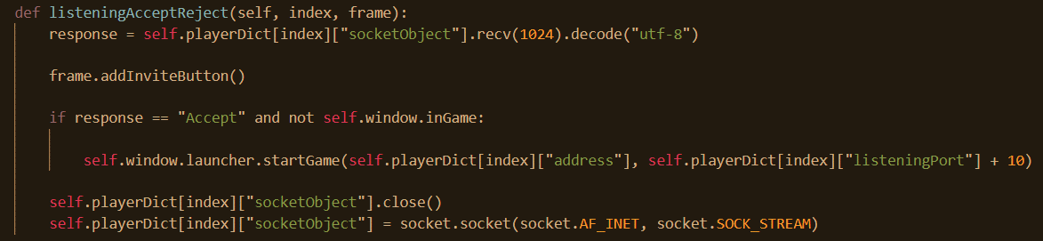

This method has already been discussed earlier but is new is that the startGame method is called in a similar fashion to above when confirmation of an invite being accepted has been received (and the player is not in the game).

This is the entirety of stage 1. Matchmaking is now complete. The game can now be launched and the python and Tkinter aspect of this program is over.

## Review

In this section, the user is now able to input his username, this will get validated and then he is able to detect invites from others as well as send out his invites and respond to invites from others.

* Player’s create a username before entering lobby or GUI
* UI
  + Lists player usernames
  + Invite button that invites users
    - Cannot invite players who are in-game
    - Accept/reject button if player receives an invite
* The player makes himself known to other players
  + Player appears in other player’s playerlist
* If a player closes the lobby program, and other players are alerted to this
  + This player no longer appears in other player’s player lists

The above links to the success criteria that has been completed.

# Stage 2 – Choose loadout

## Basic setup

Now, work is going to commence on the actual game. The game engine that is being used will be love2d which uses the programming language Lua. A new folder will be created called Game where all love2d related files and code will be stored. Within this, another folder will be created called lv which will contain all the core love2d files which are necessary for the game engine to be used. Finally, inside of the game folder, another folder will also be created called Program which will store all game related scripts that are not core to love2d. This is the current file structure.

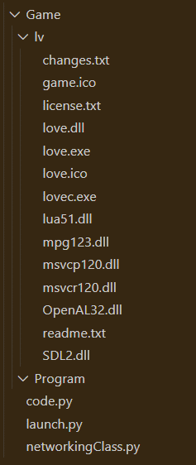

Inside of the program folder a file called main.lua will be created. Love2d games are typically ran by running love.exe and passing a folder in as an argument. Then, the game engine will search within the folder for a file called main.lua from which it will start running.

It is often standard practice for the main.lua file in love2d games to be structured in the following way.

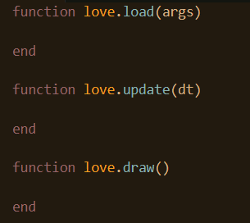

Whereby, love.load is called when the program first runs and then every time the game goes through the game loop, love.update is called followed by love.draw. It should be noted however, that it is not necessary to declare variables inside of love.load, one can do so before the function is declared and that code will also run and be processed. The “args” argument in love.load enables the user to be able to access any data that was passed into the file when the program was executed, and this cannot be accessed elsewhere. Dt, in love.update describes the time since the last update, which is useful if one would like to keep track of the time if they want to run things after a certain interval.

Aside from this, writing code inside of these functions rather than outside has two other benefits. The first being organisational, one’s code is better organised inside of the file, and the second being the variables cannot be accessed outside of the function. Variables that will be accessed everywhere will be placed outside of love.load.

The following code creates a basic window.

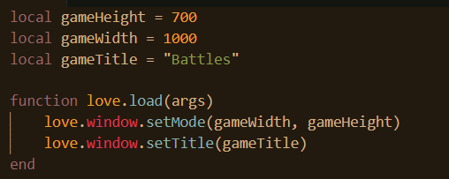

Where setMode takes the arguments of the width and height of the window.

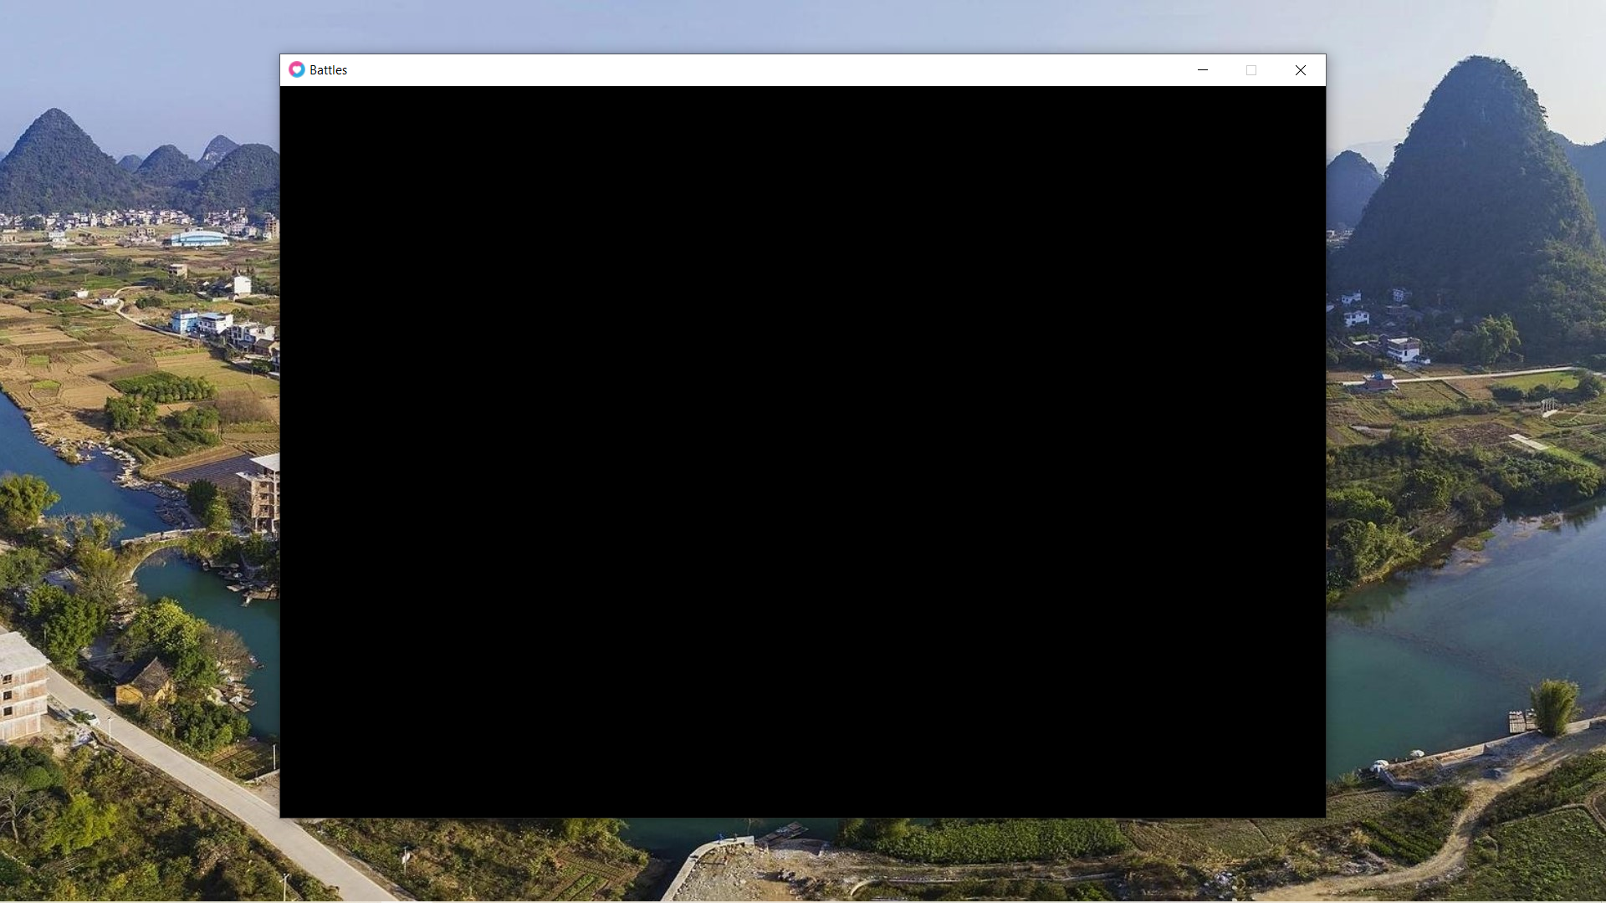

When the game begins, the player will have the option of choosing between 4 loadouts. Before programming this graphical user interface, the properties of each loadout needs to be determined beforehand.

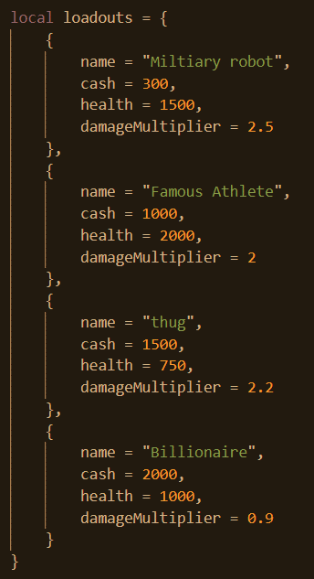

This dictionary is not very intensive programming, rather it just describes the properties of each class. This is placed outside of love.load as it will be accessed outside of love.load and thus cannot be local to love.load. Each loadout is measured against 3 main metrics, the cash, the health, and the damage multiplier. The values of each loadout have been chosen judiciously to reflect not only to ensure that each class is balanced and that no class overpowers all of the overs but also to reflect the real-life characteristics of each class.

Briefly, it makes sense for a robot to have high health and damage as it is mechanical and made of metal. Athletes are good all rounders as they exercise a lot, are strong and make a lot of money. The thug may have a lot of cash due to illicit activities and he may be quite strong from being regularly in fights but perhaps he doesn’t care too much about his health. The billionaire is obviously going to be the wealthiest and also have good health but because he is surrounded by so much luxury, he is not good with fighting.

Before I outline in detail how the user interface of the loadout menu was programmed, first of all it is necessary to understand the programming paradigm of the game. Initially, OOP was the paradigm that was planned to be used. However, a problem with OOP rests in certain hypotheticals. For instance, what do you do if you wanted to inherit from two different classes? One may argue that you should create a larger class from which the two parent classes would inherit from. The problem with this solution is that there is inheritance of redundant variables or variables that wouldn’t be used.

The problem above is solved using the principle of composition over inheritance and allows for classes to achieve greater polymorphic capabilities.

Instead of OOP, the game will be more geared towards data-oriented programming. To do this, I will be using an entity component system, this is a design pattern, where everything is split up into 3 parts: entities, components, and systems. Components can be described as containers of related data; they do not contain functions. Entities are somewhat analogous to objects in that they are a collection of components, however the difference is that they do not have any methods. Entities have no inherent data to themselves either, these are all granted through components. Finally, systems are responsible for modifying components. Entities belong to systems according to their properties. For instance, entities with a velocity component inside of a game may belong to a physics system which updates physics throughout the game.

The ECS library that will be used is concord, which has specifically been designed for Love2d.

The concord library is downloaded and placed as part of the project as can be seen here.

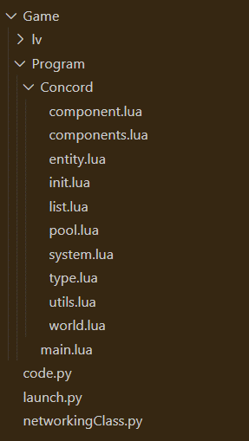

Here, the concord library is imported as well as all of its key features.

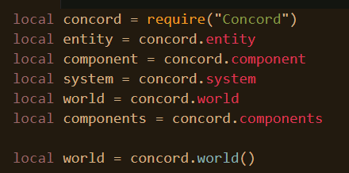

## Drawing

Something that hasn’t been mentioned but is somewhat unique to concord is that all entities and systems exist inside of worlds which can be deleted or modified.

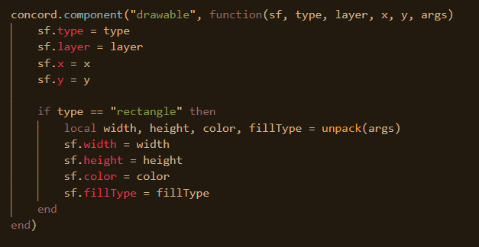

The first component here is called drawable. It takes the following properties, type, layer and args. Given that in the game, drawing is not going to be limited to rectangles, it is net necessary to specify the type of shape that is going to be drawn. At the moment however, only rectangles will be drawn. The layer value specifies at which layer or height level the object will be drawn at. If the type is rectangle, the expected values of the args are going to be the height, width colour and the fill type and these are assigned correspondingly. When a drawable object is created and the values are passed, they are passed into this function which runs through these lines of code.

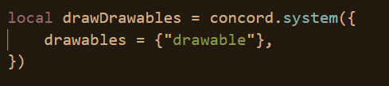

Next a system is created, this system is responsible for managing drawables, or objects that need to be drawn onto the screen. Any entity with a drawable component enters into this system. This provides a convenient way to perform operations with on all drawables.

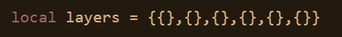

Before proceeding, a 2d array is created called layers, where each index value is a layer, so the first index is layer 1 and the second index is layer 2. Rather than just have a giant list containing all of the entities in the game, it would be more prudent to store all the entities in their corresponding layers. Thus, if there are 6 layers, the program doesn’t need to iterate through the giant array 6 times, checking if each object is in whatever layer is being drawn at the moment. Rather, if each entity exists in a special box which is their layer, then no checks need to be made if an entity is of a particular layer, improving performance.

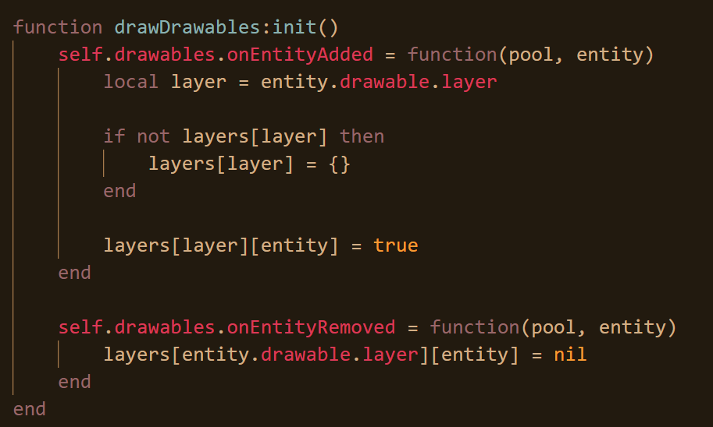

The init method is a built-in method in concord for systems allowing the programmer to edit fundamental and built-in methods to the library. For instance, here, the onEntityAdded method is being edited. What’s being amended is that whenever an entity is added to the drawDrawable system, they are automatically also added into the layers 2d array as described earlier. If the particular layer doesn’t exist, it is created. In Lua, tables can take any value as an index, including numbers, strings and in fact other tables. Here, the table reference is able to be made as the index value when storing the table in layers. This allows for the programmer to easily remove the entity from the layer should the programmer know the entity reference. Furthermore, technically, the table isn’t being stored as a value but as an index. If it was desired to remove the table from this table, all one would have to be able to do is have the reference of the table to be able to remove. When a drawable is removed from the system, it is also removed from layers.

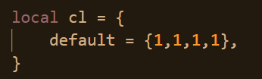

Next, a colour table is created which will contain all the colours that are to be used. Currently, there is only 1, the default, which is white in RGBA, where each value is a number from 0 to 1 as opposed from the traditional 0 to 255 and the last value is the alpha or the transparency.

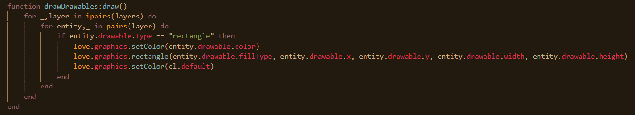

Another method is added to the drawDrawables system. Here, all the layers are being iterated through. Because tables in Lua can have anything as an index value, they can be difficult to iterate through for the computer. Therefore, there are two ways you can iterate, ipairs and pairs. Ipairs, is generally used when you know that the only indexes of the table are numbers and that these numbers are consecutive starting from 1 (tables in Lua start from 1). If such a table like this is in use, then it is generally encouraged to iterate through it using ipairs as it is more efficient. This is what has been done. Next, the layer is iterated for all the entities inside of it. As can been seen, corresponding to what has been described earlier, the index value is where the actual entity is stored. Next, a check is made to the type of the particular entity which will inform how the drawable is to be drawn. The colour is set and the rectangle is drawn. The rectangle method in love can takes 4 arguments, fill type, whether the fill is solid or line, x, y, width, and height. Finally, the colour is reverted back to default so that anything else that is drawn without a colour being set doesn’t look filtered with the previous colour.

The loadout UI can be continued on now.

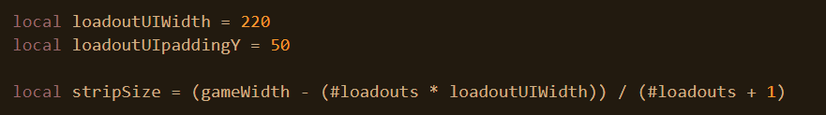

These two variables describe the width of each loadout option and vertical padding respectively. Next, one can work out the gap between each loadout box. #Table returns the number of items in the table. The reason #Table is used rather than writing 4 is in case it is decided to add or remove the number of classes.

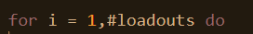

Now, every loadout is going to be iterated through and drawn.

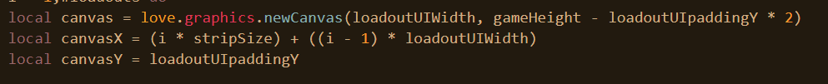

Firstly, a canvas is created when iterating through each loadout. The arguments are the width and height. A canvas basically allows for a series of objects as part of a collection drawn once off screen so that every time they need to be drawn in the game, the canvas can just be drawn and each item of the canvas doesn’t need to be drawn individually. CanvasX and canvasY refer to the x and y position respectively from which the canvas will be drawn. The y position is a constant from earlier.

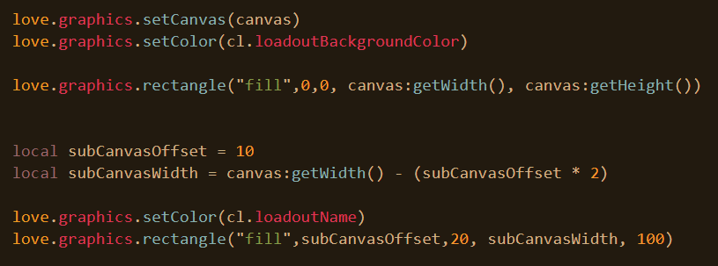

Next, the canvas is set to the canvas created above. The effect of this is that anything that is drawn or any colour that is set or anything similar to that is going to happen only to this canvas and to nothing else. Next, a rectangle is that fills the entire canvas with a specific colour, which was declared off-screen in the table called cl. Next, a smaller rectangle is created inside of the canvas whose purpose is to contain the name of the loadout. It’s 10 pixels further into the canvas horizontally on both sides, and 20 vertically. Its height is 100 and again it has a unique colour declared off screen.

Before proceeding with drawing text, it is necessary to create some fonts. This will be done outside of love.load such that the fonts can be accessed everywhere.

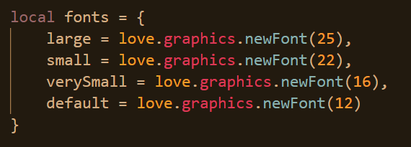

Here, fonts are created of varying sizes.

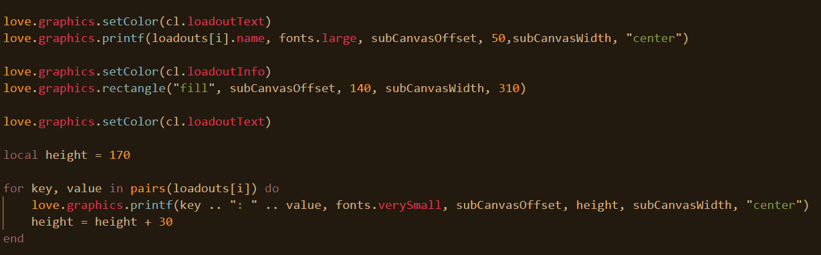Next, text is printed inside of the box described above in large text. The text is going to be the loadout name which is indexed using the position in the loop that the for loop is in. Its position is 10 positions on the x axis and 50 on the y axis, and it will be centred.

Next, another box is created, again 10 pixels offset from the left the same way that the box containing the name of the loadout was. This box will describe the properties of the loadout, the advantages, and disadvantages. Next, all the properties of the loadout are iterated through and are drawn in small font inside of this box. After a property is drawn, the height increments by 30. The starting height is 170.

Now, from here, a separate canvas is created which will contain the button for the option to select the loadout.

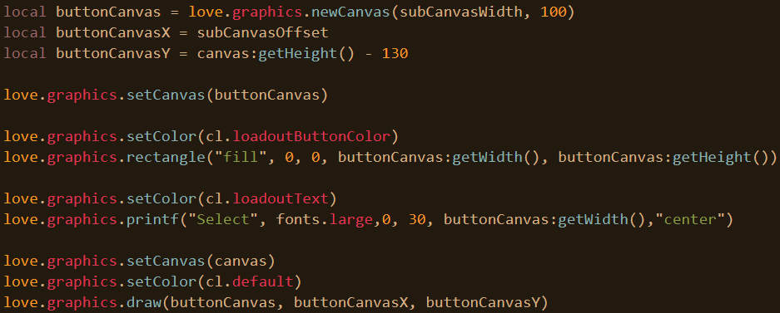

Its height will be 100 and the button will be 130 pixels from the bottom of the canvas. The canvas is set and a rectangle is created as well as the text for the button called select, written in large font. Then, the previous canvas is made active, and the button canvas is drawn onto the previous canvas.

Before, moving onto the final step of the for loop, it is necessary to amend our drawing system to be able to include canvases.

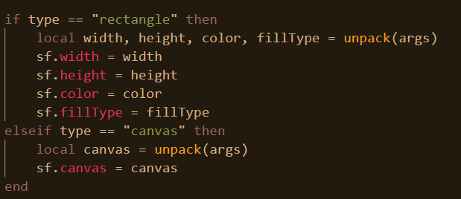

The only argument for canvas will be the canvas itself. This is part of the component.

And then the amendment in the draw method of the drawDrawables system.

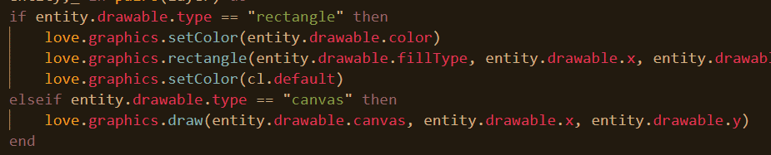

Finally, an entity can be created with the drawable component.

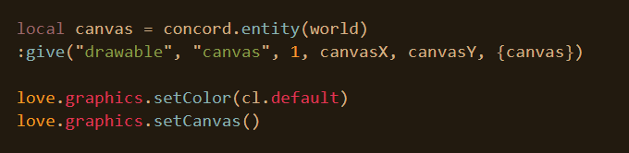

The entity is put into the world, and it’s given the drawable component with the following arguments. Then, the colour is reset to the default and the canvas is reset.

Finally, it is necessary for the draw function to be called.

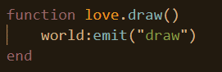

Every time the draw event function is called, every system with the draw method will run. However, for any systems to hear this, they must be added to the world as follows.

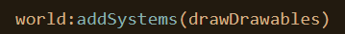

Debugging in love2d is made easier when a conf.lua file is created with the following code that results in the debug console being launched every time.

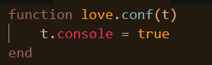

This is something that has been used in the testing and debugging of this program.

This is the end result of the programming.

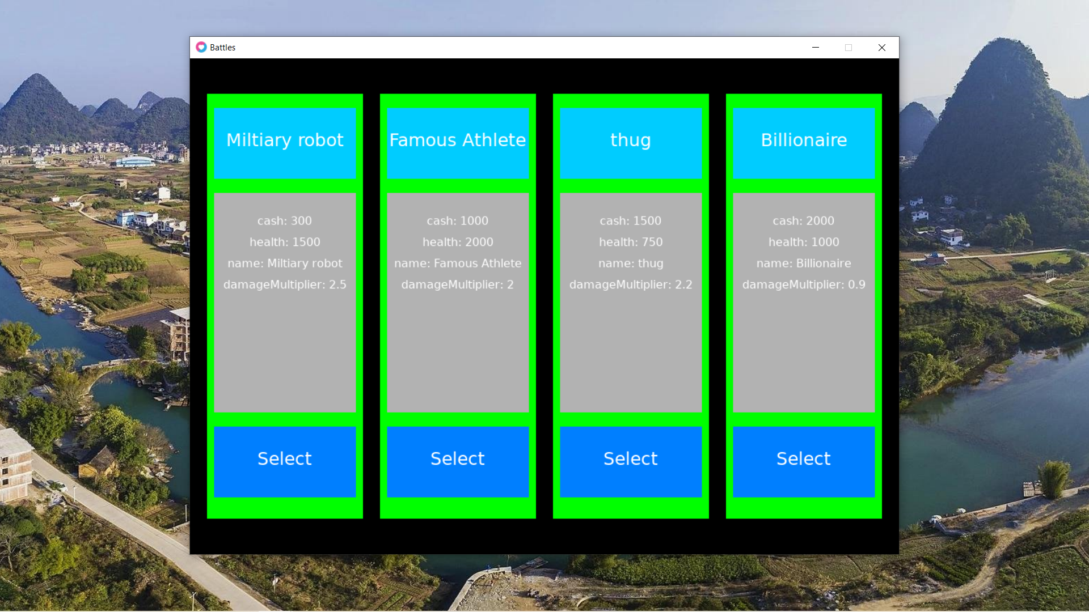

It can be seen that the background colour of the program is black this can be amended to a more complementary and aesthetically pleasing colour such as green at the beginning of the code.

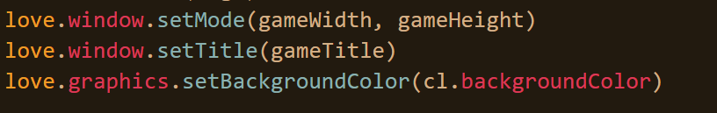

Which makes the program more pleasant to use for the user.

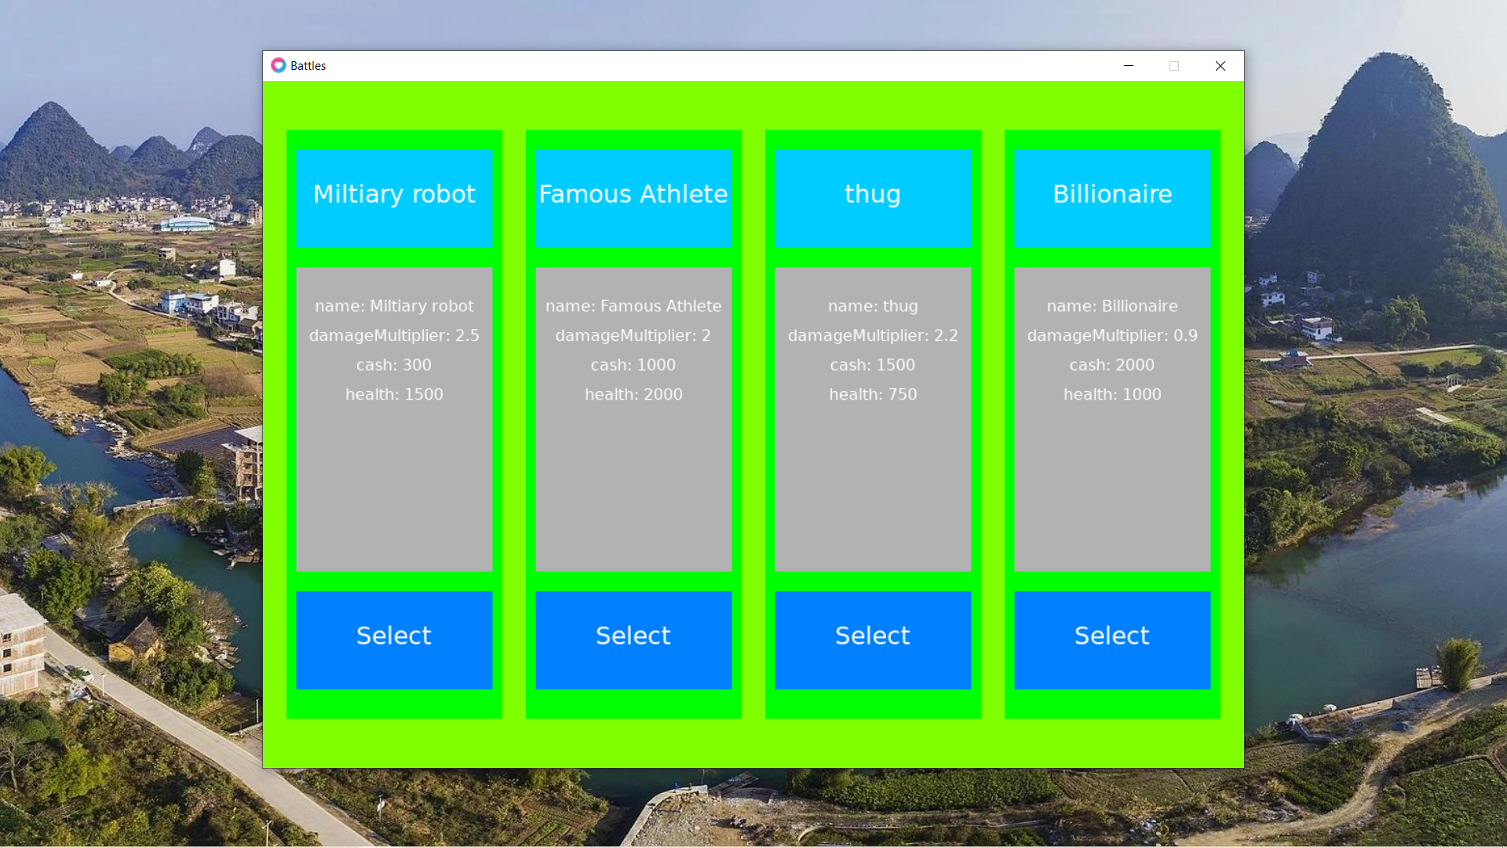

## Buttons

It should be noted that the select buttons don’t have any functionality at the moment. This is what will be worked on now.

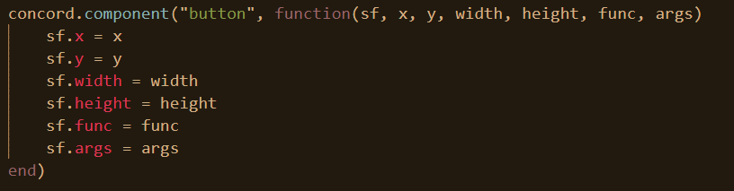

This button component takes position arguments, dimension arguments, arguments for the function once the button is clicked and arguments for the function of that button.

It should be noted that there are two aspects of a button. One being the fact that when hovered over, they can be highlighted to a particular colour, typically a greyed-out version of their normal colour, and secondly, when buttons are clicked, they perform an actual function.

Here, is the system for buttons, quite simple and rudimentary for the moment. All entities with the button component will belong to this button system.

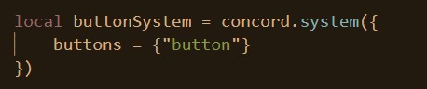

To implement the first feature of a button, however, a global entity with a drawable component needs to be created whose function it is to act as a highlight over buttons.



By default, its position is the width of the window and height of the window or off screen because by default it is assumed that the user is not hovering over a button.

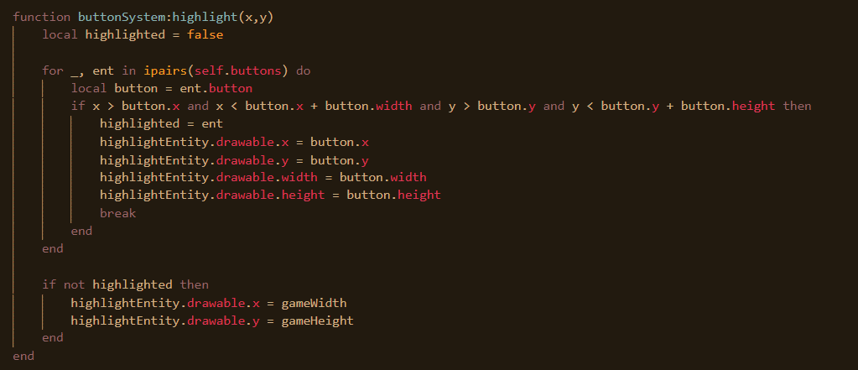

This method of the button system whose purpose it is to highlight any button when the user is hovering over. Whenever this method is called, all the buttons are iterated over. Then, it checks to see that the location of the cursor is within that of the button, if so, the highlightEntity is moved to the location of the button and its width and height is changed to match the button. If nothing happens, it’s position is changed back to be off-screen.

Again, this system is added to the world as well.



For the latter function of the button, the following method is called whenever a click is made.

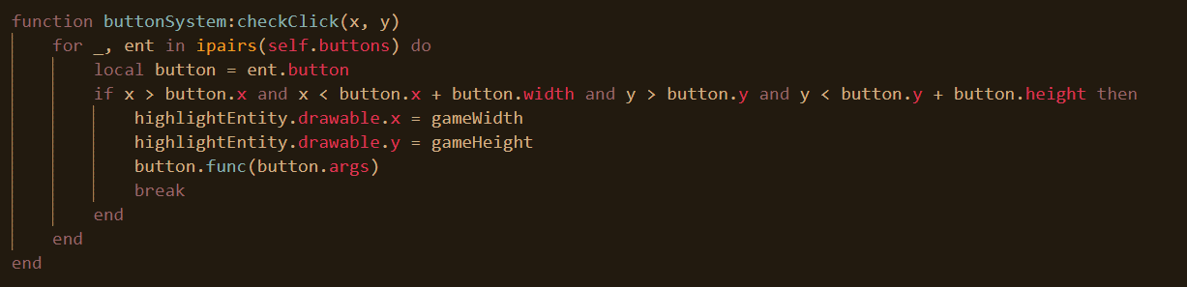

Like before, checks are made to see if the cursor is in the location of any button. If so, then firstly, the highlight is removed to indicate to the user that he has clicked and create a degree of responsiveness, then the function associated with the button is called with the corresponding arguments also called.

Finally, two methods are added to the file.

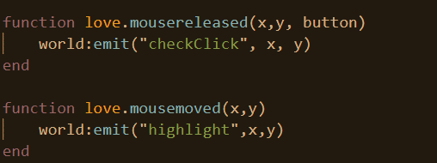

Any system with a method check click or highlight is called whenever mouse is released (a click is made) or the mouse moves and in both of these instances, the x and y value are passed through.

Before, the loadout buttons are created as entities, it is necessary first to make the functions associated with them.

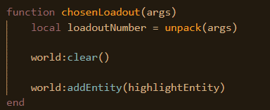

Right now, this is the function that will run when the select buttons are clicked. All entities in the world are deleted. This is done to get rid of the UI elements of the loadout menu, and then the ones that will be used again will be added back.

This button entities however need to be created again and hooked up to this function.



This button entity is created at the end of every iteration when going through and drawing every loadout as was being worked on and discussed earlier. The argument passed is the loadout number.

Initially, this was forgotten and it was assumed that the default loadout of the player was player 1 but this was remedied as shown above.

This is the result once the select button is clicked.

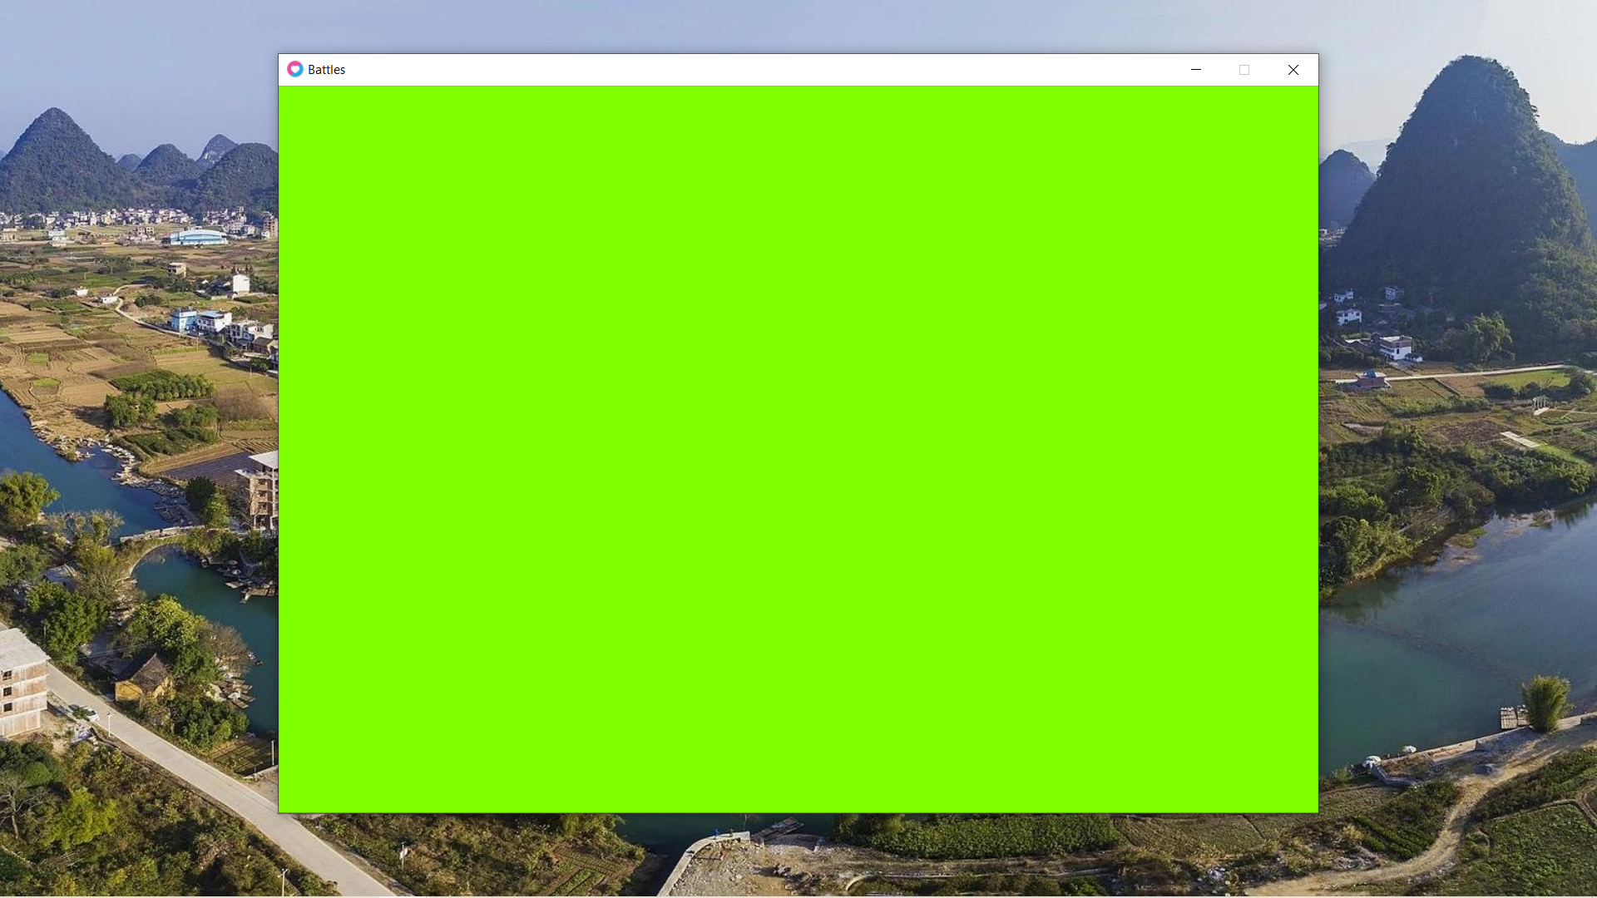

On a final note, as evidence that the highlighting of buttons is working and functioning the image below corroborates this where famous athlete is highlighted grey.

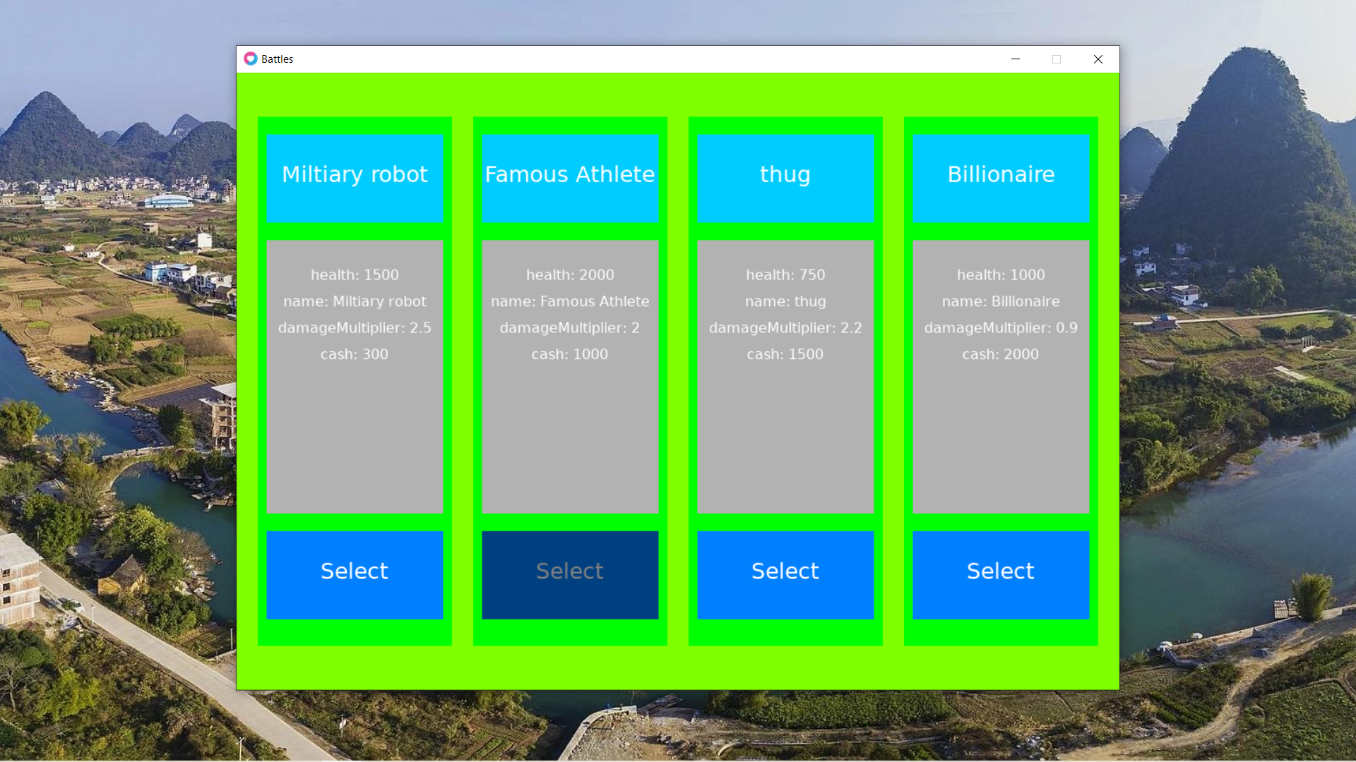

## Review

Now the window of the game is generated in love2d. A list of classes with various properties are displayed and the user is able to select a class from the list of classes.

* The player will see a menu a loadout menu before the game begins
  + In the menu there will be 4 boxes
    - The name of the loadout will be displayed in each box
    - The stats of the loadout will be displayed in each box
    - There will be a “Select” button in each box that the user can click to select the loadout
  + Varying properties of each loadout may include:
    - base health (of tower)
    - starting cash of the player
    - Tower health regeneration rate
    - Max amount of money a player can have
    - Currency increase rate
    - Specific details for reach class will be developed in the design stage and subject to change in the implementation

The above is the success criteria that has been met in my program in this stage. Tower regeneration rate, max health, currency increase rate, and max amount of money aren’t properties in this class and I decided to instead add a damage multiplier which I believe will make the game more enjoyable.

# Stage 3 – Buy/Place Items

## Drawing

In this phase, the user will be able to purchase items and place them onto the map. The first order of business is drawing the menu at the bottom of the screen that will allow for the user to purchase items and place them down. Firstly, a list of items need to be created, however, in a similar way to how the loadout table was created earlier.

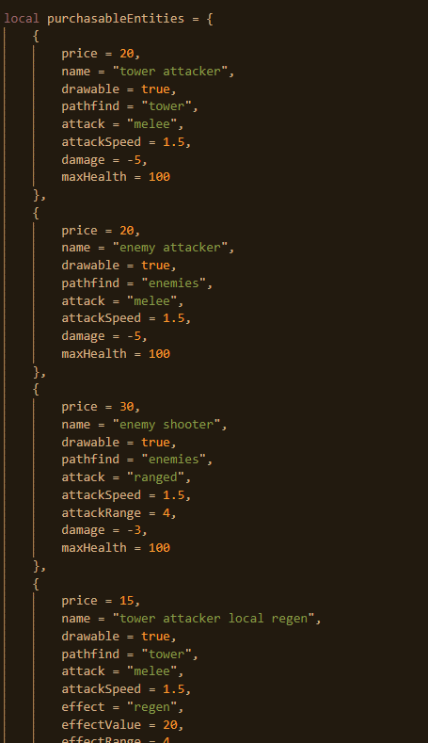

There are about 15 datapoints inside of this table so the screenshot is cut off from here. Fundamentally, what is common in all entities is their price and their name value, however, every single other property is not guaranteed to exist in all the other entities. Some entities for instance are not drawable, some do not even attack. When entities are being referred to here, they are describing entities that can be placed down and help the player win the game. Each entity has a unique skillset and different advantages and disadvantages. It is up to the player to decide if they want to place down this entity.

Before, the bottom menu is drawn, it must be determined how much space is allocated for the main game as the amount of space allocated for the menu is predicated on this.

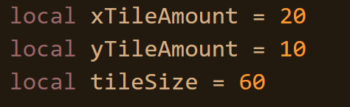

Here, it is described how many tiles there will be in the x and y direction as well as the size of these tiles.

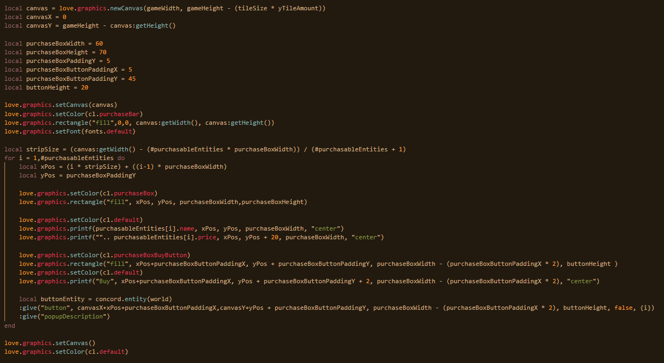

Back to the chosenLoadout function which, called by the select buttons, runs immediately after a loadout is selected. First, a canvas is created with the width of the window and the height that remains after allocating vertical space to the tilemap. This will be the menu to purchase items.

Next, the width of each box is declared, as is the height and the padding inside of the box as well as the button height and the button padding itself. The canvas is made active and a rectangle is made to fill the entire menu.

Next, a variable called strip size is declared which basically describes the space between each purchase box.

The for loop iterates through every entity that the user can purchase and according to the position the iteration is in the table, it determines the x value. The y value remains a constant. Next, a rectangle for the purchase box is made and the colour of the purchase box is set. Following this, the name and price of the purchasable item is written down inside of this box and the button to buy the item is written down as well. Once this completes for all 15 entities, the canvas exits and the colour returns. A drawable is created where like before with the loadouts and following output appears.

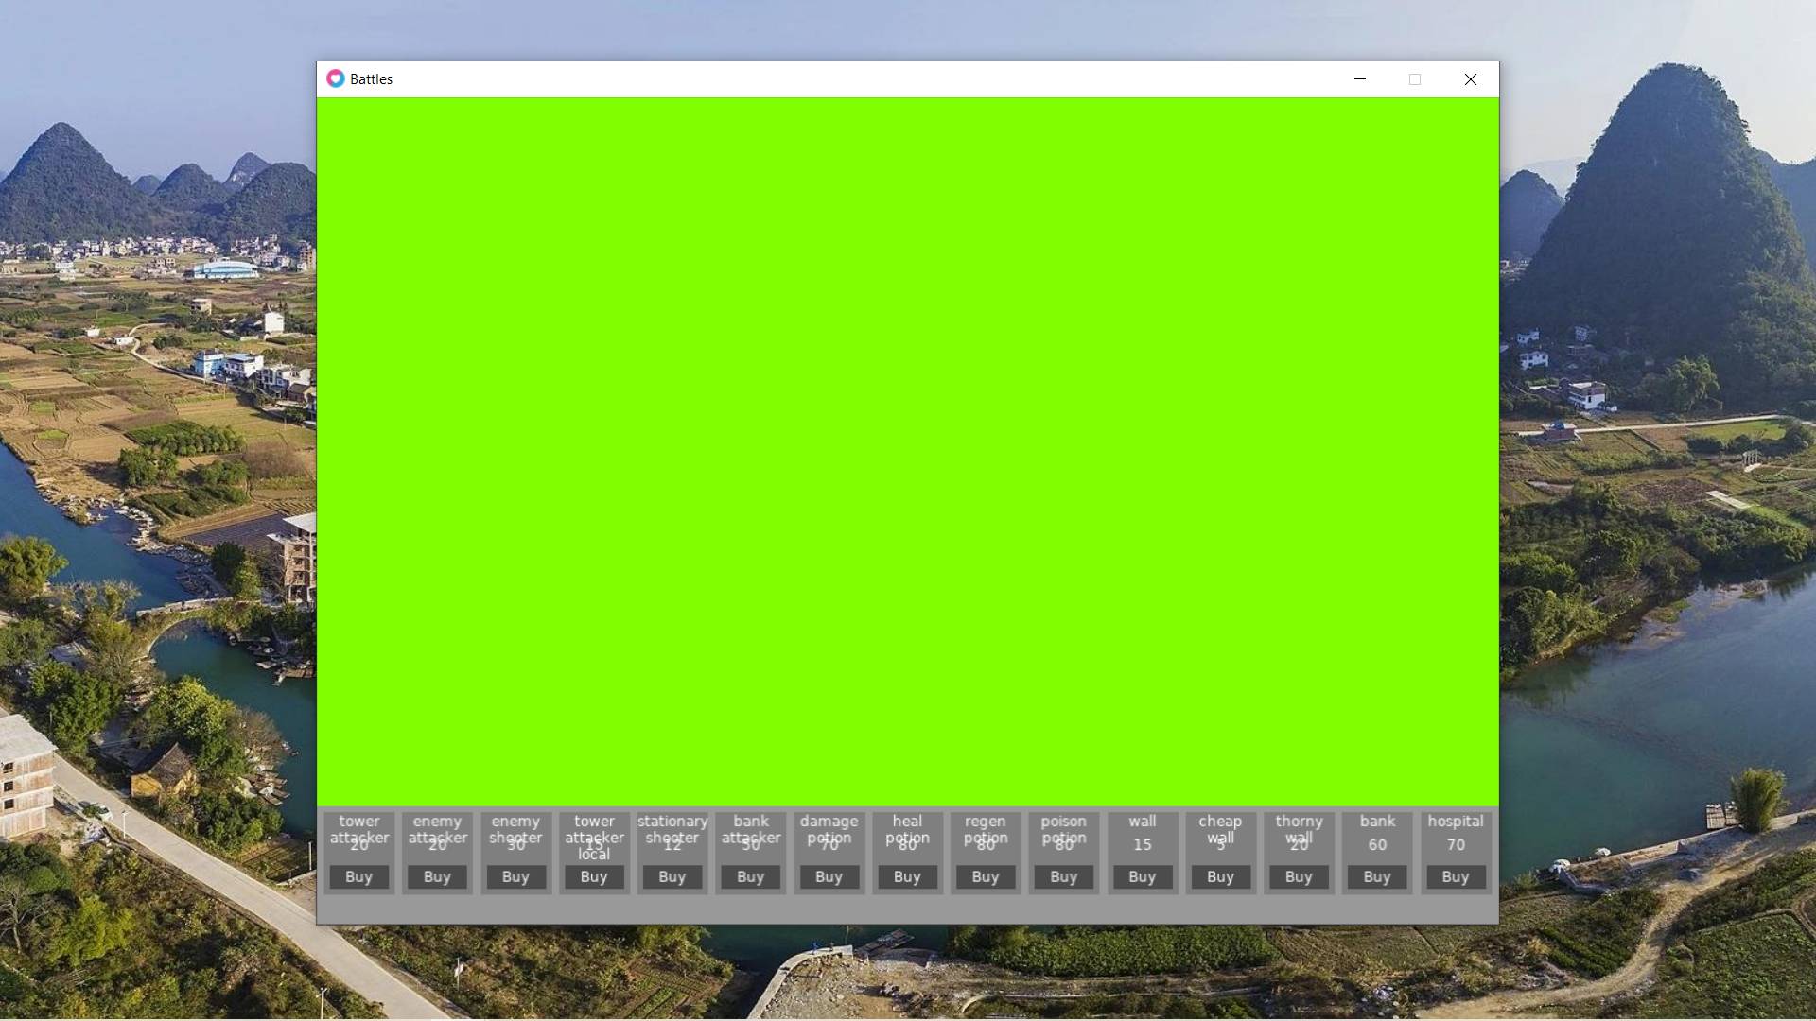

As can be seen, the price, and name of each purchase box is made visible.

## Interactivity

Next, what needs to be created is when the mouse is over the buy button, a pop-up appears. This pop-up will describe the information of the given entity that is being hovered over when it is about to be bought. Given the fact that each entity is different, the pop-up is different and a canvas needs to be recreated every time it is hovering over a different entity.

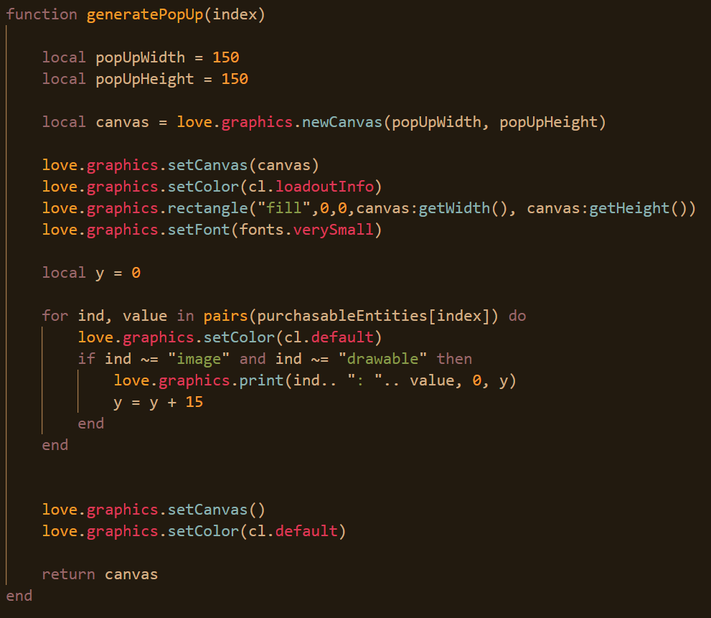

This function takes the index of the item that is going to be purchased as an argument. Then, it creates a canvas and sets the font to very small. After, it iterates through all the properties of the entity that is to be purchased. If one of the properties is either drawable or image, then that property won’t be included. This is because drawable just details whether the image has a component that is to be drawn and image is the image file that is to be drawn to the corresponding image. The text is drawn and the y value is incremented further down. Once this is done for all properties, the canvas is complete and then reset and returned.

Next, a component needs to be created that will distinguish normal buttons from a popup, this can be simple as a true and false statement.

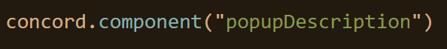

From here, now a button can be created. For the moment it’s functionality will not exist so it will just be a dummy button. The button attribute and the popupDescription attribute are being given.



From here, the highlight method can be edited as follows.

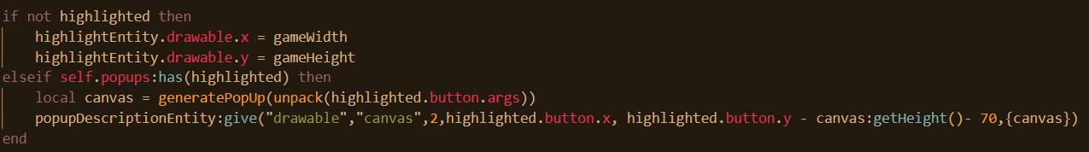

If the highlighted entity belongs to the popups pool, then a new canvas will be generated according to the buttons position, and secondly, it’s x value will match that of the button but it’s y value will be a bit above.

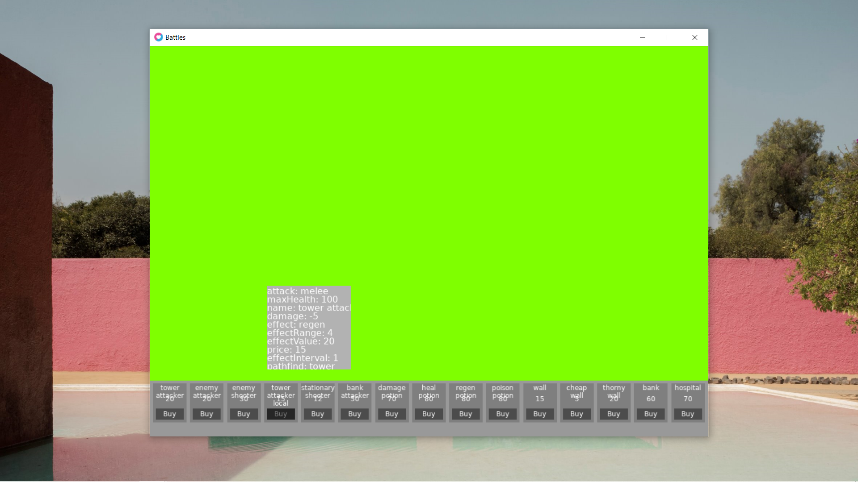

But now a problem is if the user removes the cursor from the button the popup remains so this needs to be rectified.

To be able to remove the popup however, the game needs to know if the loadout has been chosen. Otherwise, if it tries to remove the popup, since it doesn’t exist yet, there will be an error.

When the chosenLoadout function is called, the line of code below is appended.

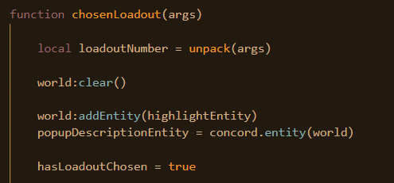

The variable is also declared false at the beginning of the program. 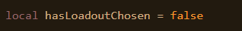

Next, when the mouse is no longer hovering over a button, the pop-up can be removed.

The entity also needs to be given the drawable component before its position is changed so again the chosenLoadout function needs to be amended to accommodate this.

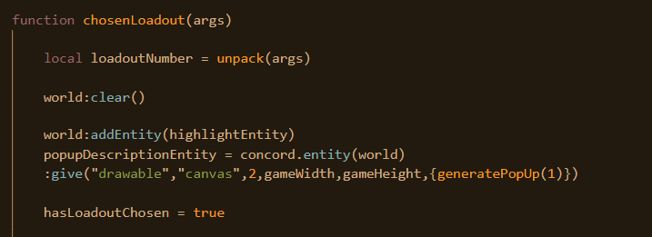

Now, going back to the highlight function, if nothing is highlighted, the pop-up description can be moved off-screen and reset.

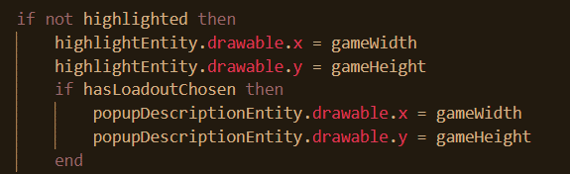

Next, the grid needs to be drawn onto the map. First, because of the dimensions or size of the tilemap, all of it won’t fit onto the screen at once. So, the user will have to scroll across to see the rest of the map. Therefore, a variable measuring the offset or how far the user has scrolled is needed.

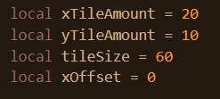

The function to make the tilemap can be made now.

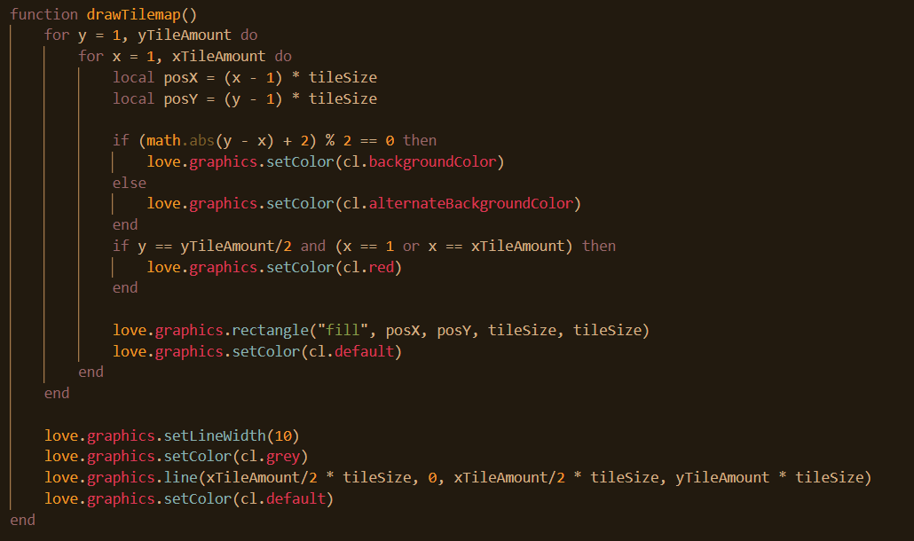

The function iterates through each row. It will have a different shade of green according to whether the square’s position itself is odd or even according to the grid. In the middle, on either end, a red square is drawn rather than one that is a shade of green to indicate that this is the object that the enemies will be attacking. Next, a 10-pixel line is drawn down the middle of the tilemap to indicate which half is the users and which half is the enemies.

This function then needs to be called.

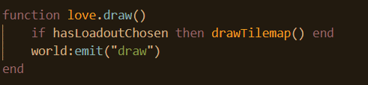

A check needs to be made that the loadout has been drawn or the map is being drawn unnecessarily. Here is what the tilemap looks like.

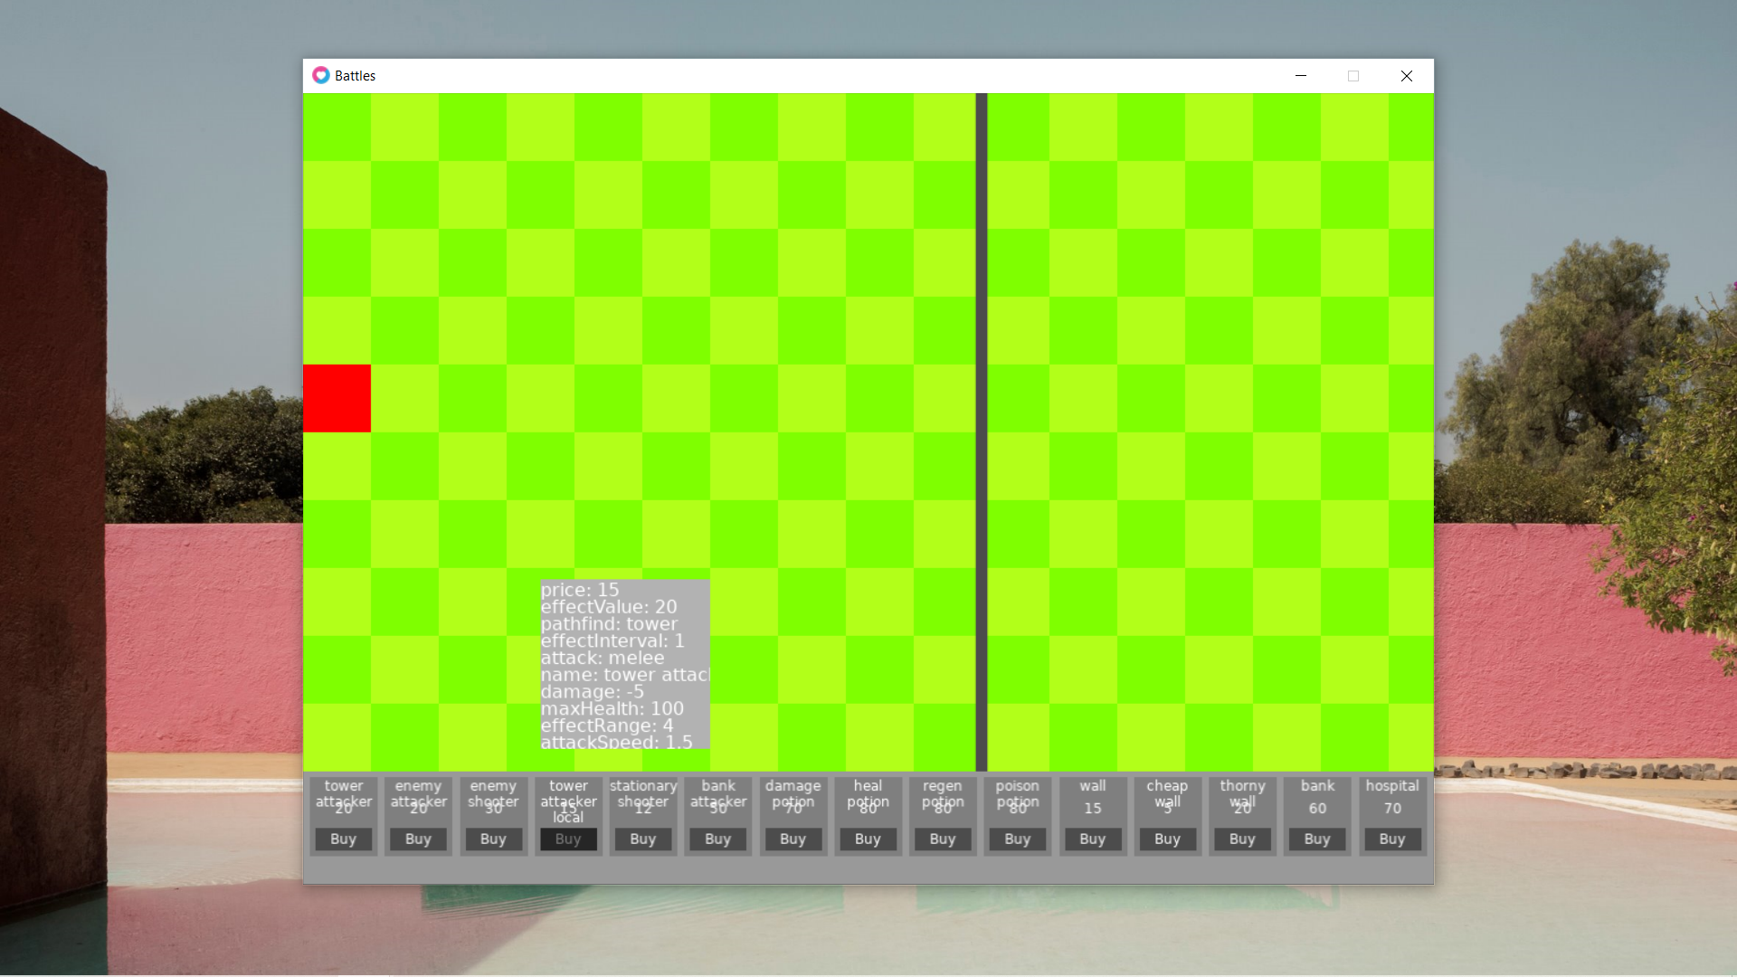

Now, what’s needed is to be able to navigate left and rightwards across the map.

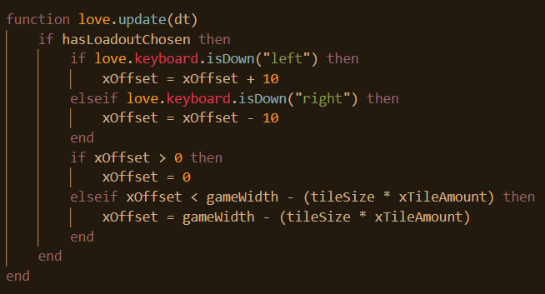

Once the loadout is chosen, should the user press left or right, the x offset increases correspondingly. It should be noted that isDown is being used to as the offset will be changing whilst the user is holding rather than isReleased or another equivalent as this will mean for the user to move rightwards, they would rapidly have to tap the right arrow. The x offset can also exist within a limited bound, if it tries to go too far left or right, it is stopped as shown above.

For this too be reflected in the tilemap, the x offset must be incorporated into the drawing of each square inside of the draw tilemap function as shown below.

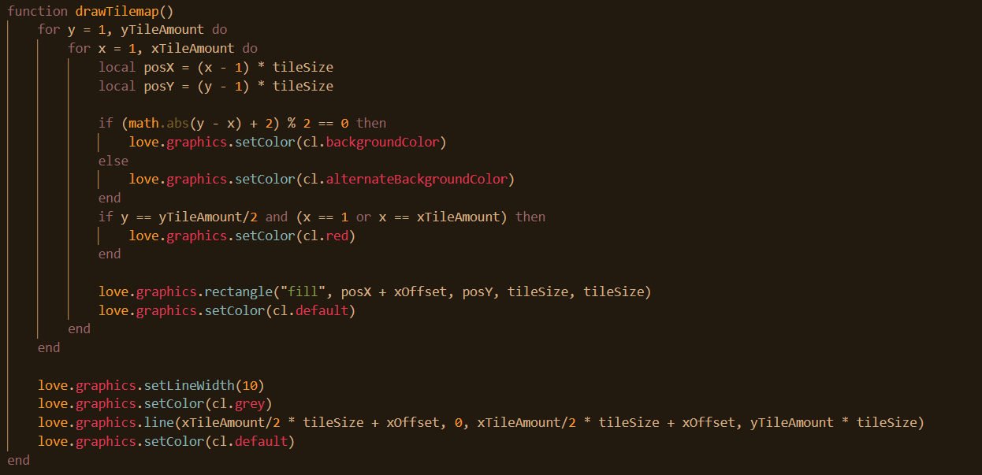

As can be seen below, the user has managed to scroll all the way to the right now.

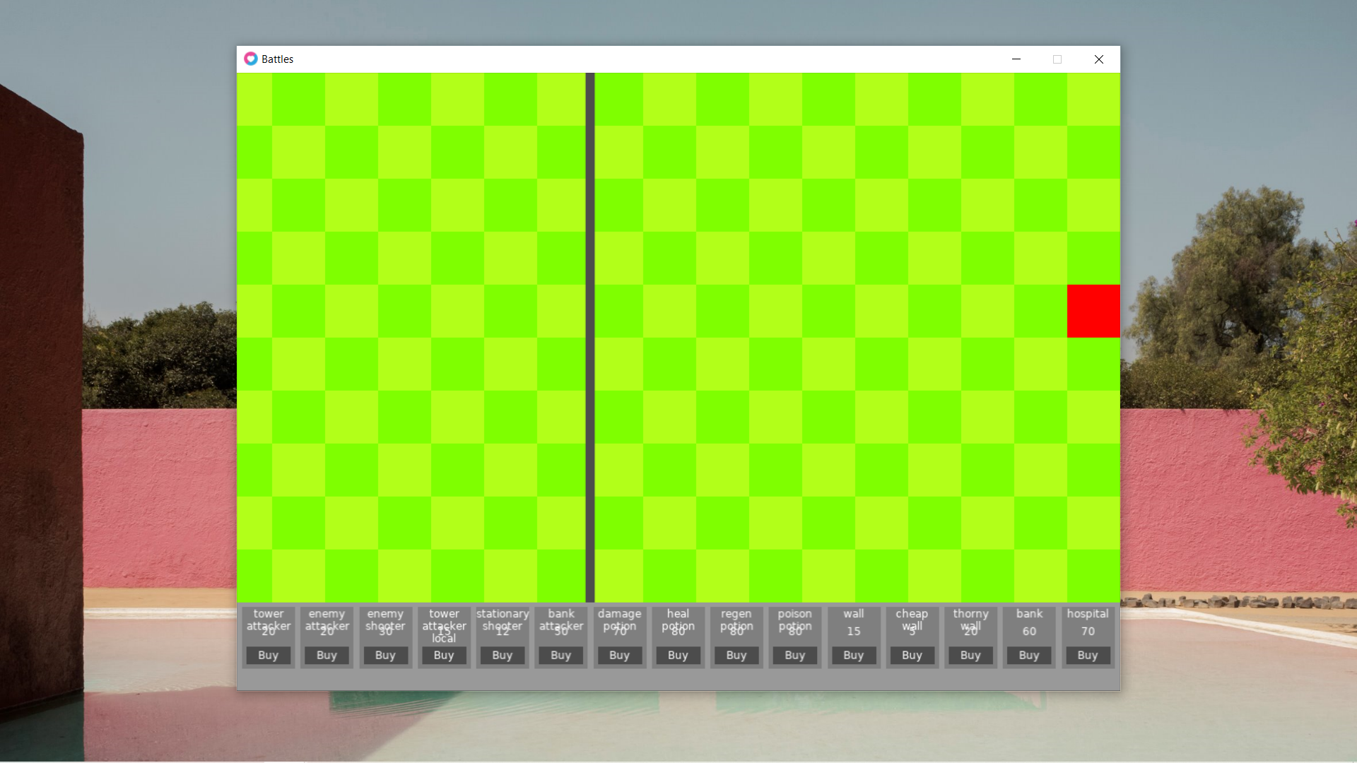

Now, what’s needed is the capacity to be able to actually place items in the game. Firstly, a variable needs to be created detailing whether the game is in the mode of placing down an item or note.

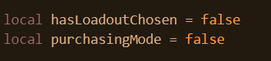

Next, once the buy button is clicked this needs to be toggled, so a function needs to be created linking to the buy button.



Now, it is desirable for there to be some form of indicator demonstrating that the button has been clicked like a red box around the tilemap prompting the user to click on the tilemap.

Firstly, this variable needs to be initialised.

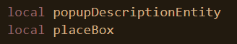

Next, once a loadout is chosen, the entity is initialised.

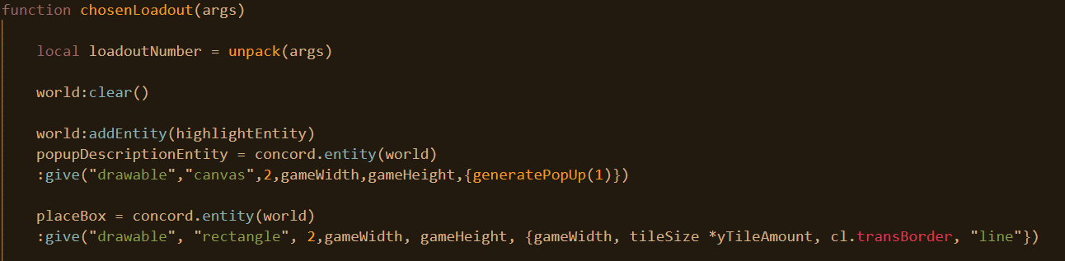

The reason an entity can’t be initialised at the beginning is because it will be cleared away after the loadout is chosen, so it must be done afterwards.

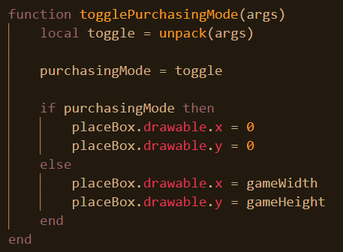

If the argument to toggle it is not false, then the variable will evaluate to true. This includes if it is a number which is going to be the case if the user pressed buy. So, what’s being stored in purchasing mode when the user presses buy is the index value of the specific buy button. If it’s true, which will be the case even if it’s a number, the red box surrounding the tilemap will be moved onto the middle. Else, it will be kept off-screen.

At first, the code just made purchasingMode equal to true but this meant that the user couldn’t exit out of purchasingMode just enter it, this was remedied.

This is the end product when the user presses buy.

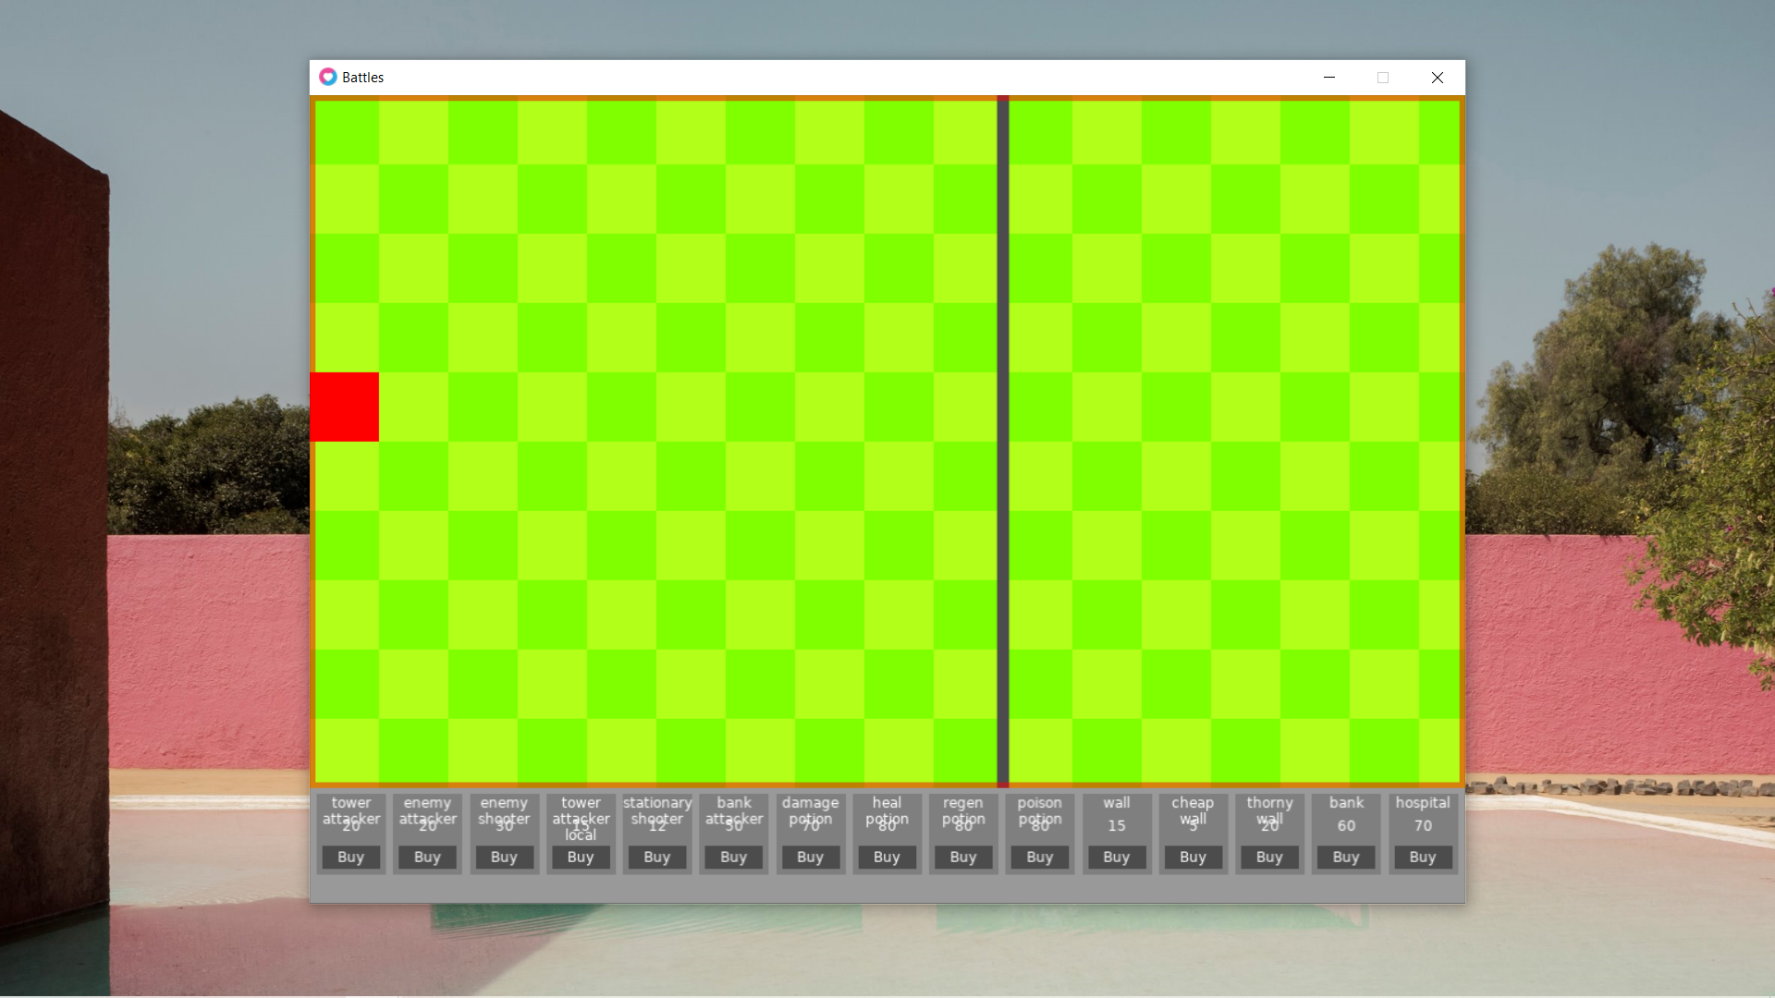

At the moment, there is no way for the user to exit this purchasing mode.

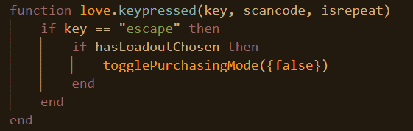

What this function does is listen for any key presses. If the escape key is pressed, and the game has chosen a loadout, the purchase mode is toggled off.

## Placing an item

Now, what’s needed is for there to be a grey square or indicator hovering over the map when the user is in purchase mode and is choosing where to place.

Again, firstly, the variable for this entity needs to be initialised.

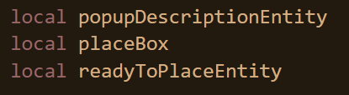

Next, the entity is initialized once the loadout has been chosen.

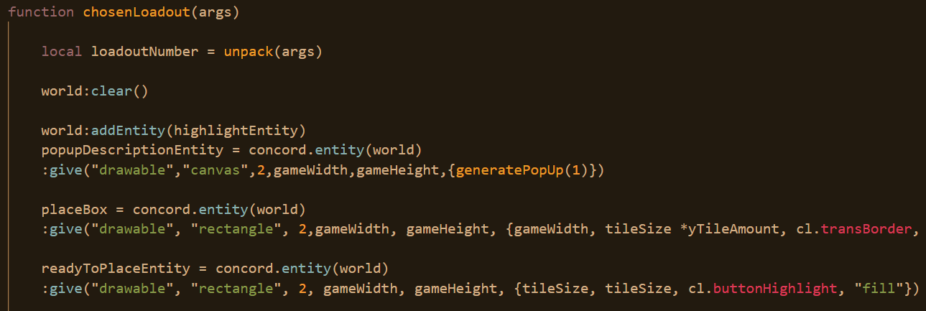

For the moment it is being kept off the screen. Now, a function needs to be created that determines where to place it on the screen. But before this, a function is needed to get the tile number from the x and y coordinated.

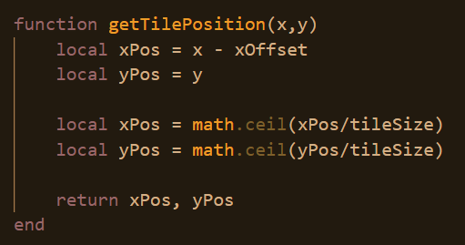

What happens is that the offset is accounted for in the cursor position. From here, with this adjusted position, the tile position is divided by the size of the tile to give us the tile location but this is automatically rounded upwards to the nearest whole number. For if rounding down were to happen, then the first tile would be 0 due to the fact that the position would be less than the tile size.

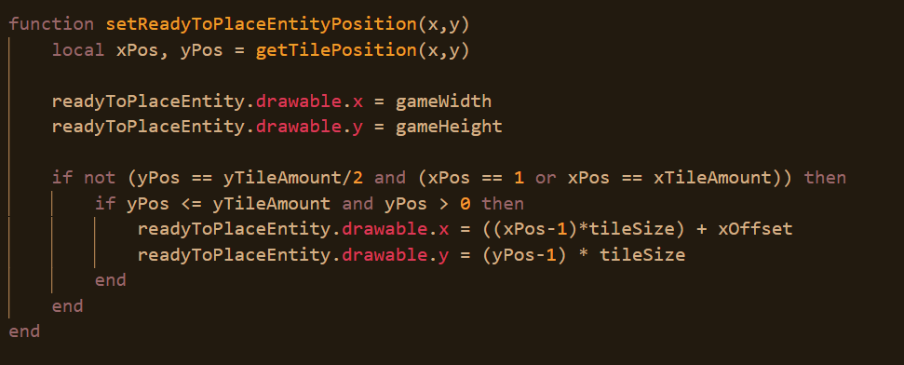

By default, the entity will be moved off-screen. First, a check is made to see if the coordinates are not that of the two red towers on either end. If so, then a check is made to see that the y coordinates fall under the correct bounds. The reason that this is not done for the x coordinates is that they operate the entire screen whereas vertically speaking, there is a menu at the bottom of the screen.

Every time the mouse is moved and the user is in purchasing mode, the location of the highlight needs to be updated.

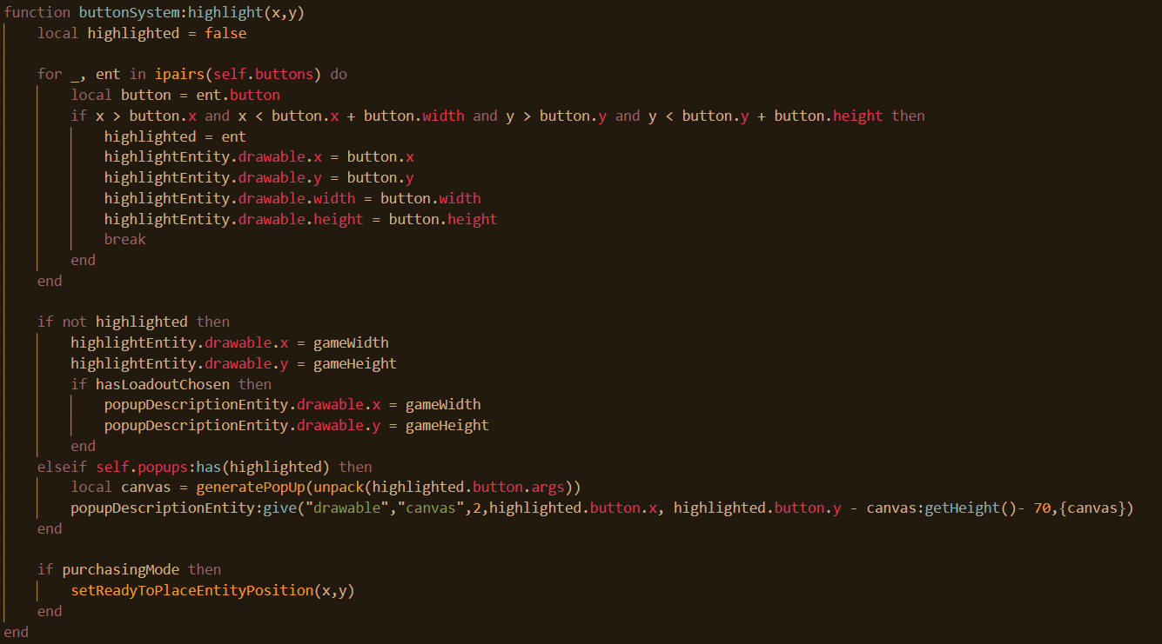

Here, it is updated at the end.

Next, every time the user pans around the map, the position again needs to be updated.

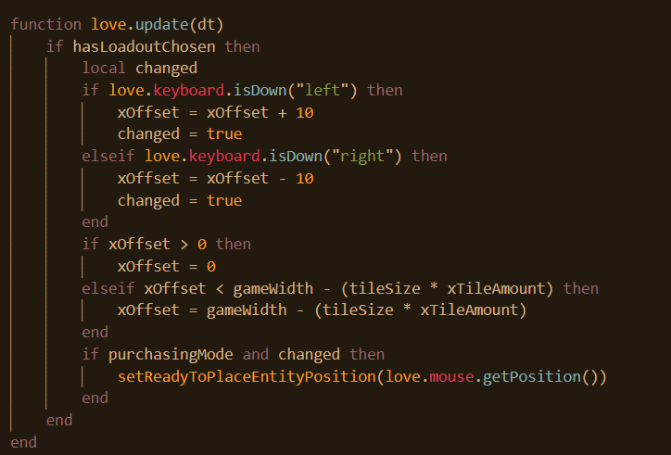

Now, whenever the user is in purchasing mode, and pans, the location is updated.

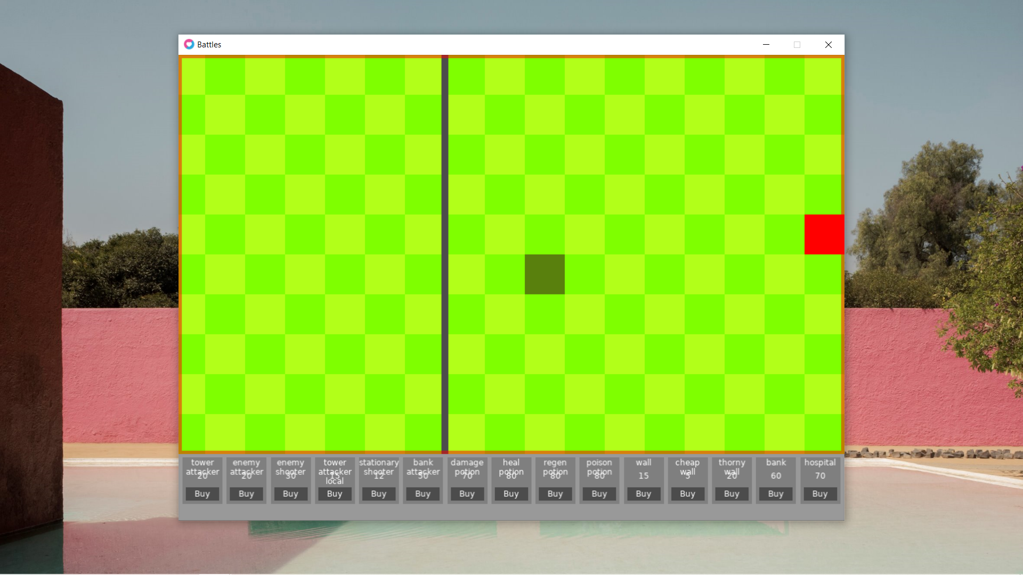

It can be seen that there is a grey highlight on the tilemap.

One final thing, once the user presses escape, the grey highlight needs to move away like the red box does.

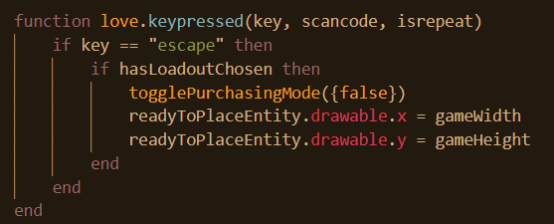

Now, it’s time for the entity to actually be placed. First of all a 2d array is needed to contain the location for every entity.

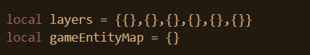

Next, once a loadout has been chosen, all the rows inside of game entity map need to be added in order to construct the 2d array.

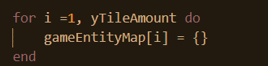

To purchase an item, a player’s cash needs to be subtracted. To subtract a player’s cash, it needs to be copied over when the loadout is chosen.

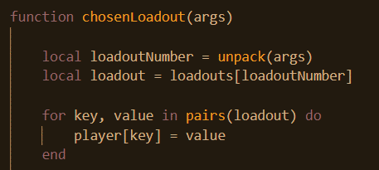

Here, all the loadout stats are copied over and saved in a table called, which is declared here.

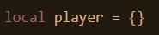

Next, the check click method of the button system needs to amended to account for the fact that the player may be placing down an item.

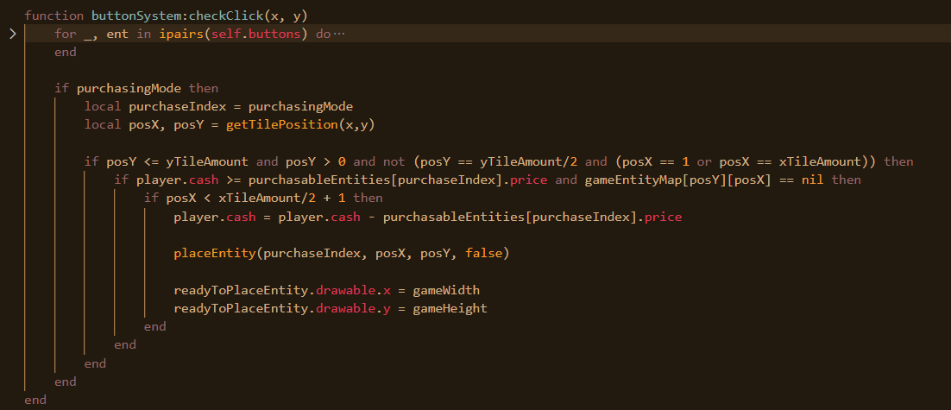

A check is made to see if the user is in purchasing mode or ready to place down an item. If so, then a check is made that the user is placing within the write tile coordinates, so not off the map and not off the coordinates. A check is also made that nothing exists in that location already. Another check is made to see to that the user is placing down in their own half. Once that this is all deemed to be the case, the cash is subtracted, the ready to place entity highlight is removed and the entity place function is called. Its arguments are the index, or the code for the item that is to be placed, it’s x and y locations and the team that it going to be placed on. By default, the team is false since the player is on the left.

Before, going into detail about the place entity function, first it is necessary to create and load the location of all the images onto the corresponding entities. Firsts, the images need to be created.

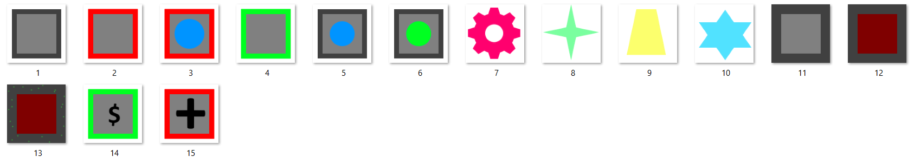

This is what they will all look like. These were created using paint.net as that is an image editor that isn’t too difficult to use.

Next, at the end of the loadout chosen function, the code is amended so that the image is loaded onto the list of purchasable entities.

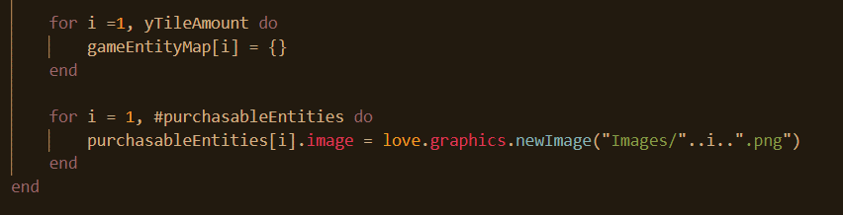

Each entity gets a new property with that being the image and an image file is loaded onto the image.

Next, this image needs to be able to be displayed and accommodated with the drawable component and method.

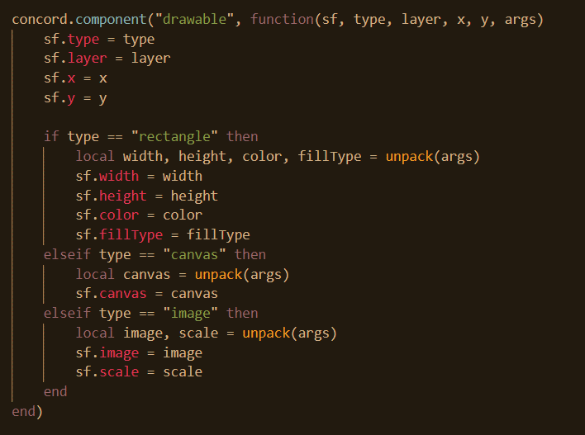

Now, an image can be passed as an argument and its image and scale values will be made as properties. This needs to be able to be drawn as well. The scale property is so that if need be the image can be reduced or enlarged in size.

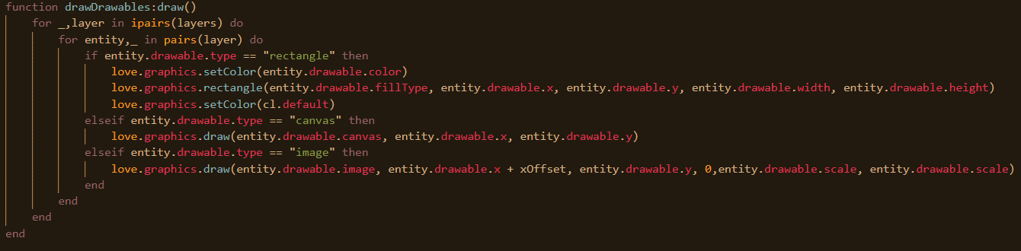

Now the image is drawn. It should be noted as well that since the only purpose images are going to have in the game is as placeable characters, the position is going to be adjusted with x offset. The 0 signifies the rotation, which is always going to be 0 for every image for the foreseeable future.

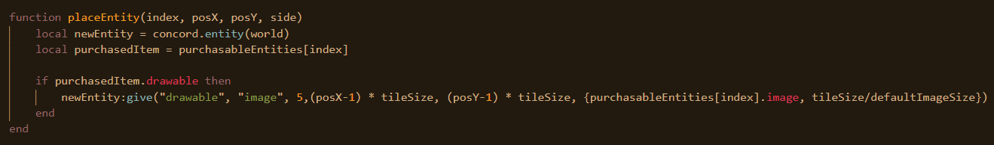

Now, back to the place entity function. If the image is drawable, then the drawable component is assigned to it. The image needs to fit into the tile so its scale is going to be the size of the tile divided by the size of the image itself.

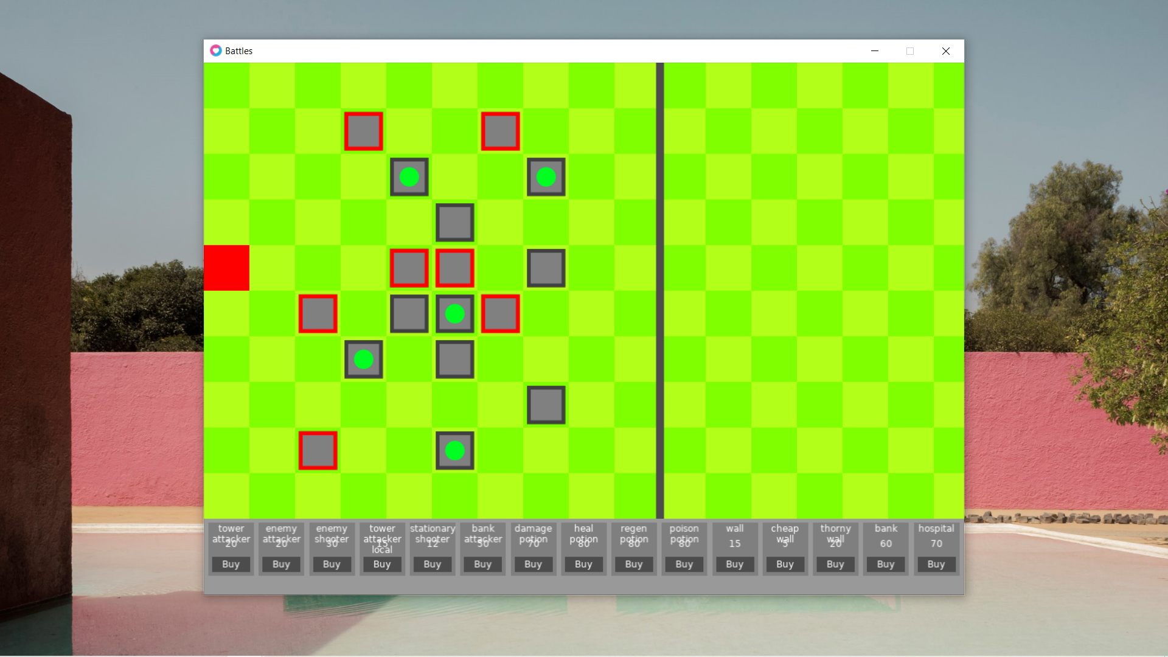

The above is an assortment of entities being placed down. There are a few more things that need to be done at the moment. First of all, the user cannot see how much cash, or health he has. This is quite a simple ordeal.

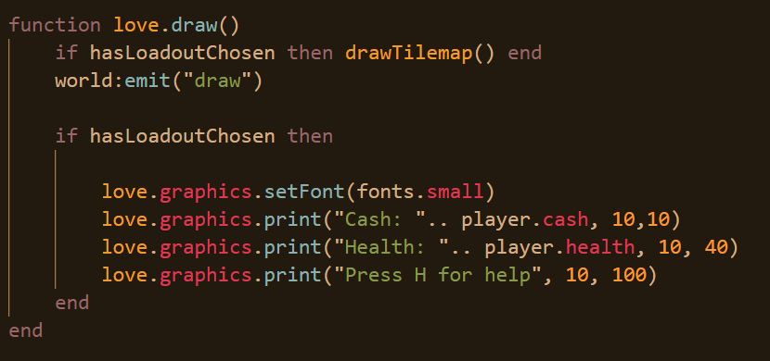

This is all drawn last as well since it needs to appear over top of everything. The output of this is the below.

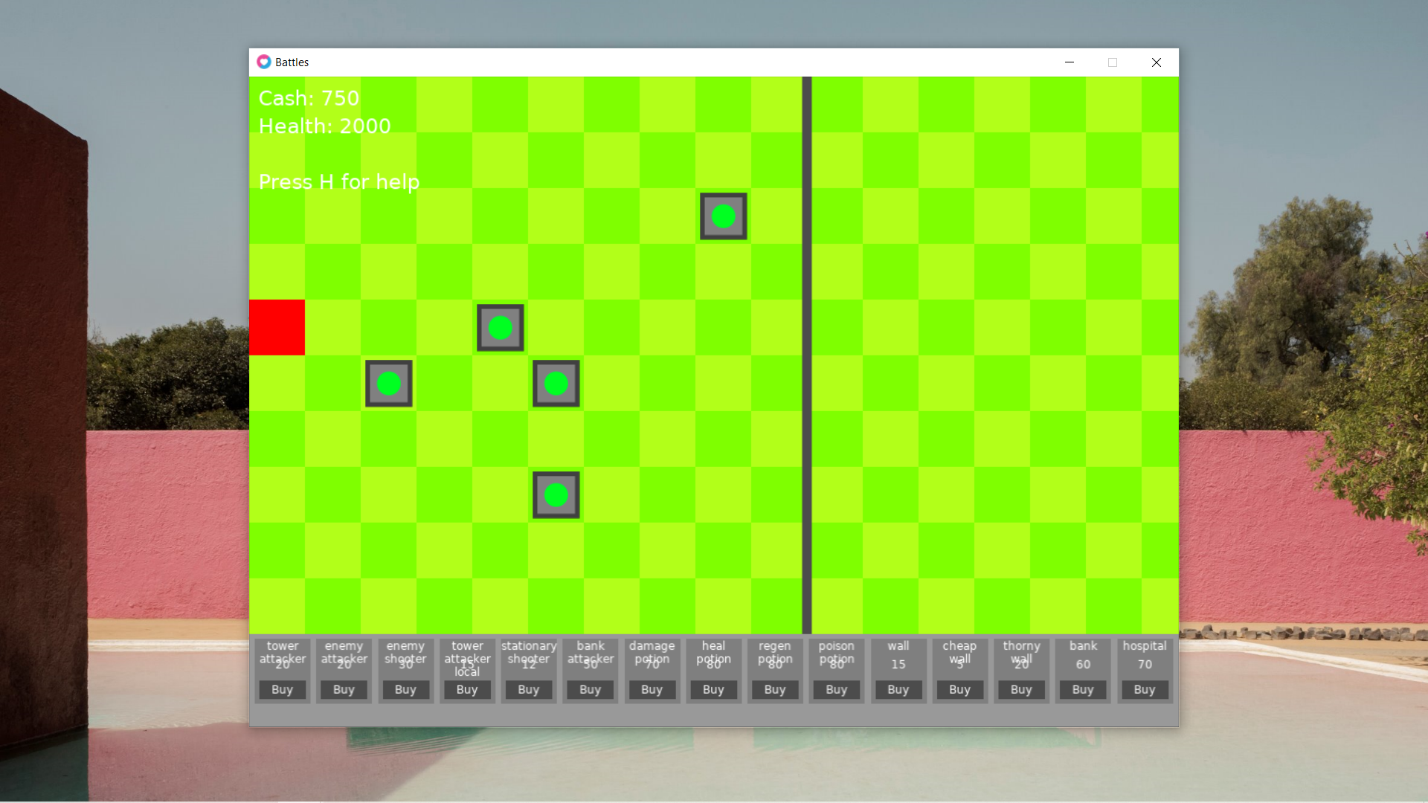

The next thing to do is make the help text actually appear when the user presses h. First of all, it is necessary to make the help canvas. First, it is necessary to initialise the variable.

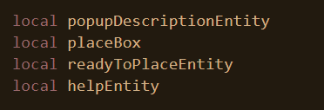

Next, the canvas needs to be made.

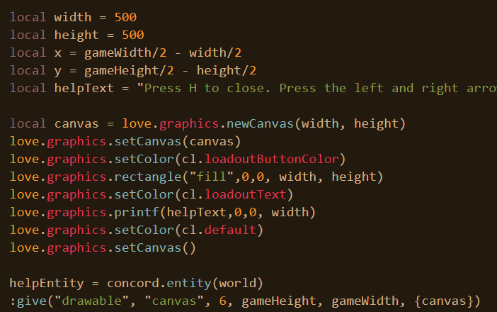

The canvas appears in the middle of the screen with dimensions of 500 and 500. It merely consists of one string of text that describes everything that you need to do in the game. A canvas is created with a particular colour filling the entire canvas. Then, the text is printed with the width being supplied as an argument to indicate that the text wraps. Then a drawable entity is created to appear off screen for the moment.

To enable or disable, a variable is needed to keep track on whether or not it is open.

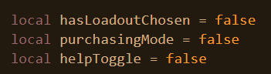

Next, a function is needed to toggle the help on and off.

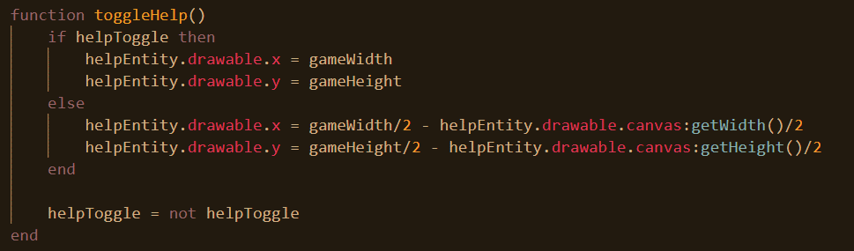

Here, if the toggle is already on, the entity is moved off screen and if it is not already on, it’s moved off. Then it’s switched to be on or off based on what it already was.

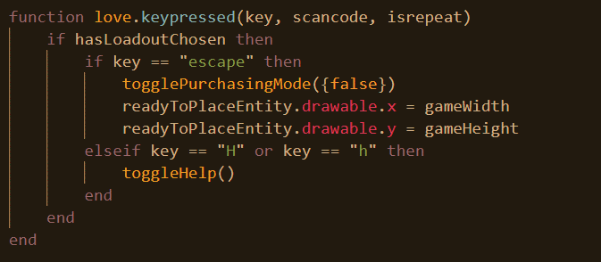

Now, whenever the user presses h after he has chosen his loadout, the canvas is toggled on or off.

The below is the final product.

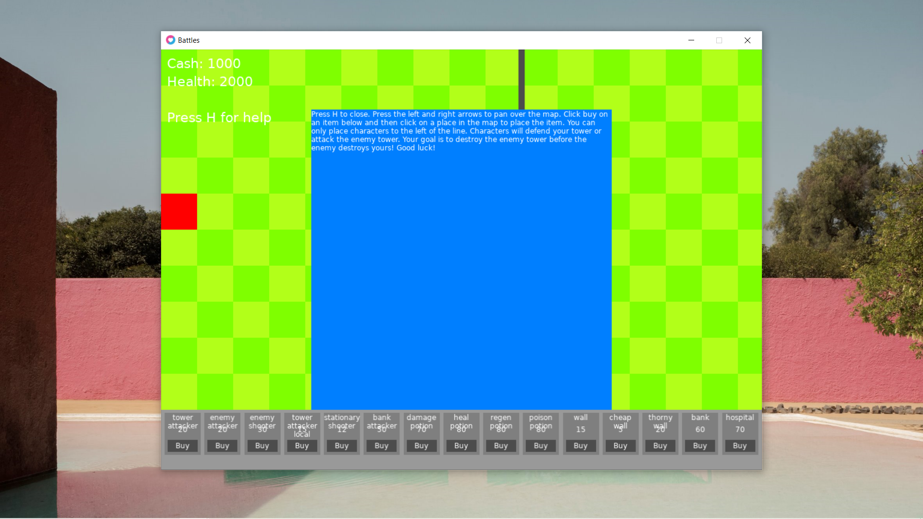

Stage 2.2 – Networking the game

Again, for the networking side of things I’m going to be using a socket library. The one that I am using here is called LuaSocket and it exists as a folder in my library.

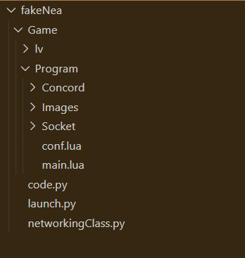

Next, I’m going to create a file and a class that my main game can use to interface with the networking library. The fill will be called.

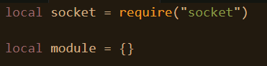

The socket library is imported and a module variable is created. This hasn’t been mentioned already but there’s no such thing as built-in OOP in Lua. This has been implemented previously in this project, but tables are very versatile and they can be created to mimic classes themselves. Tables can store functions and variables enabling for the grouping of functions and data and this has been used in the project previously.

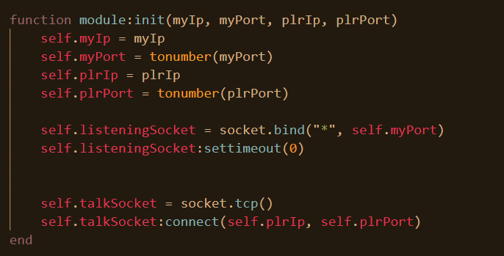

Now, it is seen that the port, and IP of both the player and enemy are passed as arguments. A listening socket is created that listens in to the particular port passed in for the user. Its timeout is set to 0 meaning that any time it tries to listen it’s not blocking. Next a TCP socket is created and attempts to connect to the other player.

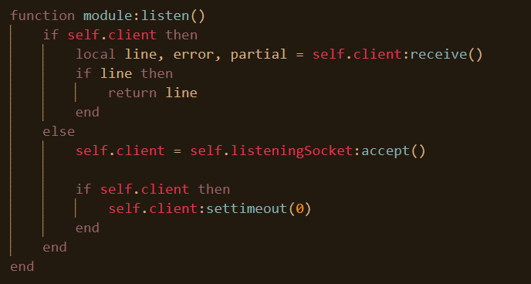

The listen method is added to the module. When it is called, a check is made to see whether the other user is connected. If so, it tries to receive any messages sent and will return then. Otherwise, it tries to connect to the client.

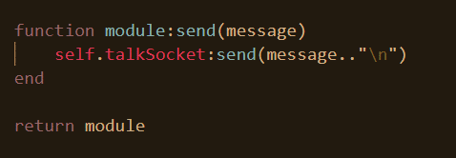

The end here is relatively simple. When the send message is called, the message is sent. Finally, the module or class is returned when this file is called.

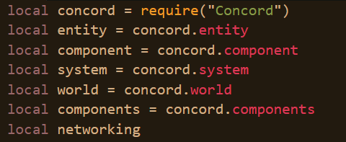

A networking variable needs to be initialized at the beginning of the program.

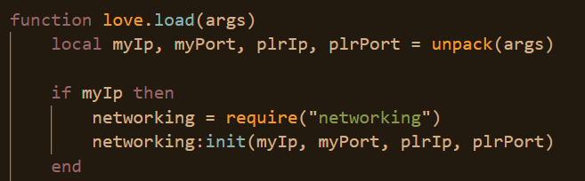

Then, the arguments that were loaded into the program are initialized. The networking module is loaded in and initialized.

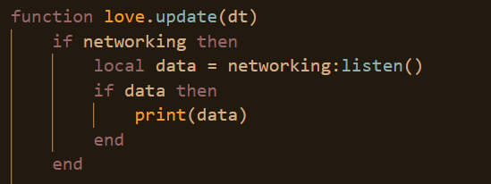

Every time the game updates, the game tries to listen for anything sent by the other player. If anything was sent it is printed out.

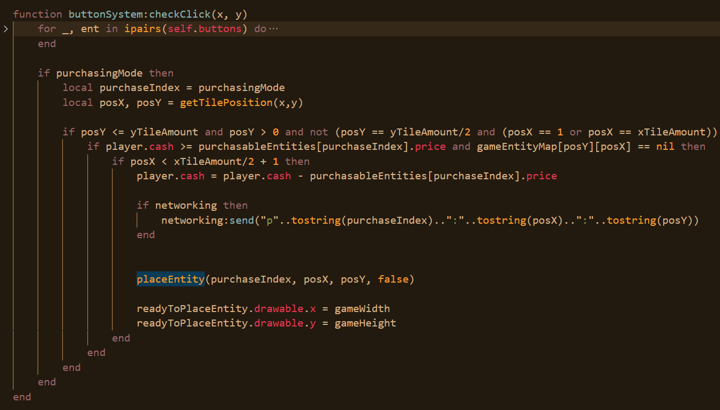

Whenever an entity is placed on the user’s side, they tell the enemy of it. A check is made to confirm that the class is loaded and they send a message prefaced with p to indicate that something has been purchased and then the x position and then the y position. All of these are separated with the colon.

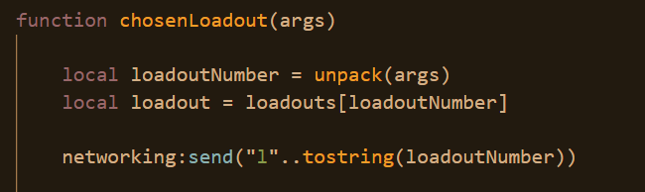

Finally, when a loadout is chosen, a message is sent prefaced with l. The l is to indicate loadout and then the number loadout that has been chosen. The reason that this needs to be communicated is that different loadouts have different attack multipliers and this needs to be accounted for later on. Secondly, the game is not meant to start until both enemies select a loadout.

When receiving a purchase message, the game updates updates.

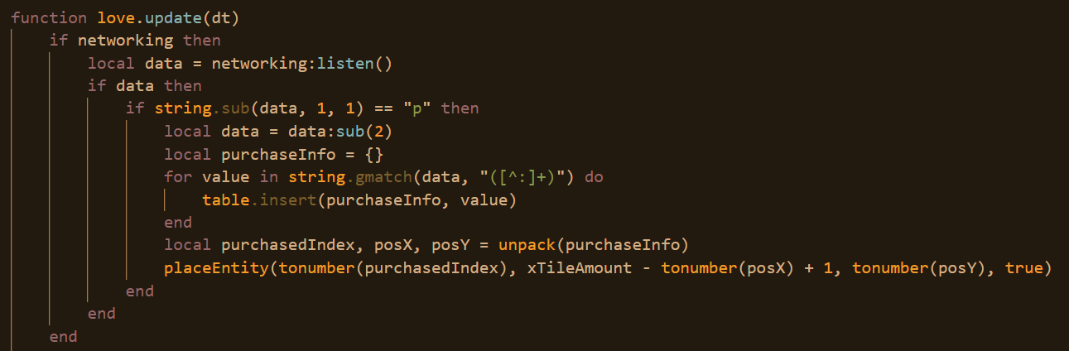

First it checks the message code, it’s p. Sub splits the string and removes the first characters tarting from the second. Next, a regex is applied to the string splitting it so that the program is iterating through each “phrase” separated by the colon and these values are being inserted into a temporary table.

Then, place entity is called and the entity is placed on the opposite end of the map.

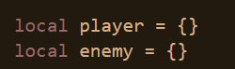

In a similar way to how a player has a set of stats determined by their loadout, so too will the enemy.

Again, the game cannot start before both the player and the enemy have chosen their loadouts so a variable is needed tracking whether the enemy has chosen a loadout or not.

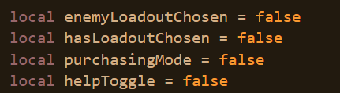

The following code is what happens when the user receives a loadout message from the other player.

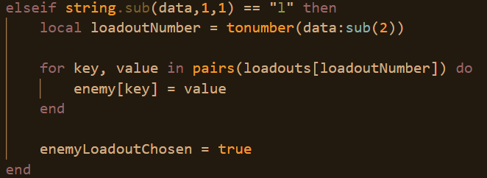

The enemy loadout values are copied down and loadout chosen is made to be true. Again, the game must not start until the both the enemy and the player have chosen a loadout.

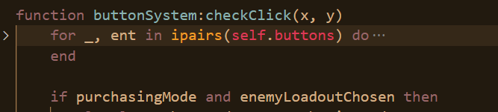

When the user clicks on the tile map, alongside checking that the user I s in purchasing mode, a check is also made that the enemy has chosen their loadout.

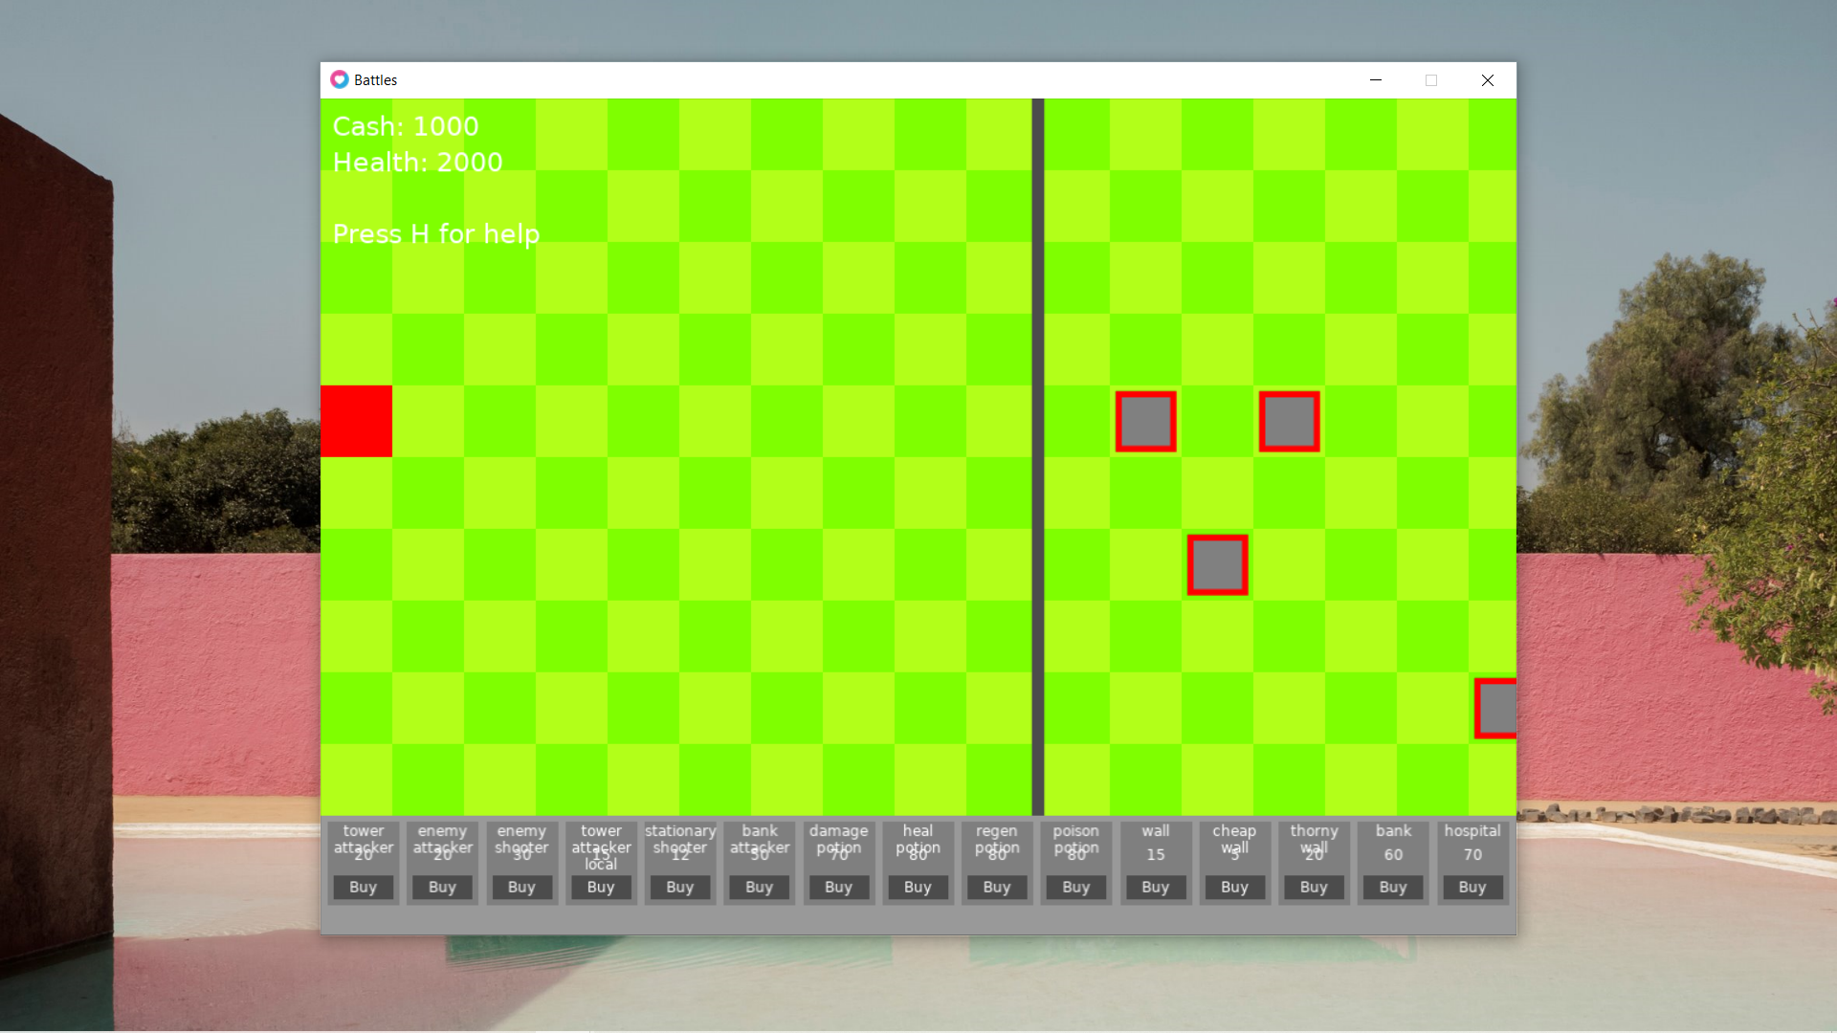

It can be seen that the enemy user has placed a series of enemy entities on his side and now they are appearing on the other side of the user.

## Review

In this stage, what is displayed is a list of entities that the user can now buy, there is interactivity involved in that the user can hover over a particular item and learn about the item to help determine if they want to buy the item. Then, the user can click place on the map to place it on the map. As of this moment, the items don’t move or perform any functions, they just sit on the map. Additionally, the user is able to pan around the map and see everything that is happening and he can press h for help.

* The game will be 2D top-down (aerial view)
  + Pressing the WASD keys moves the camera leftwards or rightwards, up or down based on what key is pressed
  + There will be a dividing line in the middle of the map to designate each side
  + Enemy tower will be drawn on each side of the map for each corresponding team
* On the bottom of the screen, there will be a menu for a selection of “character” that the user can buy and place down
  + The program checks that the user is able to afford the character before allowing the user to place it down
  + The user clicks on the entity to tell the program which entity he wants to place down
  + When the user clicks on a place in the map, the entity is deployed
  + I aim for there to be 15 unique entities
    - Each entity has a purchase price property

The above are the success criteria that has been met.

# Stage 4 – Item Interact

## Component set-up

Now the entities will be made to move and attack. Before this all happens, they need to be configured with the correct components. At the moment, the only components that the entities have is drawable.

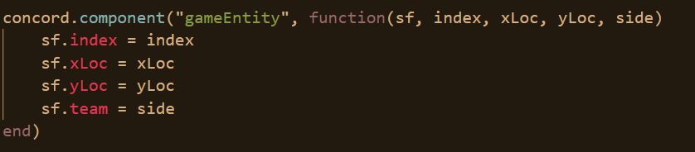

Every entity has a game entity component. This is their location, and their team.

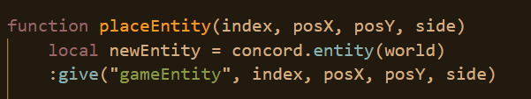Here, this has been added inside of place entity.

With regards to enemies on the other team, to distinguish them, it would be desirable for the image to be filtered with a certain colour so it looks different.

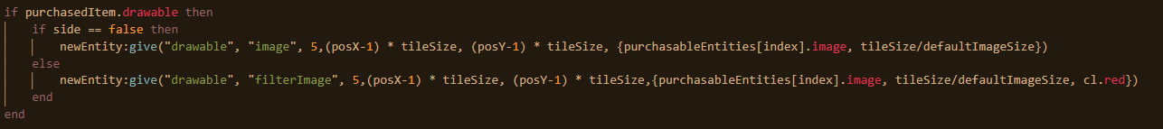

If an entity is on the other team, it will still be a drawable, but it will have a filter image type which has the additional argument of filter colour. In this case, it’s going to be red.

The filter is correspondingly added to the component initialization.

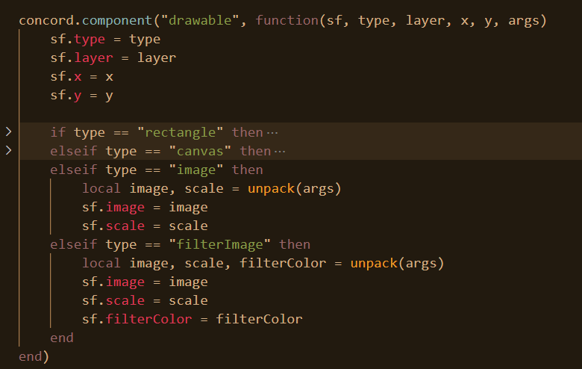

As well as the drawing.

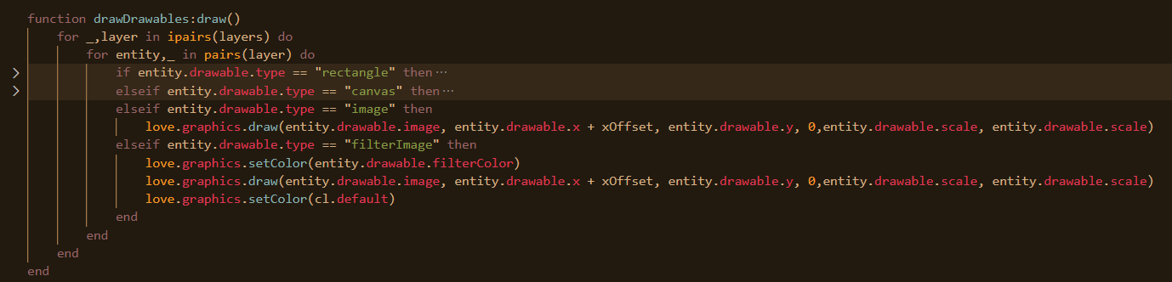

Now all that is different is that a specific colour is set before doing the drawing to cause the colour to become filtered.

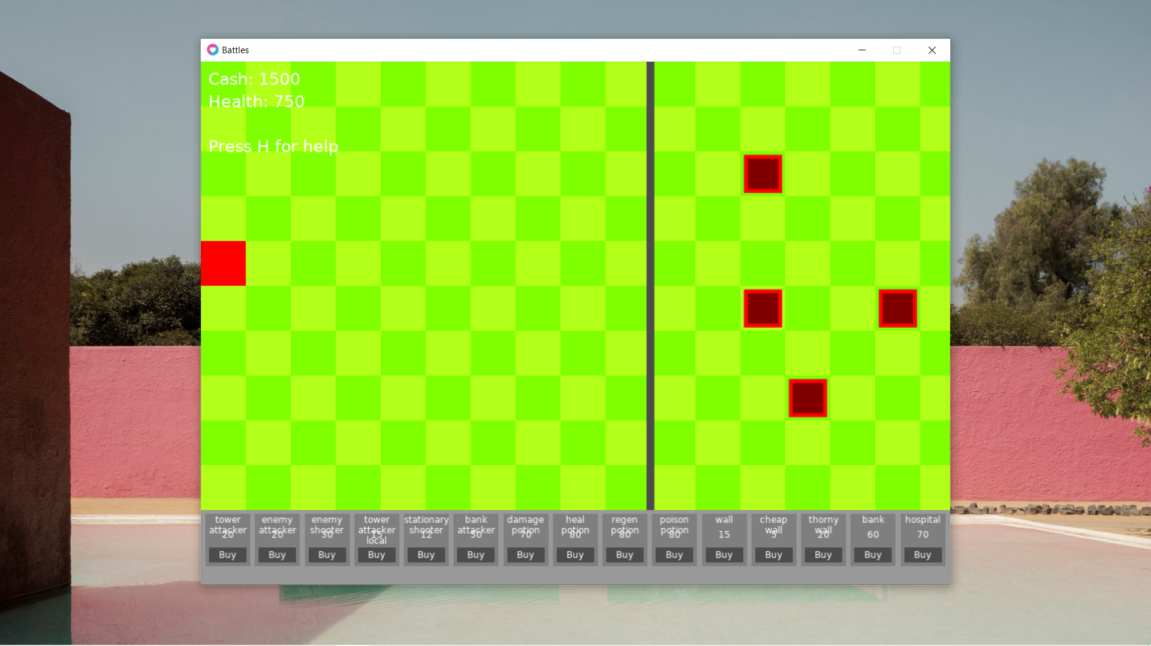

It can be seen that the enemy entities are tinted red.

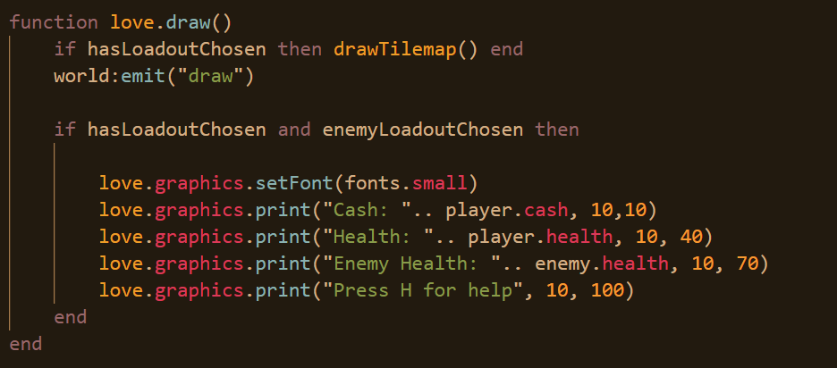

It should also be noted that now the enemies health can be seen once both players have selected their loadout as seen below.

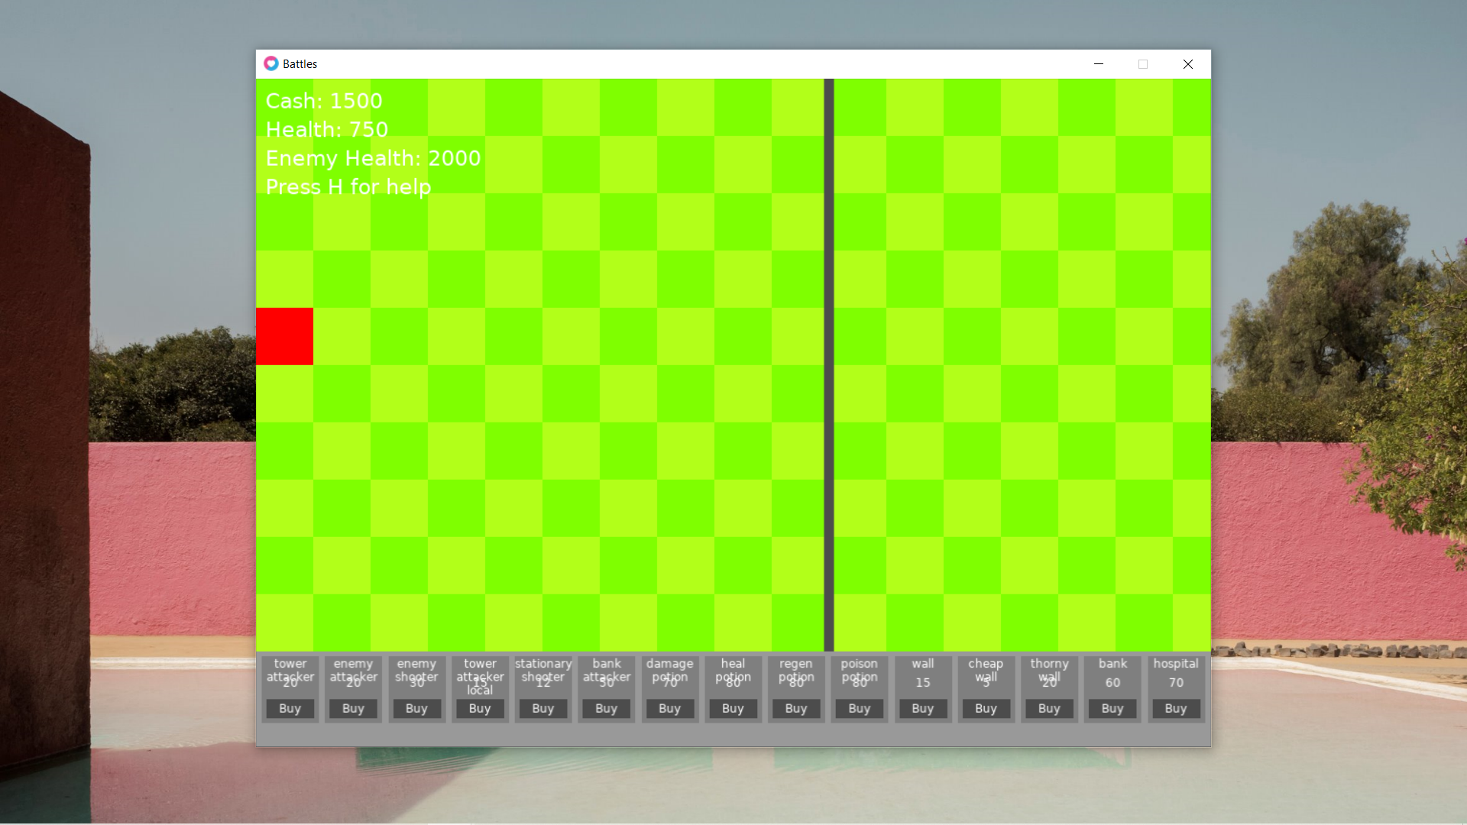

Next, a pathfind component is needed for those entities that will move towards a specific target.

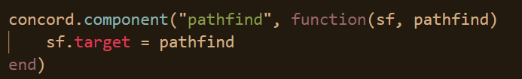

The implementation of this within place entity is relatively rudimentary.

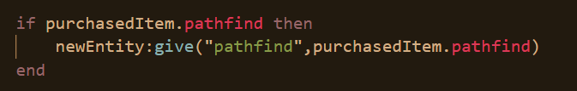

Next, is for items that attack.

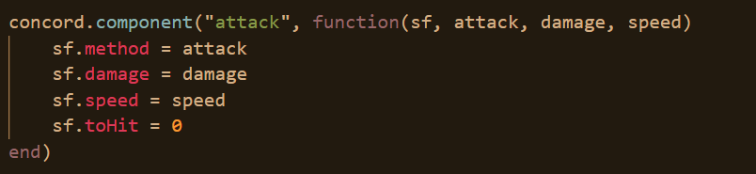

All items that attack have an attack method, a damage amount, a speed and the to hit value which is the time since they last hit an object. This is compared to their speed to decide on whether or not they can hit again.



Again, the implementation of this is simple inside of place entity. As are the implementation of all the remaining components which will be posted now.

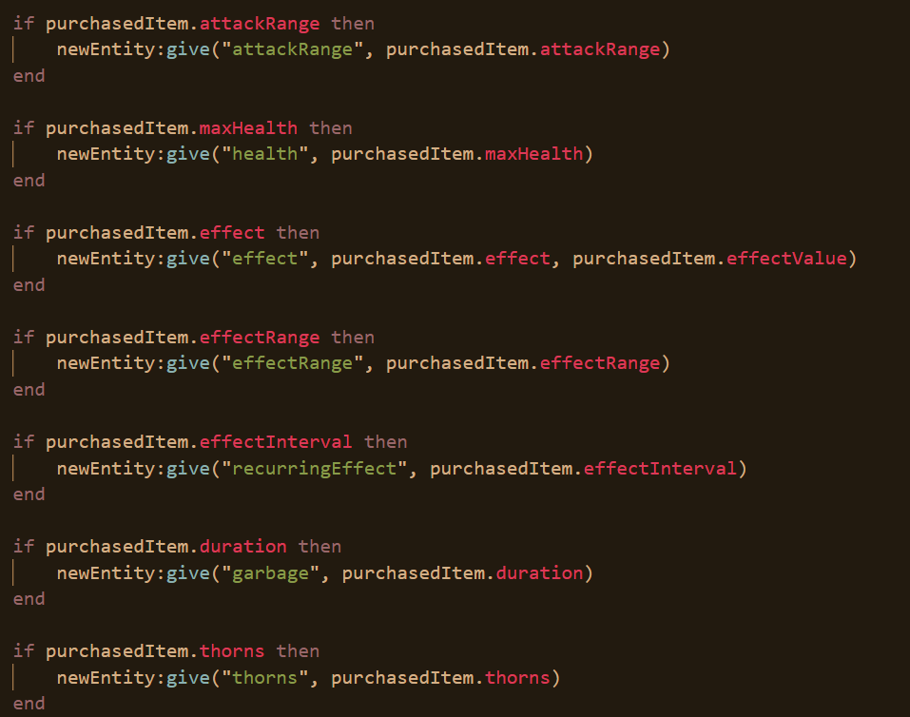

Each component will now be detailed.

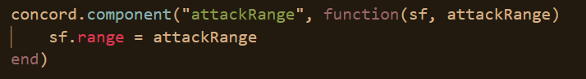

Whilst some components attack, fewer have an attack range. Which is to say, that they can hit enemies at a distance and not just those which are adjacent.

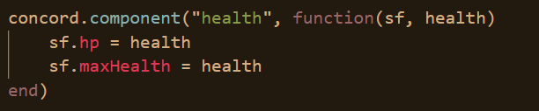

Some entities such as potions that increase health don’t have a health component whilst the majority do. There are two aspects, the health, and the maximum possible health. The maximum possible health is what the entity starts at and what regeneration potions are able to increase the health up to.

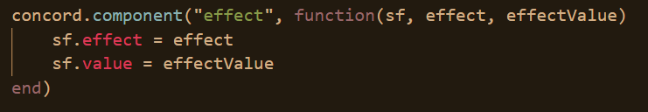

Potions are described in the code as effects. These effects can do a range of things primarily increasing, decreasing health, and increasing cash. There is a magnitude in each of these effects which is stored in its value.

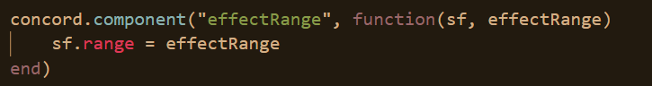

It is the potions that have an effect range. They affect all entities in their vicinity, whilst stuff like hospitals and banks, just increase the tower health and player cash, they have nothing to do with vicinity.

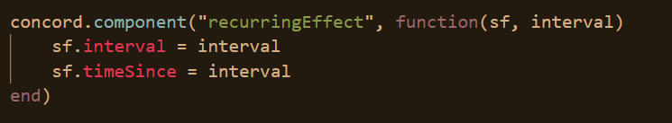

Some effects cause damage once and are done but some effects such as poison continue to cause damage for a series of seconds.

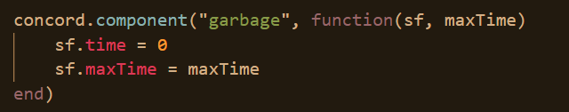

After a series of seconds, some potions will be removed, that’s why there is a garbage property to monitor how longer these entities have left to be removed.

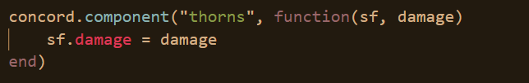

Finally, thorns are primarily found with certain walls that cause damage to the attacker when they get attacked. They have “thorns”.

Now for the systems.

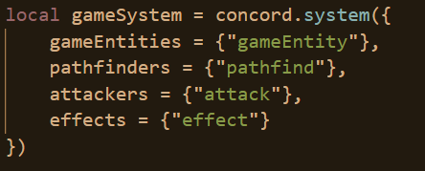

This system manages all entities that are in the game. This doesn’t apply to UI elements or anything else.

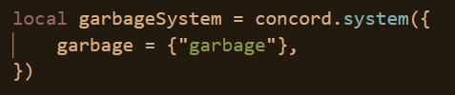

This system is responsible for throwing away or removing all garbage that has stayed surpassing its time.

These systems need to be added to the world once the loadout has been chosen.

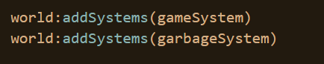

Now, it is necessary to implement the code related to the game system. Before that can be done, it is necessary to create a table storing both entities on my team and entities on the other team. This is needed so that when they are trying to find an enemy later on, they can easily iterate through a list of enemies.

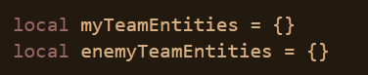

Now, one can initialise game system so that whenever an entity is added to the system it automatically gets added to their team’s entities group.

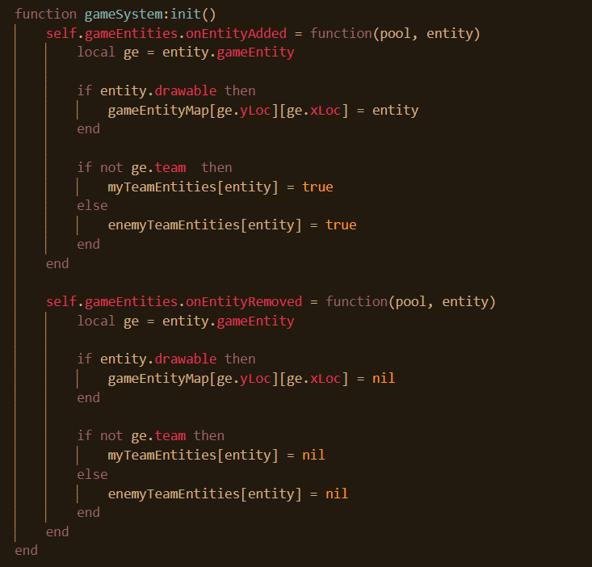

This code is self-explanatory and is similar to the code earlier where all drawable UI elements were added to the layers from which items were drawn. Furthermore, now items are added to the game entity map or the grid of items that contains the location of every item in the game. It should be noted that only drawable items are added so stuff like potions that don’t have anything drawable per se to them are not placed there. This allows for other potions and normal entities to be in the same location.

## Pathfinding and damaging

Now enemies can begin pathfinding. Before that starts however, firstly, they are going to be pathfinding after a set interval, not every time the game updates so the time since the last pathfinding session needs to be stored.

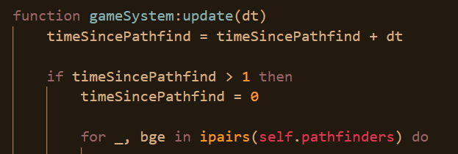

Every time this method runs, the time since the last pathfind is updated. If the time exceeds 1, the rest of the code can run and it is reset. Next, the program iterates through all game entities that can pathfind.

Before continuing, first it is necessary to create a pathfinding algorithm. But before a pathfinding algorithm can be created, an algorithm to get the distance between two points is needed.

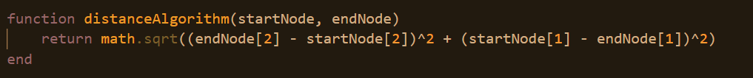

This algorithm is a standard algorithm so won’t be explained.

For pathfinding the A* algorithm will be used as it applies heuristics and doesn’t search through every possible route. This will save time as it is possible a large number of entities could be pathfinding.

When pathfinding, since the map changes every time, the entity needs to move, a new pathfinding path needs to be generated every time the entity moves. So, a whole path isn’t necessary to be generated when pathfinding, rather just knowing where the next step would be fine.

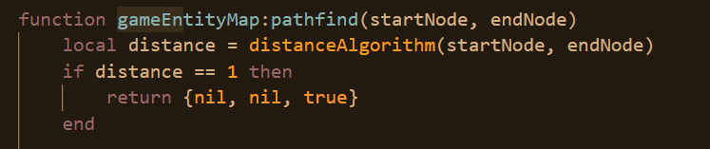

To begin with, the algorithm ends completely if the entity is one step away from the destination, returning true is the 3rd value to indicate that the entity is at the footstep of its destination.

Pathfinding algorithms typically end with telling the last step to the destination, however, it is more desirable to know in this program, the first step towards the destination, so the start and end value are to be swapped.

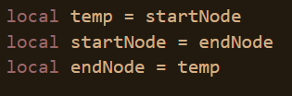

Next, a temporary map is created which contains the location of all the obstacles or every other entity on the map.

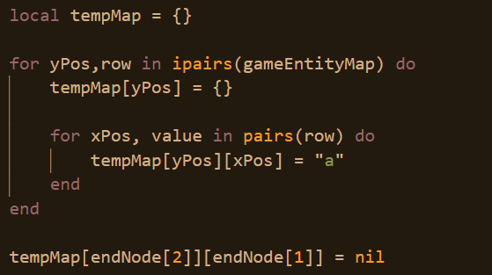

This is the bulk of the algorithm.

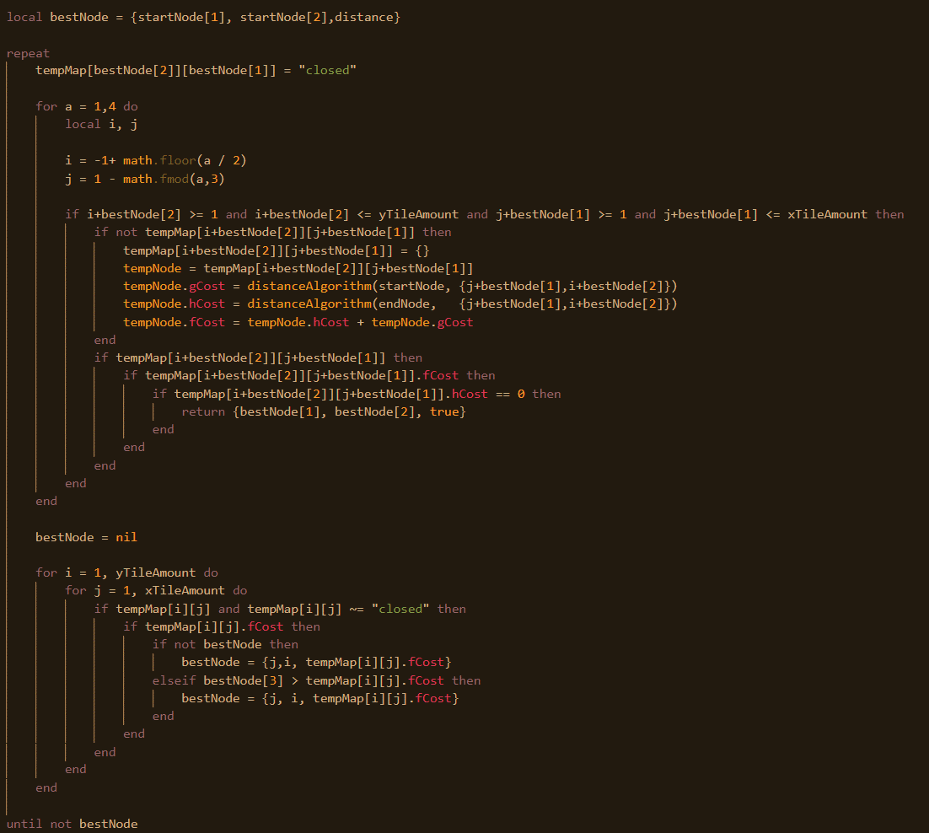

The algorithm starts at the end, which has been renamed to the start, and declares the end node to be the best node. Then it closes this node on temporary map and iterates through all it’s adjacent cells, ensuring that the ones it’s looking at are on the map and are not obstacles. Here, it determines the g cost, the distance from where it is to the end, the h cost, the distance from where it is to the start and sum or the f cost. If the h cost is 0, that means that the best node was 1 away from the start node.

The end node has pathfinded all the way back to the start node. So, the right direction towards the end node, is going onto best node.

If this isn’t the case, then the program iterates through the entire tilemap and finds the tile with the lowest f cost. If nothing is found, the repeat is exited and the program returns what is below indicating that there is no way to pathfind towards the destination.

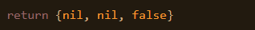

When an entity tries to pathfind towards the tower, first it tries to see if there is a route. If there is, it follows the route, if there isn’t, it just moves towards the tower until it reaches an obstacle and it stops there until the obstacle is removed.

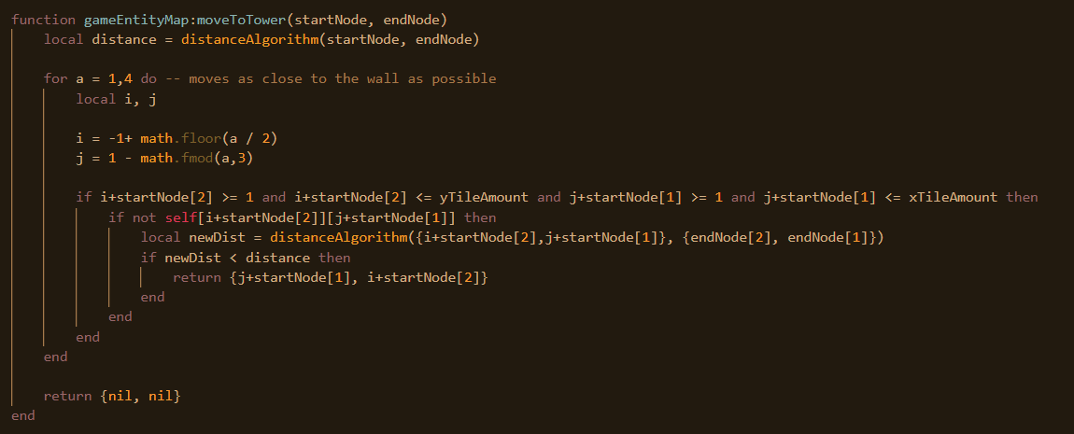

This method first checks the distance from the start node to the tower. Then, it iterates through it’s 4 adjacent cells and tries to determine if any of the adjacent cells are any closer to the tower than the current cell. If so, it returns the coordinates of this cell.

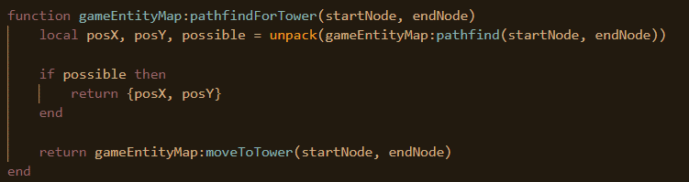

This is the function that causes objects to pathfind towards the tower. First, the entity tries to find a possible route, if there is a possible route, it follows the route towards the tower, if there isn’t it just tries to move as close as possible to the tower.

Before being able to pathfind to a particular enemy, first you need to find the closest enemy to you which isn’t a problem with pathfinding towards a tower because there is only 1 tower.

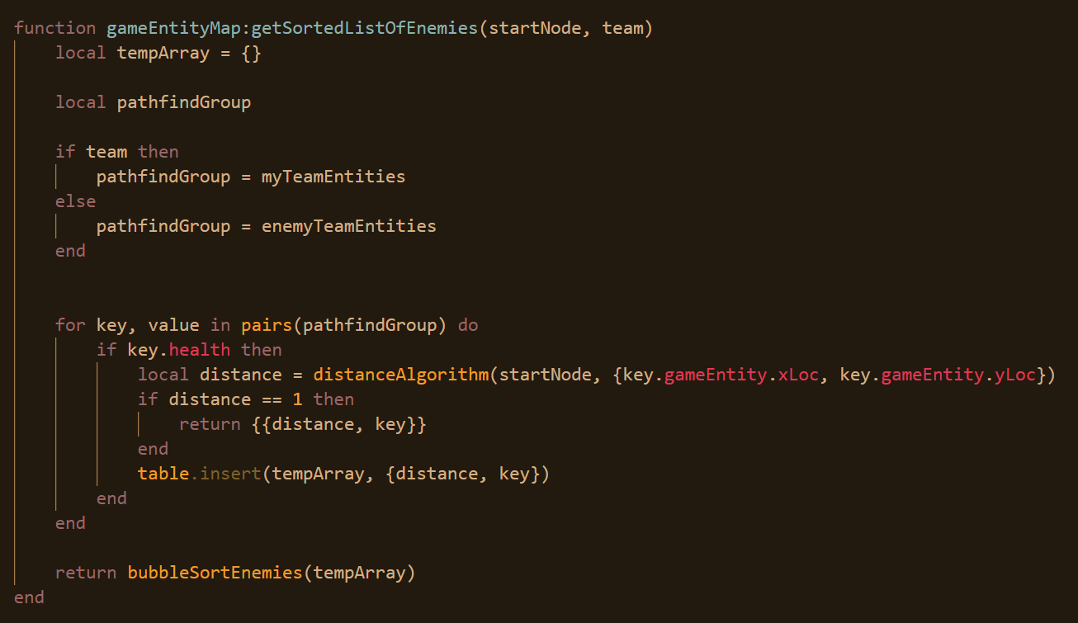

This method gets all of the enemies firstly, that have a health property, that are inside of the opposite team. Then, this table of entities will be sorted using bubble sort. I won’t commentate on the function as again it is a standard algorithm.

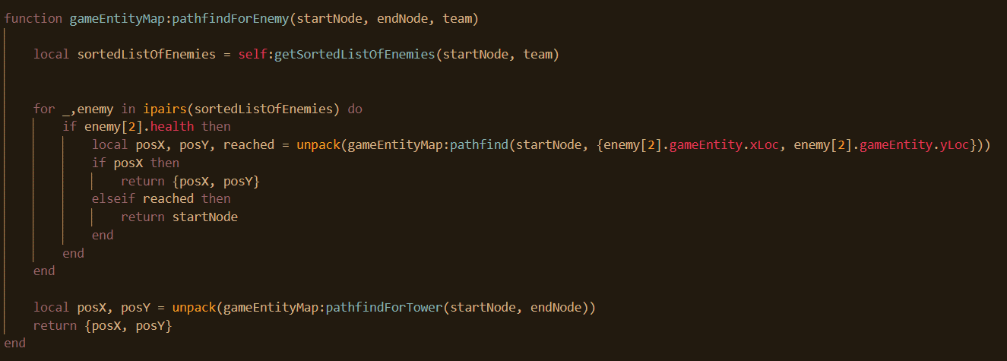

When an entity tries to pathfind for an enemy, it iterates through the sorted list of enemies. It tries to pathfind to each enemy, if it can’t do so, it moves onto the next one, if it can, it returns the place to move to. If it can’t pathfind to any enemies, it pathfind to the tower.

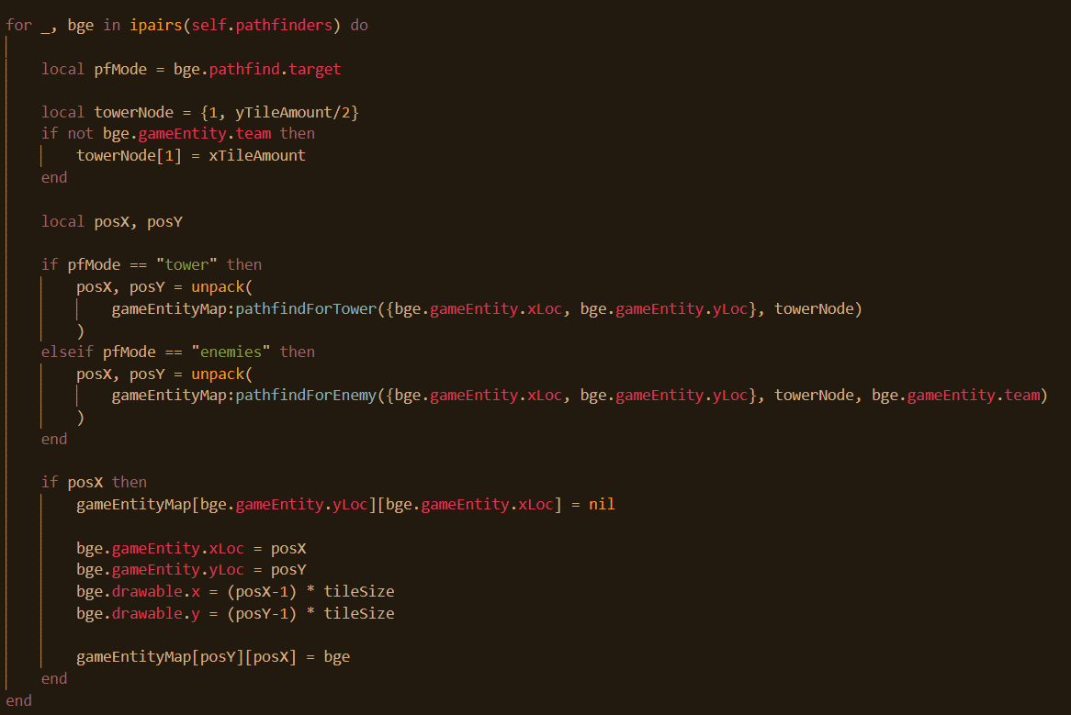

Back to the main function, if an entities pathfind mode is towards the tower, it will move towards the corresponding tower. If towards the enemy, it finds and move towards an enemy. Once it changes its location. Once this is done, it updates its location inside of itself, on the game entity map and it’s drawing position.

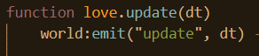

This calls all systems in the world that are listening for the update call.

Now that all entities that have the capacity to pathfind are pathfinding successfully, the focus can now shift on making entities attack. First of all, however, an algorithm is needed to get any enemy that are in immediate vicinity.

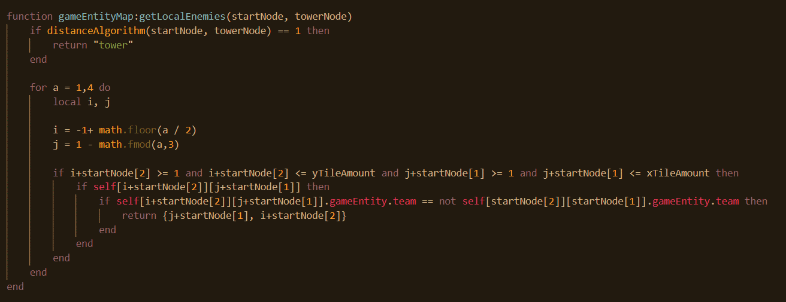

In this algorithm, if the entity is next to the tower, it just ends there and it is expected that the tower will be attacked. If not, it iterates through it’s 4 adjacent cells, and tries to find any entities not on the same team as the entity in question. If it does so, it returns and the algorithm is done.

This is only going to be useful for enemies with the attack type of melee meaning that they can only attack those which are adjacent to the cell. Otherwise, if this is not the case, another algorithm is needed to get an entity within a given range.

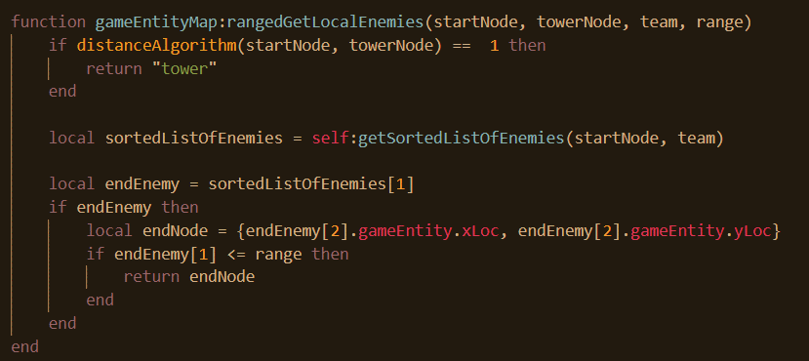

Here, a range argument is passed through. Again, a check is made to see if it is up against a tower, if so, it will attack that instead. Otherwise, it gets a sorted list of all enemies and if the first item on the list is within the range, that item will be returned.

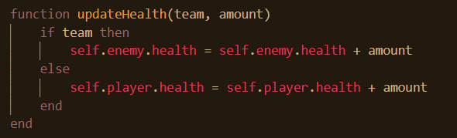

This function changes player or enemy health based on the amount given.

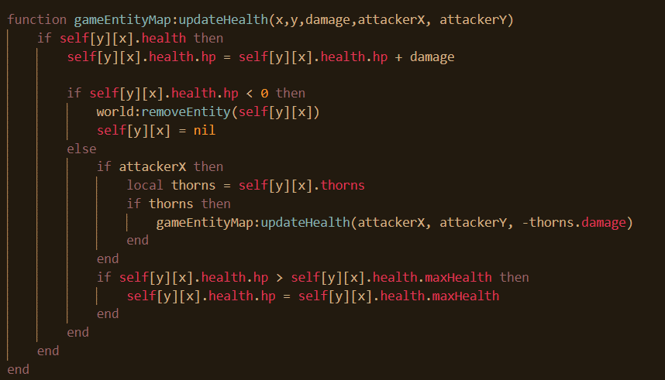Next, this method updates the health of entities. If the entity has a health property it is updated. If this becomes less than 0, it gets removed however, if it exceeds its max health, it gets capped back. The attacker x argument will be passed for items that it is desirable to have the thorns action applied. Thorns is a property of some walls that causes the walls to damage back when attacked. If a potion were to attack a thorned wall, one wouldn’t want the potion shouldn’t be attacked so it wouldn’t be passed as an argument there. If thorns exists, the method calls itself again where the method can cause damage to the enemy.

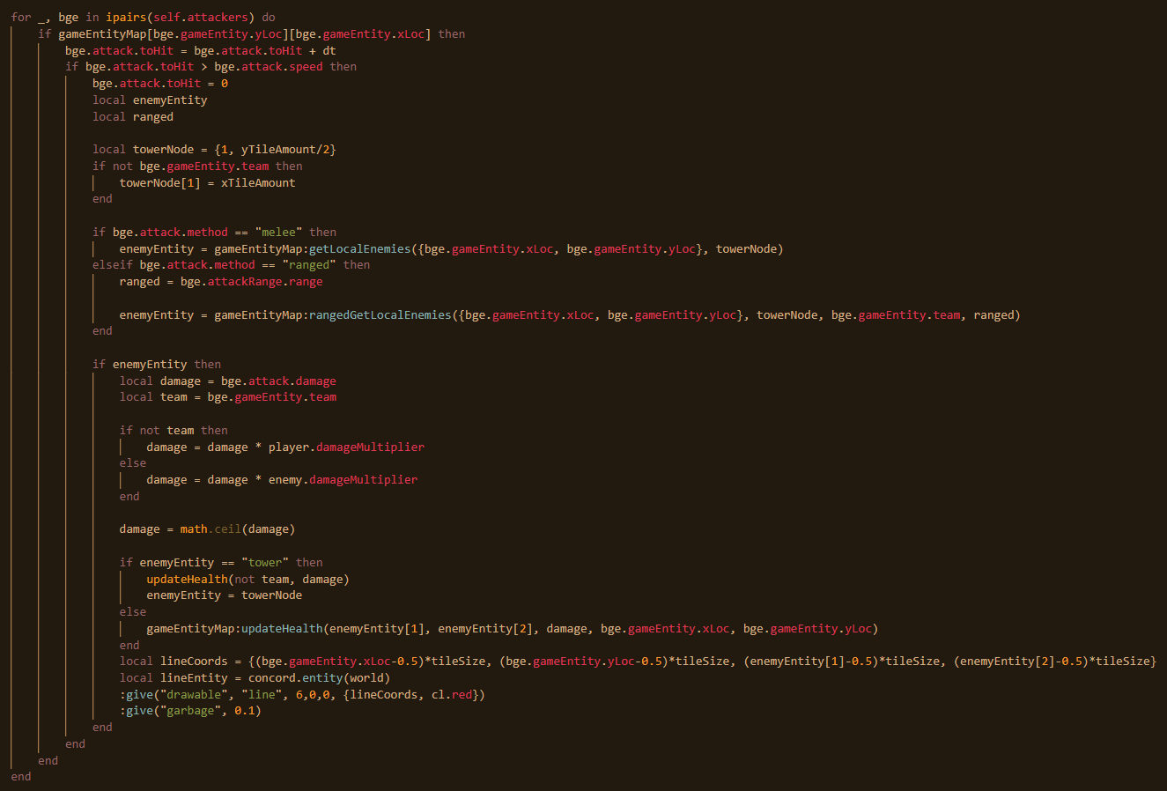

In the same update method where the pathfinding was happening, after the pathfinding is complete and all entities are in their newest positions, the enemies attack where they can. Firstly, the time since the last hit is updated and it checks that this is now greater than the attack speed, if so, the program proceeds. The time since last hit is reset. If the attack mode is melee, then the get local enemies’ function is called and the outcome is assigned to enemy entity. If the attack mode is ranged, the get ranged local enemies is called and the closest enemy is to be attacked.

Both of these return the coordinates of the enemy, or the value tower if the entity is next to a tower. Next, the damage is multiplied according to the loadout the entities player chose. Next, if it’s the tower that being attacked, the health of the respective tower is updated and if it’s the entity, the health of the respective entity is updated. Finally, a line is created that goes from the entity to the target. The purpose of this line is to serve as a visual indicator that an attack has happened. The line is to be deleted in 0.1 as the argument specifies in garbage.

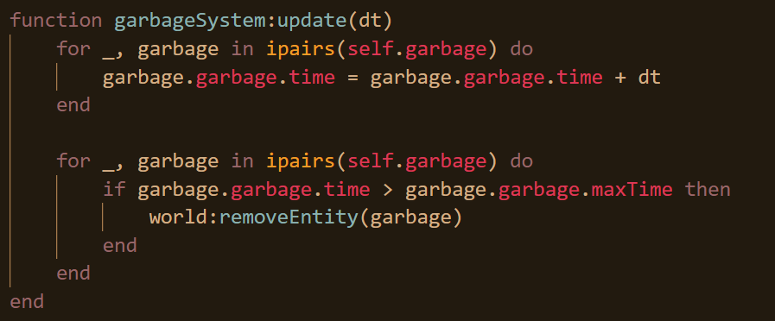

Whenever update is emitted, the garbage update method will also run. It iterates through all of its garbage and updates the time of each garbage correspondingly. Next, if any garbage has stayed longer for the max time allocated for it, it’s removed.

One other thing is that the drawable function needs to be amended to be able to incorporate lines.

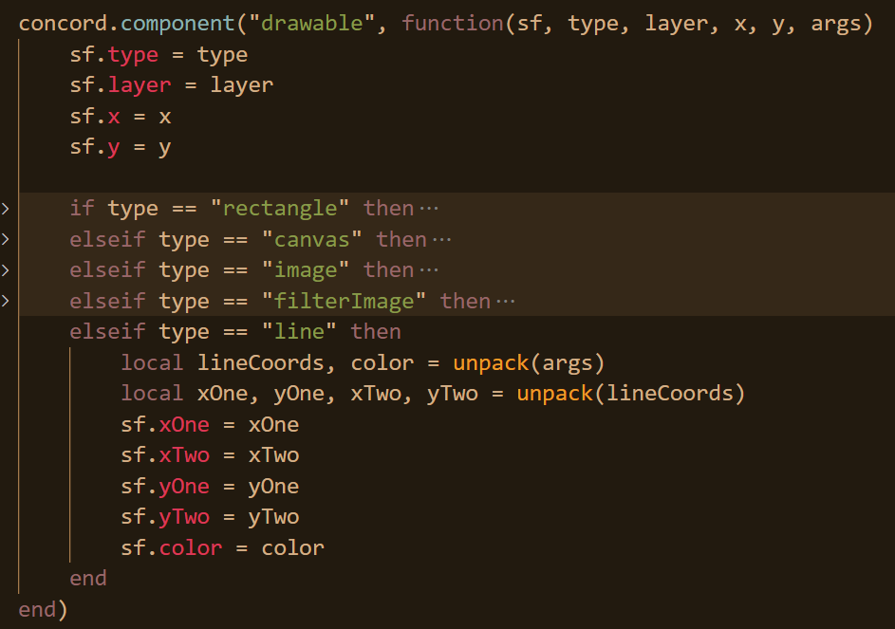

The arguments that the line type takes are the x and y position 1 and 2 as well as the corresponding colour. And the following is to draw the line.

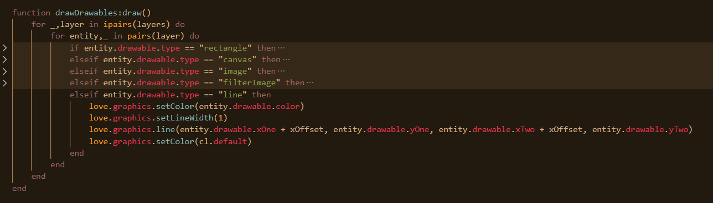

This is what the red lines look like when two enemies are attacking each other.

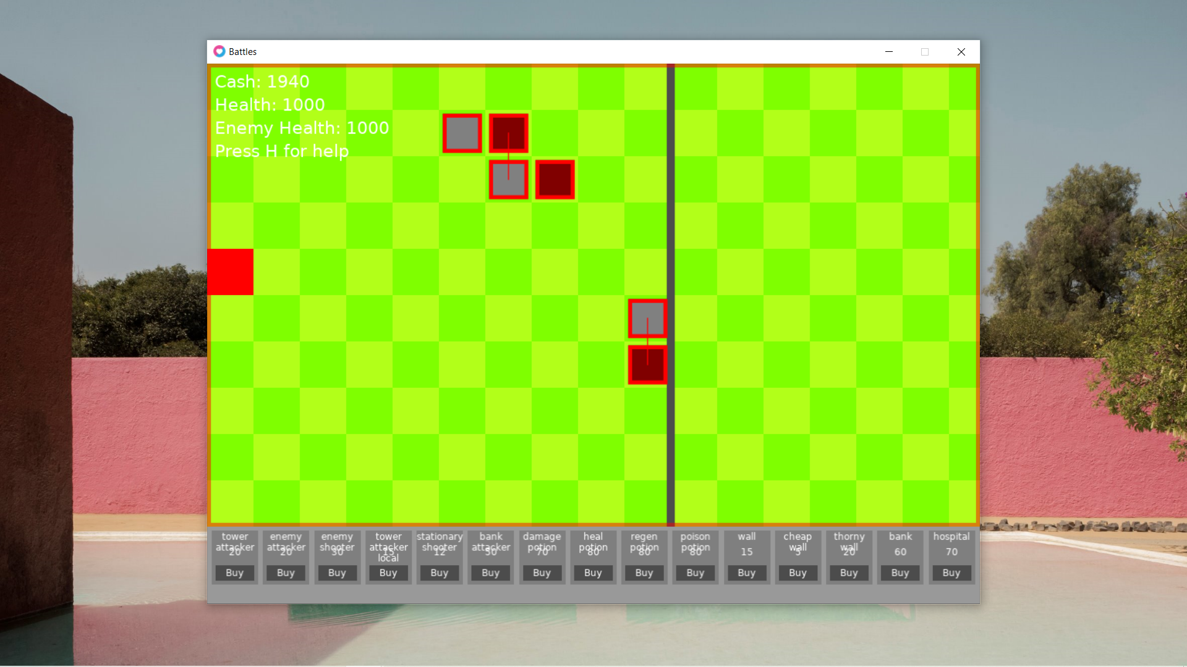

Enemy attacking is now successful. What’s needed now to be implemented is potions and other effects to occur. Some potions when placed down will have an effect whereby they fade away.

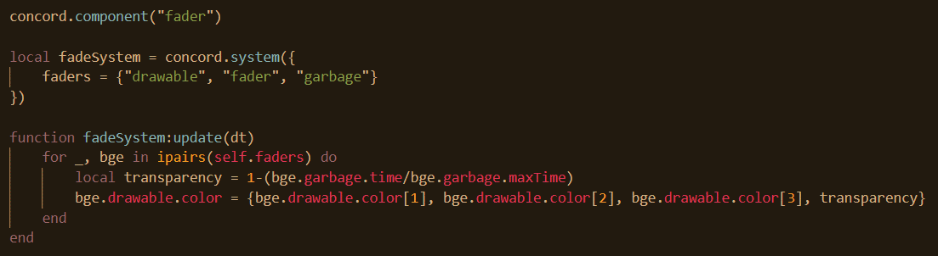

The component doesn’t have any properties. Entities will only belong to the fade system if they have something that is drawable, something with the fader property and something that is temporary so will be destroyed after a given amount of time. The fade system has the update method which will be called when the world emits update. It iterates through every fader and it updates the transparency of the drawable according to how much time has surpassed. The colour stays the same, it’s just the alpha value which is changed.

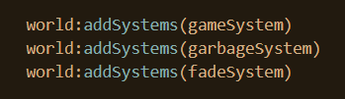

Again, this system needs to be added once a loadout has been chosen. Next, what is needed is a function that will place this temporary effect every time it is called. For instance, a poison potion may run for 10 seconds and damage once every 2 seconds, so it’s effect will have to be called 5 times.

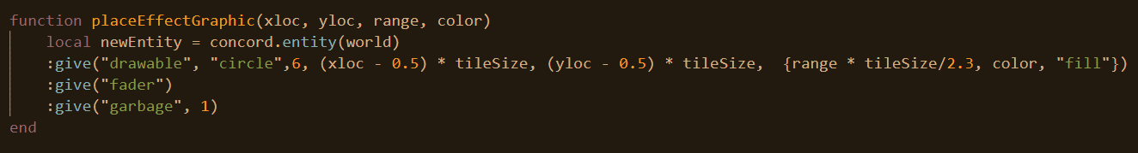

Every time such a graphic needs to be a created, a circle is generated and its radius is a function of its range. The fader property is added and the graphic lasts for just one second. A circle is a new type of drawable, so the drawable component needs to be updated as well.

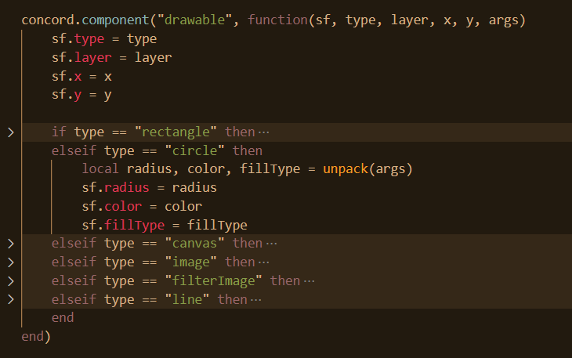

The arguments of colour, radius and fill type are assigned.

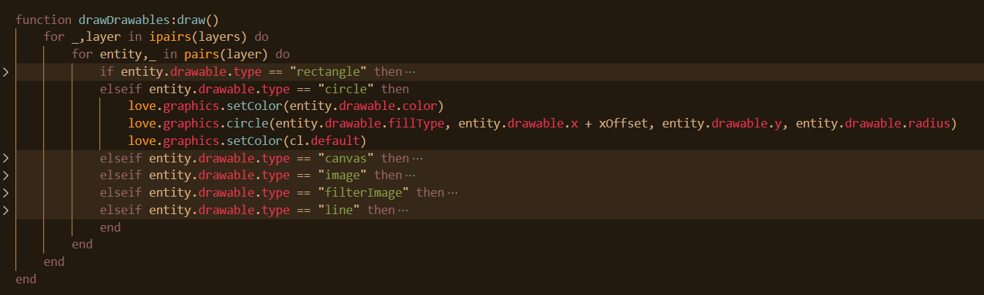

The drawable method is updated to be able to accommodate the drawing of circles now.

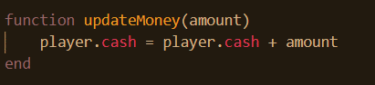

## Effects

Some effects actually increase a player’s cash balance so this function is needed.

After, all entities pathfind and all entities attack, the effects take place.

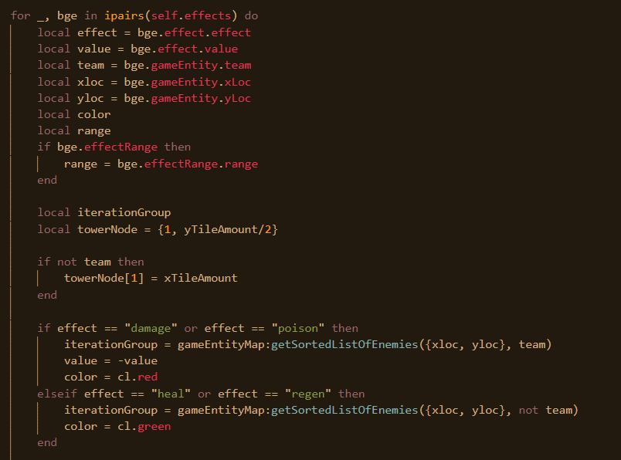

There are 6 effects: damage, poison, heal, regenerate, money and hospital. The first 4 have a graphical effect associated with them, that’s why the colour variable is being defined. Next, the team of enemies is inversed for the heal or regenerate effect since that it supposed to positively benefit your own team.

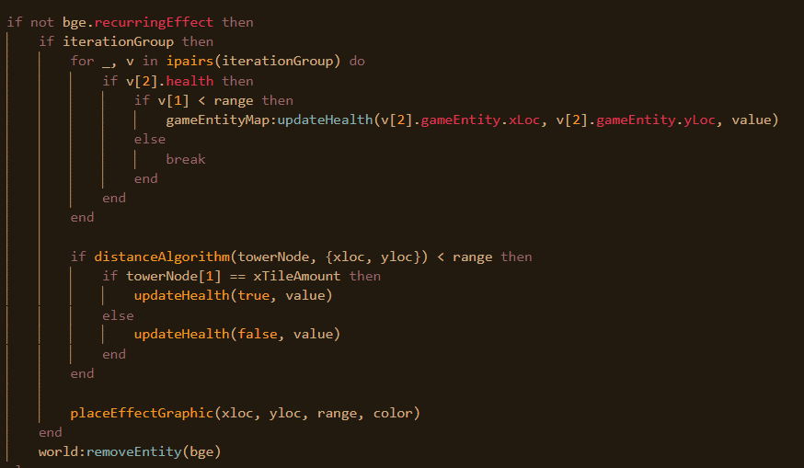

There are two types of effects, recurring and non-recurring. Recurring effects occur more than once. For non-recurring effects, the code is iterated through all enemies, or domestic entities, and updates their health accordingly until the enemy whose range is outside of the given range of the potion, then damage won’t be inflicted. The health of the tower is also updated to if the effect is close enough to it and the graphic is placed.

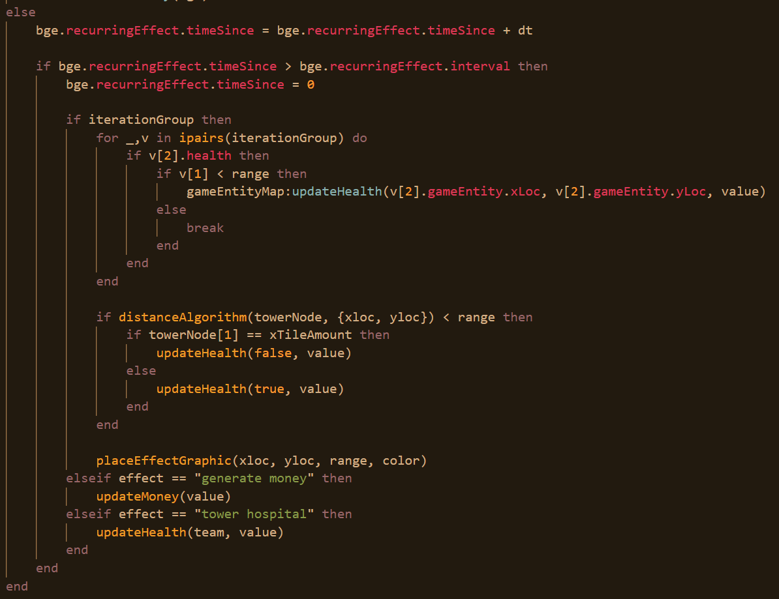

For recurring effects, a check is made to see that enough time has passed since the last time the effect was executed. If so, then the program iterates through all entities and updates health if the effect is poison, regen, heal, or damage. The same thing happens as earlier and an effect is placed down. If, however, it’s not one of the aforementioned effects, it’s either a money generator or tower health generator. The money generator updates player money, the tower hospital updates player health.

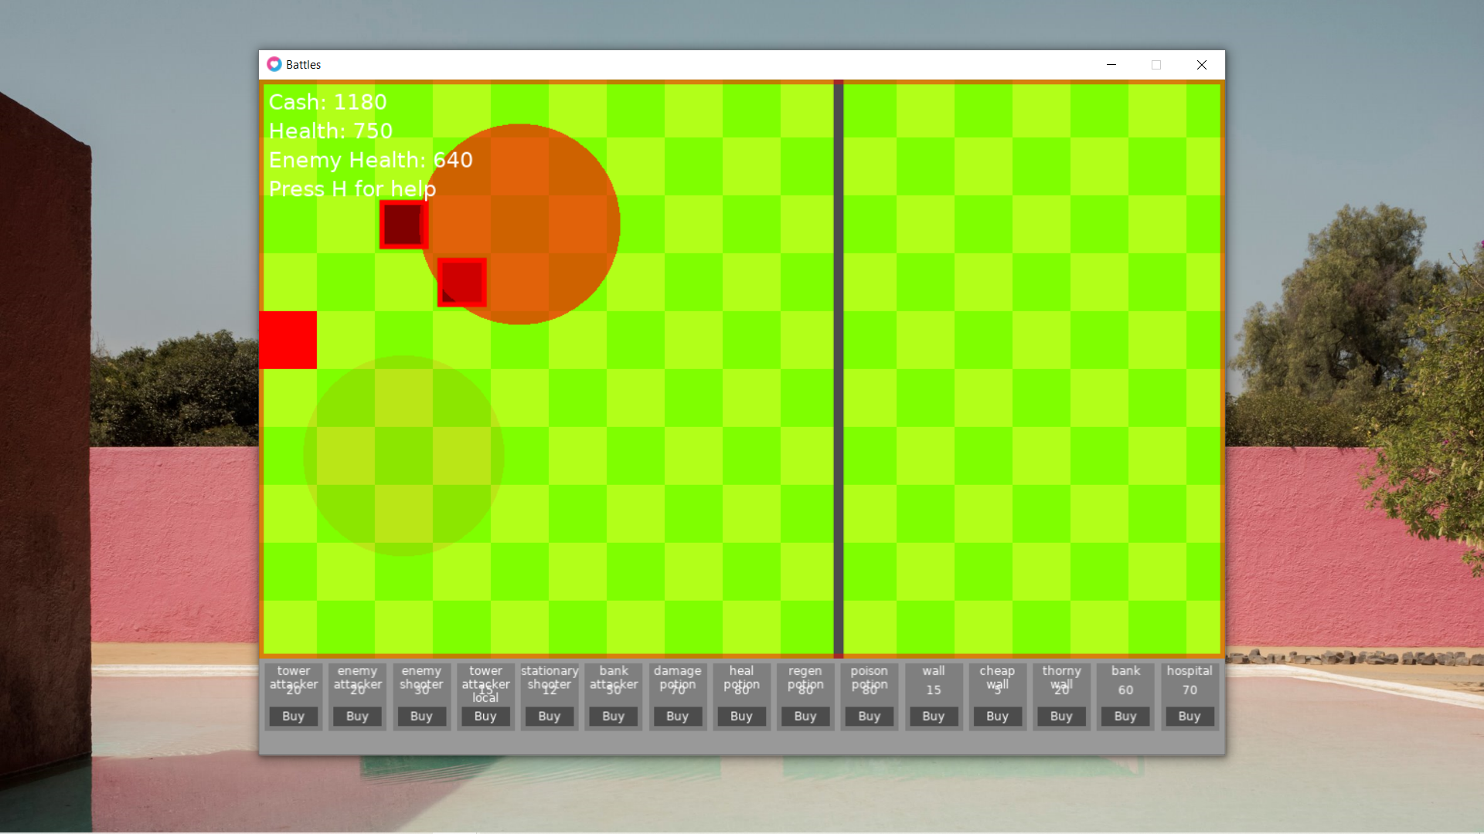

Here, is a freeze frame of a poison potion being implemented.

## Review

Now, all the entities perform their desired functionality. Some enemies are able to pathfind, some are able to damage enemies in the corresponding way that they were designed to do so, and some perform their effects. This is not all the functionality that occurs.

* Each entity has a unique functionality
  + Including but not limited to pathfinding, ranged and melee attacks, and explosions

Success criteria that has been met.

# Stage 5 – Miscellaneous finishing up

## Ending the game

At the moment, nothing happens when the game is over. This needs to be remedied.

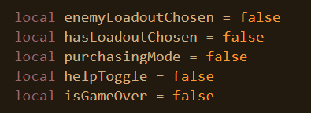

Firstly, a variable is needed to track whether or not the game is over.

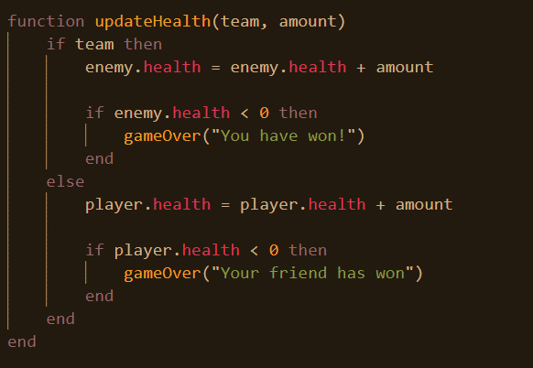Next, if the enemy’s health goes below 0 first, the game over function is called with a string being passed to reflect who has won.

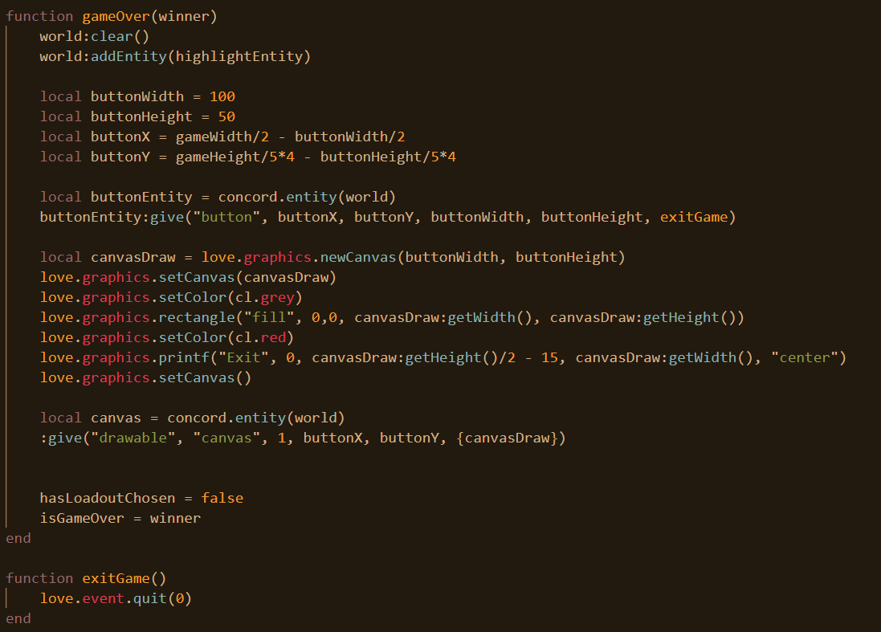

When the game over function is called, every entity is cleared from the world, but the highlight entity is added back. A button is created in the horizontal centre but vertically towards the bottom of the screen. And then, a canvas is created so that this button can be visually represented as text. The loadout chosen value is set to false, this is more of a trick so that the game moves to a pre-game loadout chosen state so nothing else in the game continues. Once the exit button is clicked, the game is over.

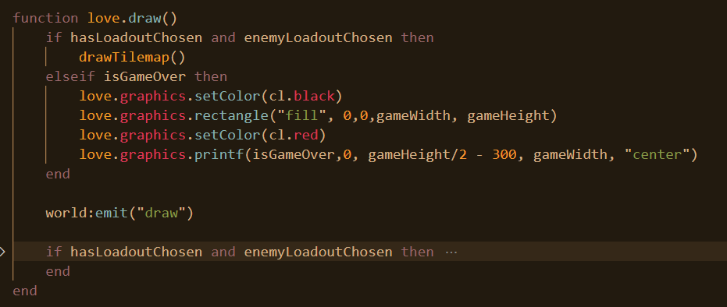

A black rectangle is drawn with the message to the user that they have either won or lost the game. The user will then have the option to click exit and the game will be over.

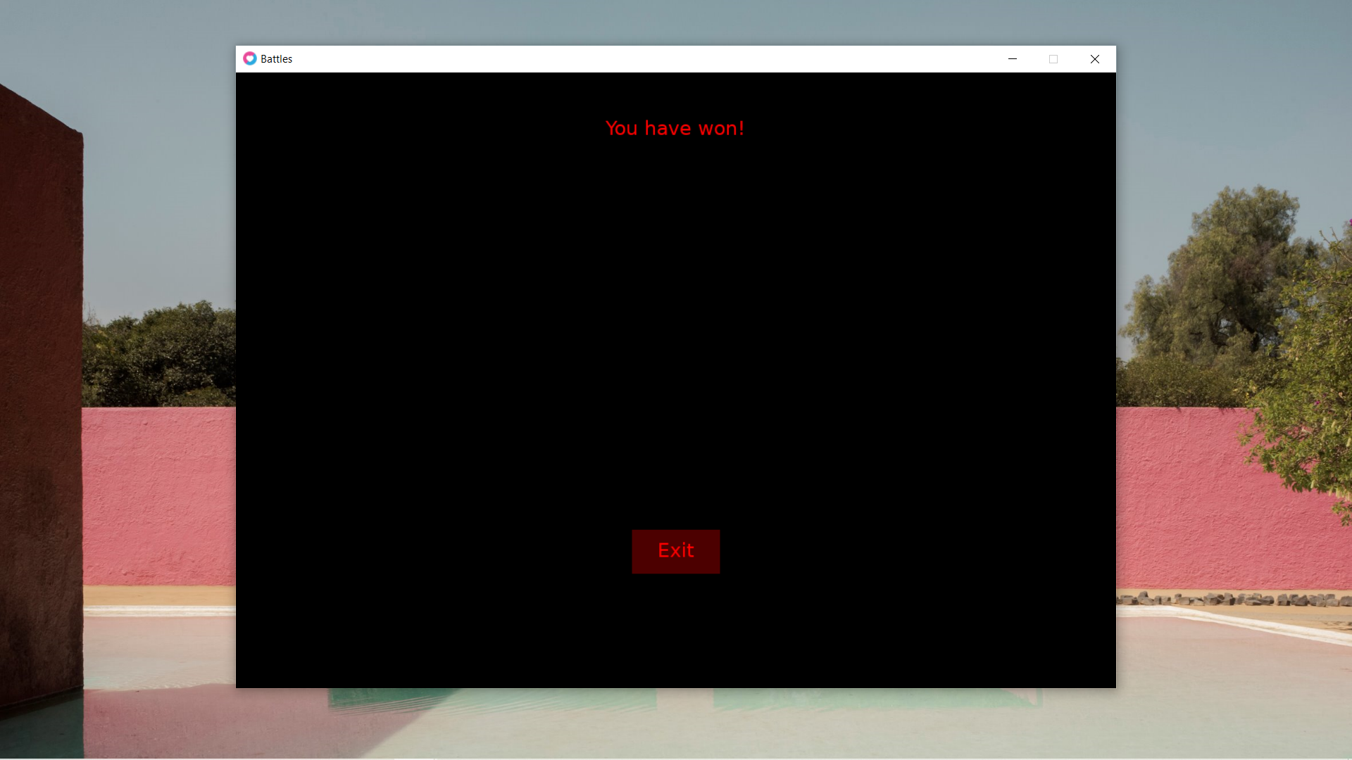

This is the final menu. Once the user clicks exit, the game is over.

## Returning home

However, this is not the end yet. It’s time to go back to the python script. There is no way at the moment for the in-game variable to be made false once the user has exited the game. This calls for action.

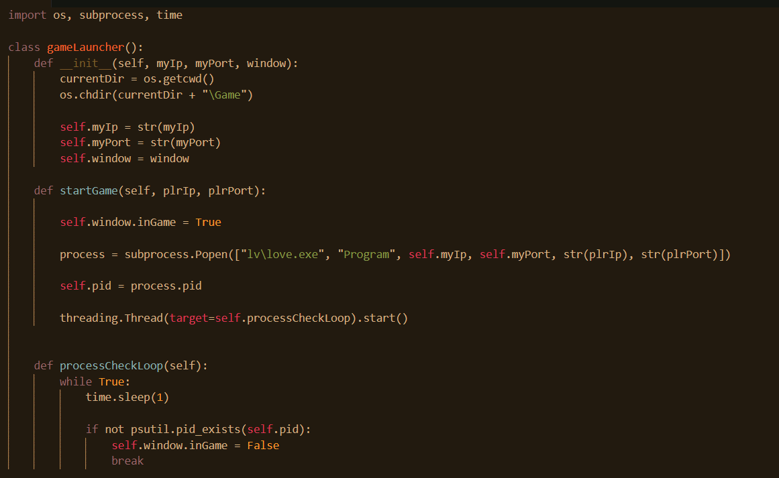

When love2d is launched, the process code is saved and a thread is created to check every second whether or not the process still exists, if it doesn’t exist, it can be assumed that the user exited the game and that the user is no longer in the game to which the program can continue.

## Review

Now, once the game is over an end game screen is presented and whoever has won is stated. There is a button to return back to the game.

* When game is over, end game screen of who won is presented
* Program returns to matchmaking window once game is over

This is the success criteria that has been met.

# Final testing and end user feedback

Testing has taken place throughout this process and the functioning of the program and its evolution has iteratively been shown. Nonetheless, a final testing table will be shown below to ensure everything works as to be expected and that which doesn’t work will be remedied.

|  |  |  |  |  |
| --- | --- | --- | --- | --- |
| **Test num** | **Function** | **Input** | **Expected** | **Actual** |
| 1 | Clicking on username textbox removes placeholder text | Mouse click on textbox | Placeholder text clears | Pass |
| 2 | Text that is not at least 2 letters won’t be accepted as input | “a” | Nothing | Pass |
| 3 | Text with numbers won’t be accepted | “num3” | Nothing | Pass |
| 4 | Text with punctuation won’t be accepted | “punc$” | Nothing | Pass |
| 5 | Text longer than 1 letter and only letters will be accepted | “Text” | Username textbox cleared, moved to next menu | Pass |
| 6 | Someone joins the network | N/A | Name appears | Pass |
| 7 | Someone sends an invite | Click invite | Invite appears | Pass |
| 8 | Someone rejects invite | Click reject | Invite button reappears, for both parties | Pass |
| 9 | Someone accepts invite | Click accept | Game launched | Pass |
| 10 | Someone leaves | N/A | After interval, player name disappears | Pass |
| 11 | Putting mouse over select loadout button highlights it | Mouse hover loadout select | Turns grey | Pass |
| 12 | Moving mouse off loadout button de-highlights it | Mouse off-hover loadout select | No longer grey | Pass |
| 13 | Clicking loadout 1 leads to corresponding stats | Click 1st loadout | Starts with 300 cash and 1500 health | Pass |
| 14 | Clicking loadout 2 leads to corresponding stats | Click 2nd loadout | Starts with 1000 cash and 2000 health | Pass |
| 15 | Clicking loadout 3 leads to corresponding stats | Click 3rd loadout | Starts with 1500 cash and 750 health | Pass |
| 16 | Clicking loadout 4 leads to corresponding stats | Click 4th loadout | Starts with 2000 cash and 1000 health | Pass |
| 17 | Purchasing item below price won’t work | Click item on map | Nothing | Pass |
| 18 | Entity can’t be placed on entity tower | Click entity tower | Nothing | Pass |
| 19 | Entities can’t be placed on other side of map | Click other side of map | Nothing | Pass |
| 20 | Entities with enough price and in correct location can be placed | Click on left hand side of map | Entity gets placed | Pass |
| 21 | Enemy entities placed will appear | Click on map | Enemy entity appears | Pass |
| 22 | Pathfinding entities will go to tower if no other enemy | Click on map | Enemy moves towards tower | Pass |
| 23 | Pathfinding entities will go around enemy walls |  | Enemy goes around wall | Pass |
| 24 | Tower health decreases when attacked |  | Tower health decreases when enemy entities are adjacent | Pass |
| 25 | Temporary effects disappear after their interval |  | Effect no longer flashes after period | Pass |
| 26 | When tower health is 0, game ends |  | End screen appears informing of winner | Pass |
| 27 | When user exits end window, matchmaking is relaunched | Click exit button | Matchmaking is now working | Pass |
| 28 | Clicking escape escapes from place mode | Escape key | Red outline disappears | Pass |
| 29 | Clicking buy enters place mode | Clicking buy entities | Red outline appears | Pass |
| 30 | Hovering over entities reveals corresponding entity information | Mouse over buy | Popup appears | Pass |
| 31 | Hovering off entities removes corresponding entity information | Mouse off buy | Popup disappears | Pass |
| 32 | Clicking h toggles help | H | Help menu appears | Pass |
| 33 | Clicking right causes user to pan rightwards across map | Right | Camera moves right | Pass |
| 34 | Clicking left causes user to pan leftwards across the map | Left | Camera moves left | Pass |
| 35 | Ranged entities cannot damage outside of their range | N/A | No shots | Pass |
| 36 | Once entities have a health of 0 they are destroyed | N/A | Entity is destroyed | Pass |
| 37 | Enemy health received when enemy picks loadout | Enemy click select | Enemy health stats is correct | Pass |
| 38 | Shooters can damage non-adjacent enemy entities | N/A | Shooter can shoots enemy that it is not touching but in range | Pass |
| 39 | Player cash displayed | N/A | Current player cash levels are displayed | Pass |
| 40 | Player health displayed | N/A | Current player health levels are displayed | Pass |
| 41 | Enemy player health displayed | N/A | Current enemy player health levels are displayed | Pass |
| 42 | Player buys entity a grey highlight is made to help user place | N/A | Grey highlight on the map grid should appear | Pass |
| 43 | When player escapes from buying an entity, grey highlight disappears | Escape | Grey highlight should disappear | Pass |

It would be redundant to show images of the above tests as evidence as much of the images will simply be duplications of images used in the iterative development above and so it is not necessary to do this. Should one need evidence that the code works as functions, one can look at the screenshots above for such evidence.

## End user feedback

I sent the game to various people to play and all had positive feelings towards the game, however I interviewed someone with more open-ended questions to gather more detailed feedback.

**How did you find the matchmaking process of the game?**

It worked fine. I was easily able to create a username and invite another player to play with me. One thing that I didn’t like was that the user interface seemed a little drab and boring. It didn’t look like it was going to be for a game.

**Having joined a game, how did you find the actual game**

I found the game to be very well made and I enjoyed playing the game a lot. It was pretty obvious you had to choose a class and once I did so, I saw that I had to buy characters to place and attack the enemy team. It was also clear to me which characters were mine and which were the enemy since the enemies were tinted red so there was no confusion there.

**Did you experiment with the variety of characters that there are for you to place**

Yeah, I did experiment with the different characters. One criticism here is that I feel that there are simply too many characters and it can be a bit overwhelming for a new player. Nonetheless, through multiple games, I came to learn how each character operated and when each character would best be used. I am now able to appreciate the variety given.

**How difficult was it to “learn” how to play the game**

I’ve played a lot of games similar to this such as Clash Royale and League of Legends so I generally didn’t need a prompt to tell me what to do. However, as I’ve mentioned above, it can be difficult to know what each character does in the beginning, perhaps a tutorial would be nice so that the user can understand how each character operates. Other than that though, I feel like that at lot of the time it’s pretty obvious what you need to do and it doesn’t need to be explained such as when choosing a loadout.

**Were there any features that you felt were missing**

The game is pretty well-rounded but as mentioned above, a tutorial would be nice so that a new user can quickly understand how to play without having to experiment a lot by themself. One other thing that surprised me wasn’t there is no taunting ability that the player can use against the other player. I know it’s not necessary for the functioning of the program but it would still make the game more fun.

# Evaluation

## Criteria reflections

The implementation of the game is complete and now I will reflect on the success criteria.

* Player’s create a username before entering lobby or GUI

This has been the case using Tkinter. The username is validated and then the user is allowed to move onto the matchmaking stage. Pass.

* UI
  + Lists player usernames
  + Invite button that invites users
    - Cannot invite players who are in-game
    - Accept/reject button if player receives an invite

A list of players is visible and invite functionality does work as set out. Pass.

* The player makes himself known to other players
  + Player appears in other player’s playerlist

The user does make himself known through broadcasting and does appear in other player’s playerlists. Pass

* If a player closes the lobby program, and other players are alerted to this
  + This player no longer appears in other player’s player lists

If the player closes his lobby program other players are alerted to this after a certain period of time. This can become more instantaneous in the future by simply tying a special exit broadcast message that will run when the user closes the program. Nonetheless, this feature does exist in some form. Semi-pass.

* The game will be 2D top-down (aerial view)
  + Pressing the WASD keys moves the camera leftwards or rightwards, up or down based on what key is pressed
  + There will be a dividing line in the middle of the map to designate each side
  + Enemy tower will be drawn on each side of the map for each corresponding team

The game is top-down and the user is able to pan around the map, which is split into two sides for each team. One area thing that wasn’t implemented was the camera moving upwards and downwards but that simply turned out to be a feature that wasn’t necessary otherwise the map would become too big so it simply wasn’t needed. Pass

* The player will see a menu a loadout menu before the game begins
  + In the menu there will be 4 boxes
    - The name of the loadout will be displayed in each box
    - The stats of the loadout will be displayed in each box
    - There will be a “Select” button in each box that the user can click to select the loadout
  + Varying properties of each loadout may include:
    - base health (of tower)
    - starting cash of the player
    - Tower health regeneration rate
    - Max amount of money a player can have
    - Currency increase rate
    - Specific details for reach class will be developed in the design stage and subject to change in the implementation

There is a loadout menu where the user can choose one of 4 loadouts which have unique advantages and disadvantages. Whilst each class didn’t have the specific properties described, these were merely suggestions and I did end up using some of them as well as coming up with another property. Pass.

* Once both users choose a loadout, the game begins, and the loadout menu is cleared

When the user presses select, the game is cleared and the game can begin. One thing that the loadout didn’t mention is that it is necessary for both players to have chosen a loadout for the game to begin. This was implemented. Pass

* Taunts

These were not implemented due to time constraints and given the fact that they were a non-essential feature. As a result of the fact that in the project investigation in the beginning users did have favourable attitudes towards this feature, this would be a good and not difficult feature to add into the future.

* On the bottom of the screen, there will be a menu for a selection of “character” that the user can buy and place down
  + The program checks that the user is able to afford the character before allowing the user to place it down
  + The user clicks on the entity to tell the program which entity he wants to place down
  + When the user clicks on a place in the map, the entity is deployed
  + I aim for there to be 15 unique entities
    - Each entity has a purchase price property
    - I will describe in more detail what the functionality of each entity in the design phase

The user is able to choose one of 15 entities and place them onto the map according to if he is able to afford them or not. Pass.

* Each entity has a unique functionality
  + Including but not limited to pathfinding, ranged and melee attacks, and explosions

Unique functionality has been given to each of these entities. Pass.

* When game is over, end game screen of who won is presented
  + Program returns to matchmaking window once game is over

When the game is over, the user is informed of who has won and they have a button to go back to the matchmaking window where they can play someone else. Pass.

## Limitations, Solutions and Maintenance

Admittedly, there are several limitations to this project.

With regards to the networking, it should be noted, that for most networks, the user cannot play with other users since the packets sent by the user are blocked by the router. Therefore, a workaround that a user must employ is to create their own network. Whilst this is admittedly an inconvenience, it is not as difficult as it seems. One way to this is that the user can set up a hotspot on their phone to which the players that wish to join him can join. Or, the user can do this on their own computer as well.

Another point of difficult, is that some users may require their firewall to be disabled to be able to run this game, which some users may be reluctant to do.

Both of the above can be handled internally by the program however and so the user doesn’t have to fish around in his computer settings or configuration to get the program to work. This can be a future feature.

As mentioned earlier, taunts, a feature that users had positive sentiments towards, was something that couldn’t be added but really this wasn’t a program integral feature so the program can still function without it. Despite this, one user in the end user feedback mentioned that he felt the game would’ve been more fun if taunting was a feature.

Finally, a non-computational can be made that this solution isn’t very artistically pleasant. This is something particularly that the end users have remarked upon, particularly in the matchmaking process where one user remarked that it didn’t even look like a game. Future maintenance can include employing someone with a greater background in design to improve some of the images and UI in this project.

Another thing that was mentioned in the end user feedback was a lack of a tutorial so could be difficult for some users to learn how to play the game and understand how the game works. This is something that could be implemented later on.

Given the nature of projects in this domain, updates are frequently requested to keep the game from becoming stale. This won’t be too difficult given the data oriented nature of this game and it will be quite easy to create new entities to incorporate in the game as well as simply adjusting entity properties to make them more balanced or creating entirely new systems with new functionality. This is the result of using the concord library.

This documentation can also act as a thorough manual explaining each aspect of the code in detail as well aiding in future maintenance. Git, a version control software has also been employed throughout and can be used to help further development.

# References

[1] https://www.statista.com/statistics/1135778/clash-royale-downloads-country

[2] https://play.google.com/store/apps/details?id=com.supercell.clashroyale

[3] https://play.google.com/store/apps/details?id=com.ninjakiwi.bloonstdbattles

[4] https://www.statista.com/topics/4266/league-of-legends

[5] https://www.leagueofgraphs.com/rankings/game-durations

[6] <https://pythonguides.com/python-tkinter-checkbutton>

[7] http://moonside.games/docs/encompass/why/architecture/ecs

[8] https://github.com/Tjakka5/Concord

[9] https://www.youtube.com/watch?v=-L-WgKMFuhE